**ISYS224 2018 – ASSIGNMENT ONE**

**StudentID: 45183228**

**StudentName: Christopher James Howden**

**Workshop Number: Practical 1(7) eStudent Class Timetable**

**Tutor Name: Jandson Hossain**

**Workshop Day and Time: Thursday 11 – 12 (9WW / E6A 112)**

Task 1: Data model

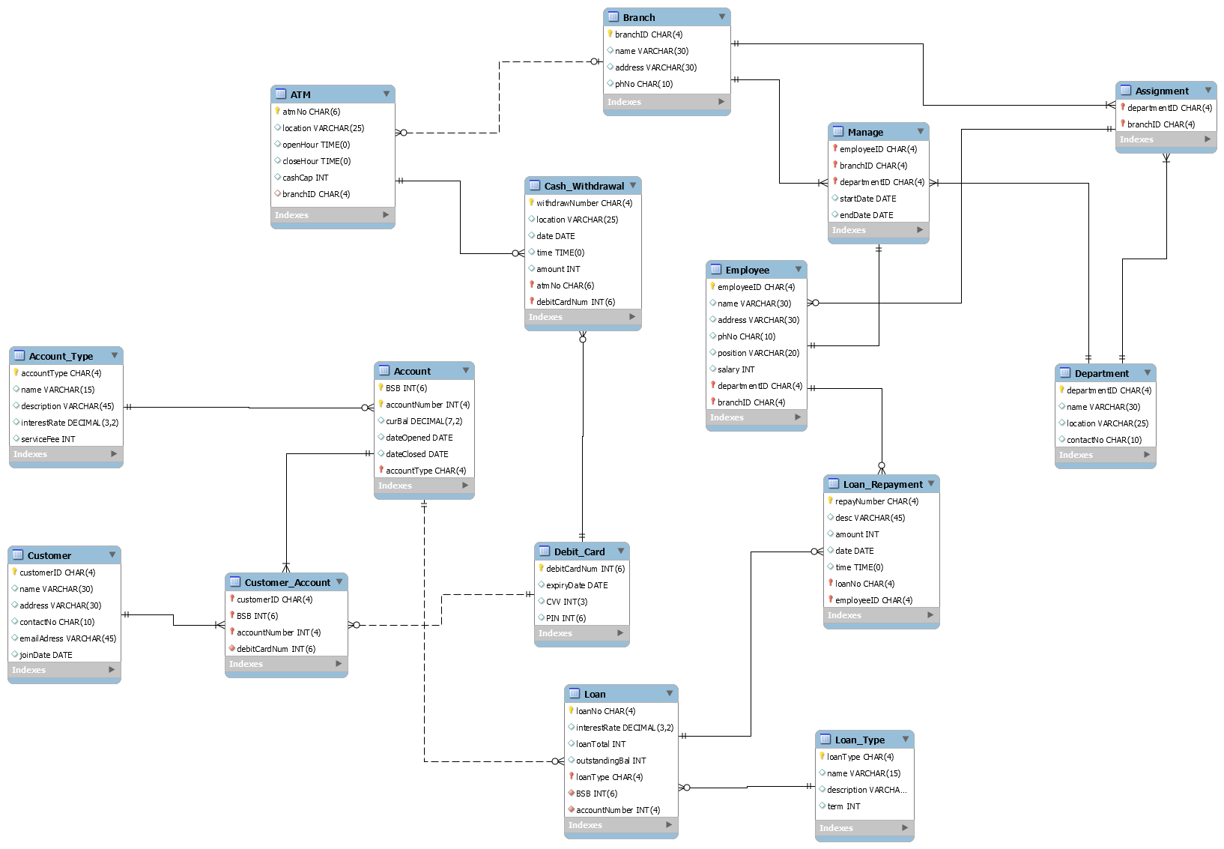

Task 2: Normalisation

**Transform table from 1NF to 2NF**

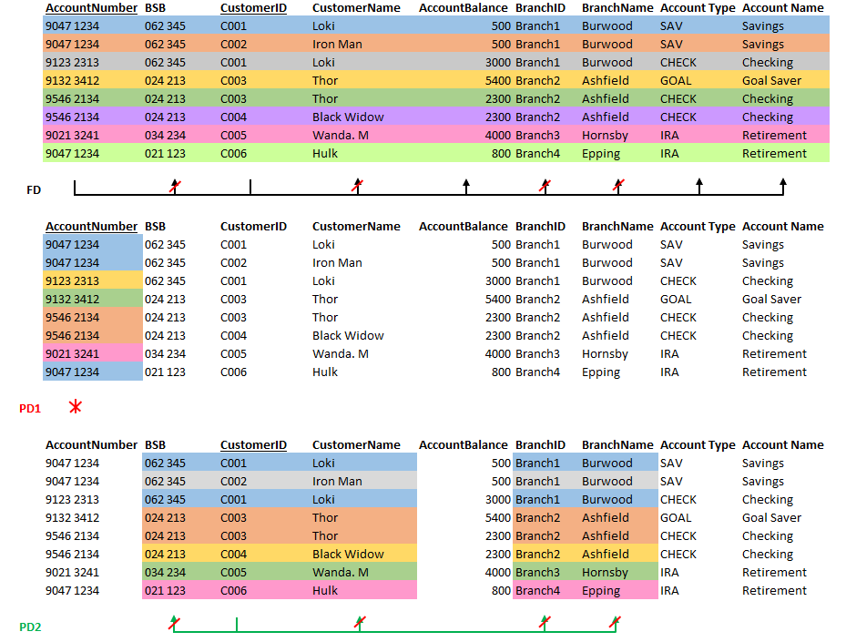

Underlined = Primary Key

Red = Foreign Key

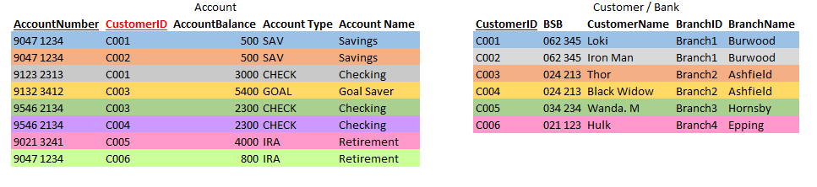

**Transform tables from 2NF to 3NF**

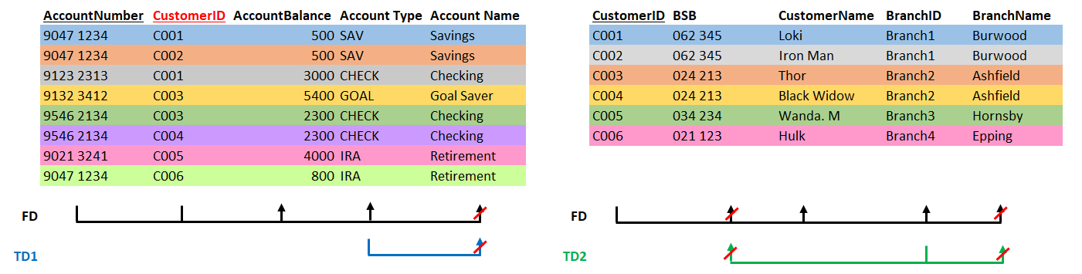

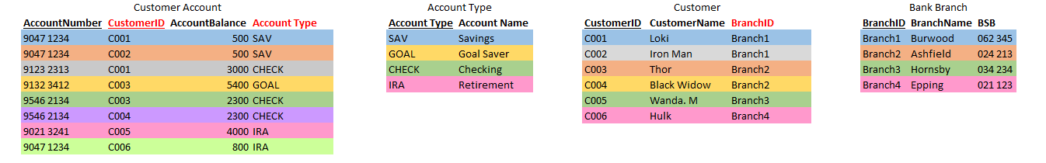

Task 4: DML

## Branch

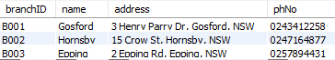

## Customer

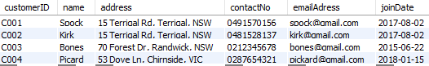

## Debit Card

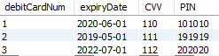

## Account Type

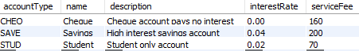

## Account

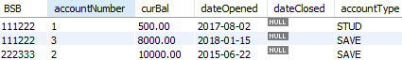

## ATM

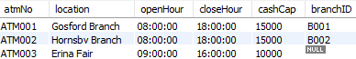

## Department

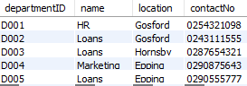

## Assignment

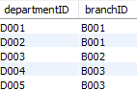

## Employee

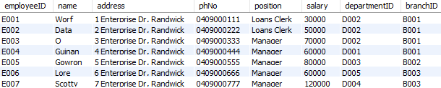

## Loan Type

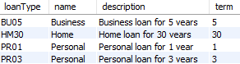

## Loan

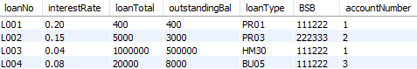

## Cash Withdrawal

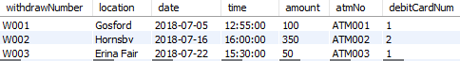

## Loan Repayment

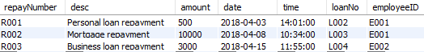

## Customer Account

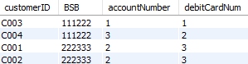

## Manage

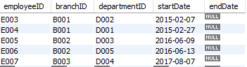

Task 5: DQL

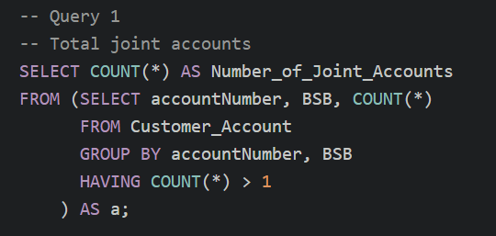



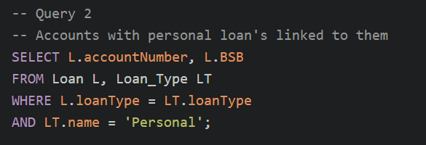



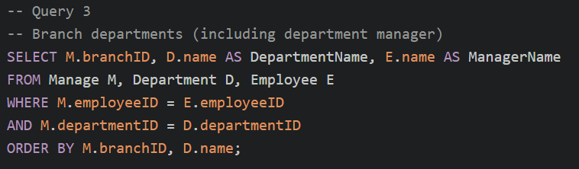

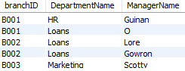

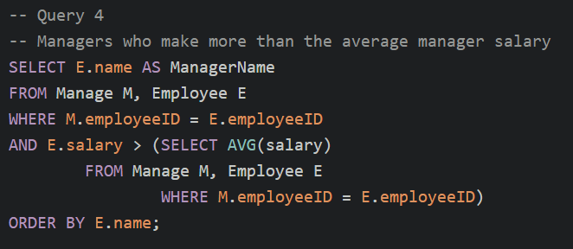



Assumptions:

Task 1 - Model:

* An ATM can exist outside of a branch e.g. A shopping centre (Erina Fair)
* Customers must have an account when signing up
* A single account may have multiple loans
  + A loan will be attached to an account (foreign key) but the account won’t be linked
  + If an account is deleted, the loan will still exist (we instead assume that the loan is reattached / associated to another account before deletion)
* Department location is the branch it is located at
  + This means if you want the same department at a different location, need to create new department type
* Attributes like address have been simplified for the exercise, in real life these would be separated into fields (e.g. Postcode, state, suburb, etc.)

Task 4 – DML Scripts:

* Debit Card table contains the PIN, which in a proper database would be encrypted and not able to be decrypted (even by DBA). For testing the system, it will just be stored as INT
* Some fields can have a NULL value (e.g. Branch of ATM, where not located at a branch)