# Trig rules

**1a.** The following diagram shows triangle .

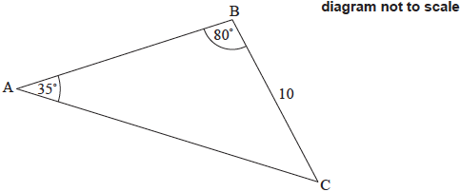



Find . *[3 marks]*

**1b.** Find the area of triangle . *[3 marks]*

**2a.** The following diagram shows a quadrilateral ABCD.

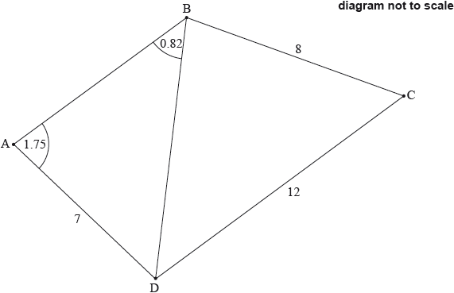



Find BD. *[3 marks]*

**2b.** Find . *[3 marks]*

**3a.** The following diagram shows the quadrilateral ABCD.

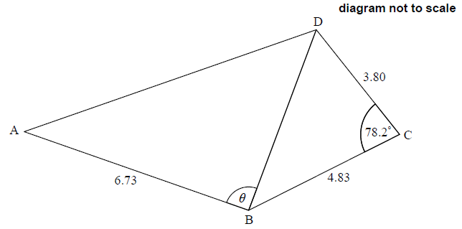

AB = 6.73 cm, BC = 4.83 cm, BĈD = 78.2° and CD = 3.80 cm.

Find BD. *[3 marks]*

**3b.** The area of triangle ABD is 18.5 cm2. Find the possible values of *θ*. *[4 marks]*

**4a.** The following diagram shows three towns A, B and C. Town B is 5 km from Town A, on a bearing of 070°. Town C is 8 km from Town B, on a bearing of 115°.

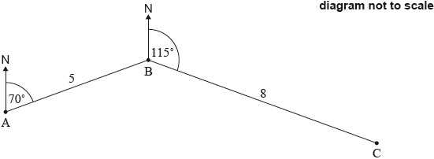

Find . *[2 marks]*

**4b.** Find the distance from Town A to Town C. *[3 marks]*

**4c.** Use the sine rule to find . *[2 marks]*

**5a.** In triangle ,  and . The area of the triangle is .

Find the two possible values for . *[4 marks]*

**5b.** Given that  is obtuse, find . *[3 marks]*

**6a.** A communication tower, T, produces a signal that can reach cellular phones within a radius of 32 km. A straight road passes through the area covered by the tower’s signal.

The following diagram shows a line representing the road and a circle representing the area covered by the tower’s signal. Point R is on the circumference of the circle and points S and R are on the road. Point S is 38 km from the tower and RŜT = 43˚.

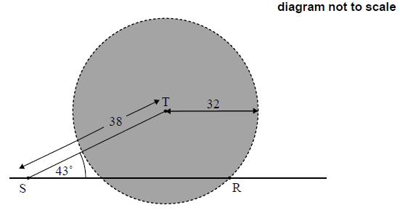

Let SR = . Use the cosine rule to show that . *[2 marks]*

**6b.** Hence or otherwise, find the total distance along the road where the signal from the tower can reach cellular phones. *[4 marks]*

**7a.** The following diagram shows the quadrilateral .

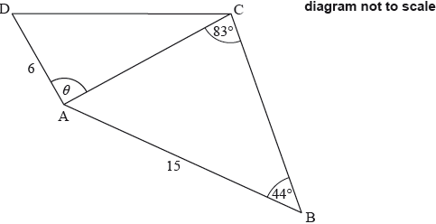



Find . *[3 marks]*

**7b.** Find the area of triangle . *[3 marks]*

**7c.** The area of triangle  is half the area of triangle .

Find the possible values of . *[5 marks]*

**7d.** Given that  is obtuse, find . *[3 marks]*

**8a.** The following diagram shows a square , and a sector  of a circle centre , radius . Part of the square is shaded and labelled .

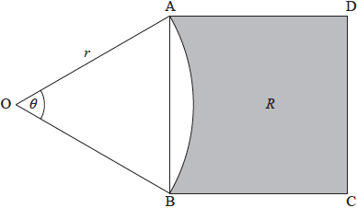



Show that the area of the square  is . *[4 marks]*

**8b.** When , the area of the square  is equal to the area of the sector . *[4 marks]*

(i)     Write down the area of the sector when .

(ii)     Hence find .