BECA / Dr. Huson / IB Math Name:

5 September 2019

**Homework: Function domain & range**

1. State which of the following sets, diagrams, or equations are functions. (5 marks)

a. b. f(x) = x2 – 5x + 6

**A**

**B**

**C**

**W**

**X**

**Y**

**Z**

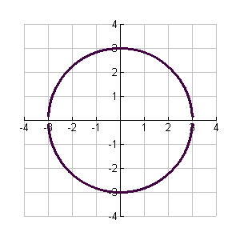

c. {(1,2), (2,4), (3,6), (4,8)} d.

e. x = y2

1. A function h(t) = 1 – 2x2 is defined for t ∈ {-2, -1, 0, 1, 2, 3}. (6 marks)

* 1. Represent h(t) using a mapping diagram. Label fully.
  2. List the elements of the domain of h(t).
  3. List the elements of the range of h(t).

1. Using set notation, state the **domain** and the **range** for the following relations. (10 marks)

a. {(1,2), (2,4), (3,6), (4,8)} b. f(x) = 2x

c. f(x) = x2 – 5x + 6 d. x2 + y2 = 4

e. f(x) = 

1. Find the range of each function with the given domains. (2 marks)
   1. g(x) = 3 – 2x, for -2 ≤ x ≤ 2 b. f(x) = x2, for -1 ≤ x < 4
2. Consider the function f(x) = 2 – x2. (6 marks)
   1. Find f(-3)
   2. Find f(1- x) and simplify
   3. Find x when f(x) = -7
3. For y = 3(x – 2)2 find the following: (4 marks)
   1. coordinates of the *x*- and *y*- intercepts
   2. coordinates of the vertex
   3. equation of the axis of symmetry
4. A stone is projected vertically upwards from the top of a building 250 m high. The height of the stone, *H(t)* meters above the ground level, *t* seconds after it is thrown is given by the equation:

*H(t) = 250 + 100t - 10t2, t ≥ 0.* (5 marks)

* 1. After 1 second, what was the height of the stone (above ground level)?
  2. How long did it take for the stone to reach its maximum height?
  3. What was the maximum height that the stone reached (above ground level)?