# BECA / Huson / IB Math

# 8 October 2019

# 1.21 Unit Test: Trigonometry Applications (Trig rules annex)

**1a.** The diagram shows a circle of radius  metres. The points ABCD lie on the circumference of the circle.

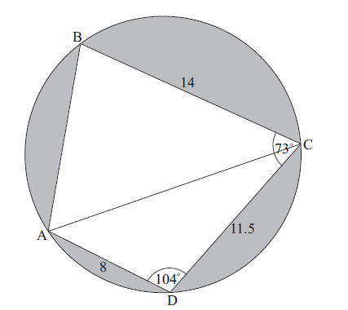

BC =  m, CD =  m, AD =  m,  , and  .

Find AC. *[3 marks]*

**1b.** (i)     Find  .

(ii)     Hence, find  . *[5 marks]*

**1c.** Find the area of triangle ADC. *[2 marks]*

**1d.** Hence or otherwise, find the total area of the shaded regions. *[4 marks]*

**2a.** The following diagram shows a circular play area for children.

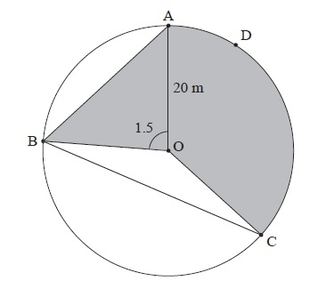

The circle has centre O and a radius of 20 m, and the points A, B, C and D lie on the circle. Angle AOB is 1.5 radians.

Find the length of the chord [AB]. *[3 marks]*

**2b.** Find the area of triangle AOB. *[2 marks]*

**2c.** Angle BOC is 2.4 radians.

Find the length of arc ADC. *[3 marks]*

**2d.** Angle BOC is 2.4 radians.

Find the area of the shaded region. *[3 marks]*

**2e.** Angle BOC is 2.4 radians.

The shaded region is to be painted red. Red paint is sold in cans which cost  each. One can covers . How much does it cost to buy the paint? *[4 marks]*