# BECA / Dr. Huson / IB Mathematics

# 19 September 2019

# **Do Now: Laws of sines and cosines practice**

**1a.** The following diagram shows triangle ABC.

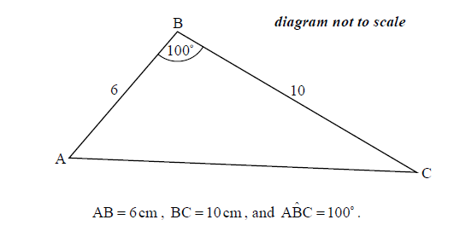

Find AC. *[3 marks]*

**1b.** Find . *[3 marks]*

**2a.** In triangle ,  and . The area of the triangle is .

Find the two possible values for . *[4 marks]*

**2b.** Given that  is obtuse, find . *[3 marks]*

**3a.** The following diagram shows a triangle ABC.

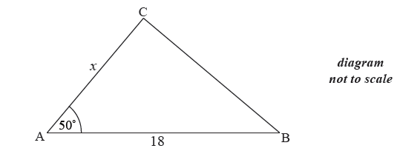

The area of triangle ABC is  cm , AB  cm , AC  cm and  .

Find  . *[3 marks]*

**3b.** Find BC. *[3 marks]*

**4a.** The following diagram shows  , where RQ = 9 cm,  and  .

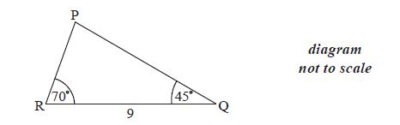

Find  . *[1 mark]*

**4b.** Find PR . *[3 marks]*

**4c.** Find the area of  . *[2 marks]*

**5a.** The diagram shows a circle of radius  metres. The points ABCD lie on the circumference of the circle.

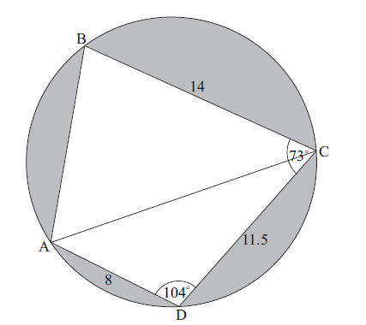

BC =  m, CD =  m, AD =  m,  , and  .

Find AC. *[3 marks]*

**5b.** (i) Find  . *[5 marks]*

(ii) Hence, find  .

**5c.** Find the area of triangle ADC. *[2 marks]*

**5d.** Hence or otherwise, find the total area of the shaded regions. *[6 marks]*