**Homework: Summary statistics review**

**1a.** Consider the following frequency table.

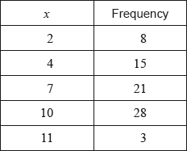

Write down the mode. *[1 mark]*

**1b.** Find the value of the range. *[2 marks]*

**1c.** Find the mean. *[2 marks]*

**1d.** Find the variance. *[2 marks]*

**2a.** A school collects cans for recycling to raise money. Sam’s class has 20 students.

The number of cans collected by each student in Sam’s class is shown in the following stem and leaf diagram.

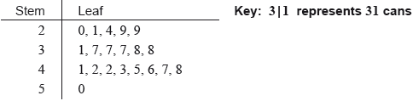

Find the median number of cans collected. *[2 marks]*

**2b.** The following box-and-whisker plot also displays the number of cans collected by students in Sam’s class.

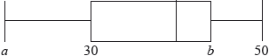

(i) Write down the value of .

(ii) The interquartile range is 14. Find the value of . *[3 marks]*

**2c.** Sam’s class collected 745 cans. They want an average of 40 cans per student.

How many more cans need to be collected to achieve this target? *[3 marks]*

**2d.** There are 80 students in the school.

The students raise $0.10 for each recycled can.

(i) Find the largest amount raised by a student in Sam’s class.

(ii) The following cumulative frequency curve shows the amounts in dollars raised by all the students in the school. Find the percentage of students in the school who raised more money than anyone in Sam’s class. *[5 marks]*

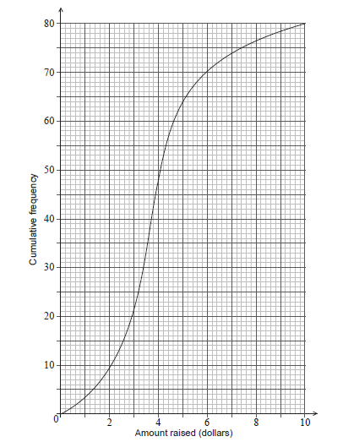

**2e.** The mean number of cans collected is 39.4. The standard deviation is 18.5.

Each student then collects 2 more cans.

(i) Write down the new mean.

(ii) Write down the new standard deviation. *[2 marks]*