**Do Now: Statistics practice**

*Answer in the space provided*

**1a.** Ten students were surveyed about the number of hours, *x*, they spent browsing the Internet during week 1 of the school year. The results of the survey are given below.

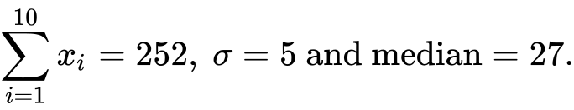

Find the mean number of hours spent browsing the Internet. *[2 marks]*

**1b.** During week 2, the students worked on a major project and they each spent an additional five hours browsing the Internet. For week 2, write down

(i) the mean;

(ii) the standard deviation. *[2 marks]*

**1c.** During week 3 each student spent 5% less time browsing the Internet than during week 1. For week 3, find

(i) the median;

(ii) the variance. *[6 marks]*

**1d.** During week 4, the survey was extended to all 200 students in the school. The results are shown in the cumulative frequency graph:

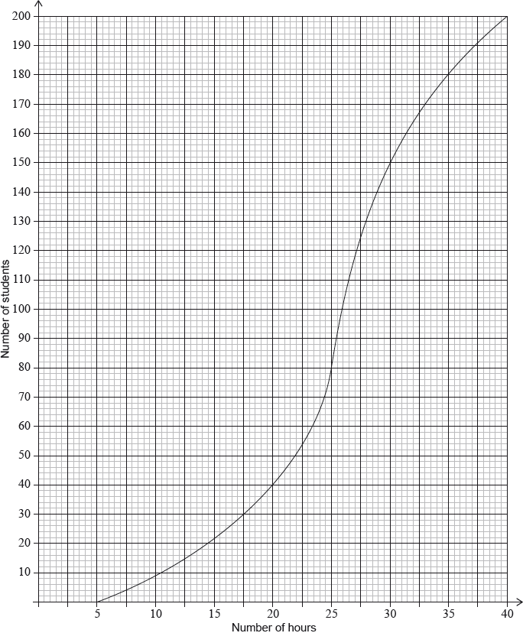

(i) Find the number of students who spent between 25 and 30 hours browsing the Internet.

(ii) Given that 10% of the students spent more than *k* hours browsing the Internet, find the maximum value of *k*. *[6 marks]*

**1e.** Complete the frequency table

|  |  |  |  |  |  |  |  |
| --- | --- | --- | --- | --- | --- | --- | --- |
| Hours | 5-10 | 10-15 | 15-20 | 20-25 | 25-30 | 30-35 | 35-40 |
| Frequency |  |  |  |  |  |  |  |
| Cumulative frequency |  |  |  |  |  |  |  |

**Early Finishers / Spicy**

**2a.** Consider the following sequence of figures.

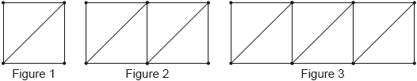

Figure 1 contains 5 line segments.

Given that Figure  contains 801 line segments, show that . *[3 marks]*

**2b.** Find the total number of line segments in the first 200 figures. *[3 marks]*

**3a.** The following diagram shows [AB], with length 2 cm. The line is divided into an infinite number of line segments. The diagram shows the first three segments.

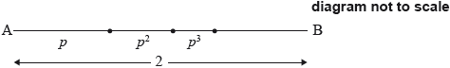

The lengths of the line segments are , where .

Show that 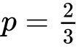. *[5 marks]*

**3b.** The following diagram shows [CD], with length , where . Squares with side lengths , where , are drawn along [CD]. This process is carried on indefinitely. The diagram shows the first three squares.

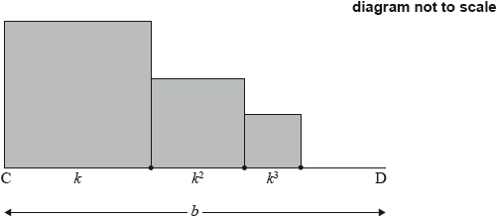

The **total** sum of the areas of all the squares is . Find the value of . *[9 marks]*