Classwork (challenge): Frequency table and cumulative distribution

**3a.** A running club organizes a race to select girls to represent the club in a competition.

The times taken by the group of girls to complete the race are shown in the table below.

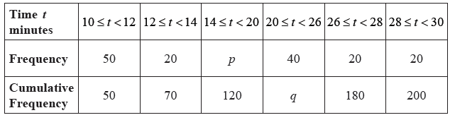

Find the value of *p* and of *q*. *[4 marks]*

**3b.** A girl is chosen at random.

(i) Find the probability that the time she takes is less than 14 minutes.

(ii) Find the probability that the time she takes is at least 26 minutes. *[3 marks]*

**3c.** A girl is selected for the competition if she takes less than  minutes to complete the race.

Given that 40% of the girls are not selected,

(i) find the number of girls who are not selected;

(ii) find *x*. *[4 marks]*

**3d.** Girls who are not selected but took less than 25 minutes to complete the race, are allowed another chance to be selected. The new times taken by these girls are shown in the cumulative frequency diagram below.  
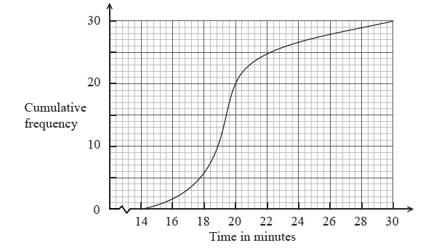

(i) Write down the number of girls who were allowed another chance.

(ii) Find the percentage of the whole group who were selected. *[4 marks]*