**Do Now: Statistics frequency table, box plot (complete on lined paper)**

**1a.** Consider the following frequency table.

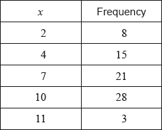

Write down the mode. *[1 mark]*

**1b.** Find the value of the range. *[2 marks]*

**1c.** Find the mean. *[2 marks]*

**1d.** Find the variance. *[2 marks]*

**2a.** There are 10 items in a data set. The sum of the items is 60.

Find the mean. *[2 marks]*

**2b.** The variance of this data set is 3. Each value in the set is multiplied by 4.

(i) Write down the value of the new mean.

(ii) Find the value of the new variance. *[3 marks]*

**3a.** The following box-and-whisker plot represents the examination scores of a group of students.

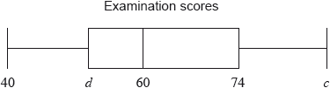

Write down the median score. *[1 mark]*

The range of the scores is 47 marks, and the interquartile range is 22 marks.

**3b.** Find the value of

(i) ;

(ii) . *[4 marks]*