**PreTest: Statistics, sequences, overall review (complete on lined paper)**

(109 points, approximately 2 hours work. 1 hour’s work due tomorrow)

**1a.** Consider the following frequency table.

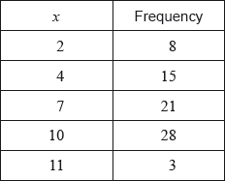

Write down the mode. *[1 mark]*

**1b.** Find the value of the range. *[2 marks]*

**1c.** Find the mean. *[2 marks]*

**1d.** Find the variance. *[2 marks]*

**2a.** There are 10 items in a data set. The sum of the items is 60.

Find the mean. *[2 marks]*

**2b.** The variance of this data set is 3. Each value in the set is multiplied by 4.

(i) Write down the value of the new mean.

(ii) Find the value of the new variance. *[3 marks]*

**3a.** Let .

For the graph of *f*:

(i) write down the -intercept;

(ii) find the -intercept;

(iii) write down the equation of the horizontal asymptote. *[4 marks]*

**3b.** On the grid on page 5, sketch the graph of , for . *[3 marks]*

**4a.** The following box-and-whisker plot represents the examination scores of a group of students.

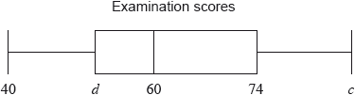

Write down the median score. *[1 mark]*

The range of the scores is 47 marks, and the interquartile range is 22 marks.

**4b.** Find the value of

(i) ;

(ii) . *[4 marks]*

**5.** Three consecutive terms of a geometric sequence are , 6 and .

Find the possible values of . *[6 marks]*

**6.** In a geometric sequence, the fourth term is 8 times the first term. The sum of the first 10 terms is 2557.5. Find the 10th term of this sequence. *[6 marks]*

**7a.** The first three terms of an arithmetic sequence are .

Find the common difference. *[2 marks]*

**7b.** Find the 30th term of the sequence. *[2 marks]*

**7c.** Find the sum of the first 30 terms. *[2 marks]*

**8a.** The sums of the terms of a sequence follow the pattern



Given that , find  and . *[4 marks]*

**8b.** Find a general expression for . *[4 marks]*

**9a.** Let  and  .

Express  in the form  , where  . *[4 marks]*

**9b.** The graph of *g* is a transformation of the graph of *f* . Give a full geometric description of this transformation. *[3 marks]*

**10.** Solve  , for  . *[7 marks]*

**11a.** Let  .

(i) Show that  .

(ii) Write down the domain of  . *[3 marks]*

**11b.** Solve the equation  . *[4 marks]*

**12a.** Let , for .

Find . *[3 marks]*

**12b.** Let  be a function so that . Find . *[3 marks]*

**13a.** The following diagram shows the graph of a function .

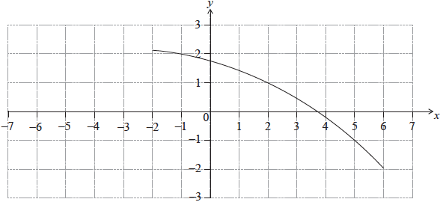

Find . *[2 marks]*

**13b.** Find . *[3 marks]*

**13c.** On the same diagram, sketch the graph of . *[2 marks]*

**14.** Let  and .

Find . *[2 marks]*

**15.** Let , for . The line  intersects the graph of  in two distinct points. Find the possible values of . *[7 marks]*

**16a.** Consider . The graph of  has a minimum value when .

The distance between the two zeros of  is 9.

Show that the two zeros are 3 and . *[2 marks]*

**16b.** Find the value of  and of . *[4 marks]*

**17a.** Let .

Write down the -intercept of the graph of . *[1 mark]*

**17b.** Solve . *[3 marks]*

**18a.** Let 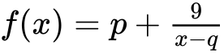, for . The line  is a vertical asymptote to the graph of .

Write down the value of . *[1 mark]*

**18b.** The graph of  has a -intercept at .

Find the value of . *[4 marks]*

**18c.** Write down the equation of the horizontal asymptote of the graph of . *[1 mark]*

**(continued from page 1)**

**3.** Let .

**3b.** On the grid on page 5, sketch the graph of , for . *[3 marks]*

