BECA / Huson / IB Mathematics Name:

21 November 2019

**3.8** **Classwork: Pretest summary statistics review**

**1a.** A fisherman catches 200 fish to sell. He measures the lengths, *l* cm of these fish, and the results are shown in the frequency table below.  
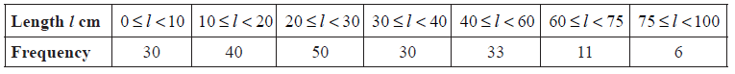

Calculate an estimate for the standard deviation of the lengths of the fish. *[3 marks]*

**1b.** A cumulative frequency diagram is given below for the lengths of the fish.

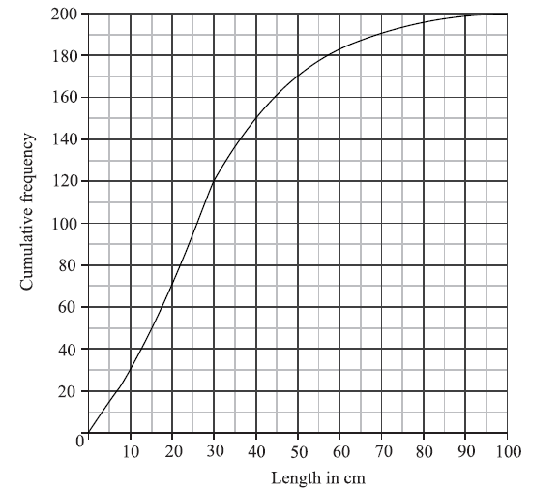

Use the graph to answer the following. *[6 marks]*

(i)     Estimate the interquartile range.

(ii)    Given that  of the fish have a length more than , find the value of *k*.

**1c.** In order to sell the fish, the fisherman classifies them as small, medium or large.

Small fish have a length less than .

Medium fish have a length greater than or equal to  but less than .

Large fish have a length greater than or equal to .

Write down the probability that a fish is small. *[2 marks]*

**1d.** The cost of a small fish is , a medium fish , and a large fish .

Copy and complete the following table, which gives a probability distribution for the cost  .

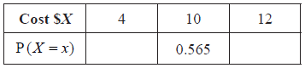 *[2 marks]*

**1e.** Find  . *[2 marks]*