An Illustration of the Fibonacci Sequence

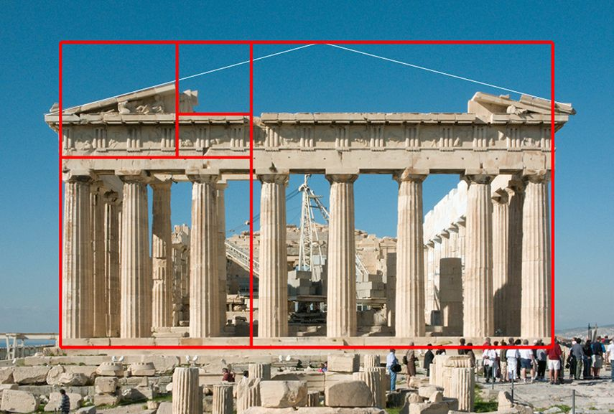 The Fibonacci sequence is a famous mathematical topic, dating to roughly 800 years ago when Leonardo of Pisa wrote about it to illustrate the use of the Hindu-Arabic number system, which he introduced to Italy and hence the western world (Science Encyclopedia). The Golden Ratio is an even older mathematical idea, known and popularized by the ancient Greeks, and was important to their view of beauty and design, as can be seen in the proportions of an ancient Greek temple, Figure 1. Not only are they important and interesting in their own right, but the Fibonacci sequence and the Golden Ratio are connected. Understanding the connection requires the use of limits, a method from calculus to deal with infinity, which we will study next year.

Figure : The face of this Greek temple is in the proportion of the Golden Ratio (Hegde)

The aim of this paper is to explore these two interesting topics, the Fibonacci Sequence and the Golden Ratio, and to show their connection through the use of limits.

The organization of this paper is as follows. First, I explain the Fibonacci Sequence, write out the first few terms, and state its recursive definition using proper mathematical notation. In addition to the algebraic definition, I construct a geometric depiction, the well-known Fibonacci spiral. Second, I define the Golden Ratio as the solution to an equation of proportions, which I solve for its value, called ϕ. Third, I informally show the link between the topics by examining the behavior of the ratio of consecutive terms in the Fibonacci Sequence, which approaches ϕ as the sequence goes to infinity. Finally, I conclude with a short review showing that I have met my aim and reflect on the result.

Create an image in Geogebra based on a spiral layout of the Fibonacci sequence, as shown, for example, in Figure 1. Copy it to MS Word and write a short exposition. You should show the recursive formula for the sequence (use the Equation Editor).

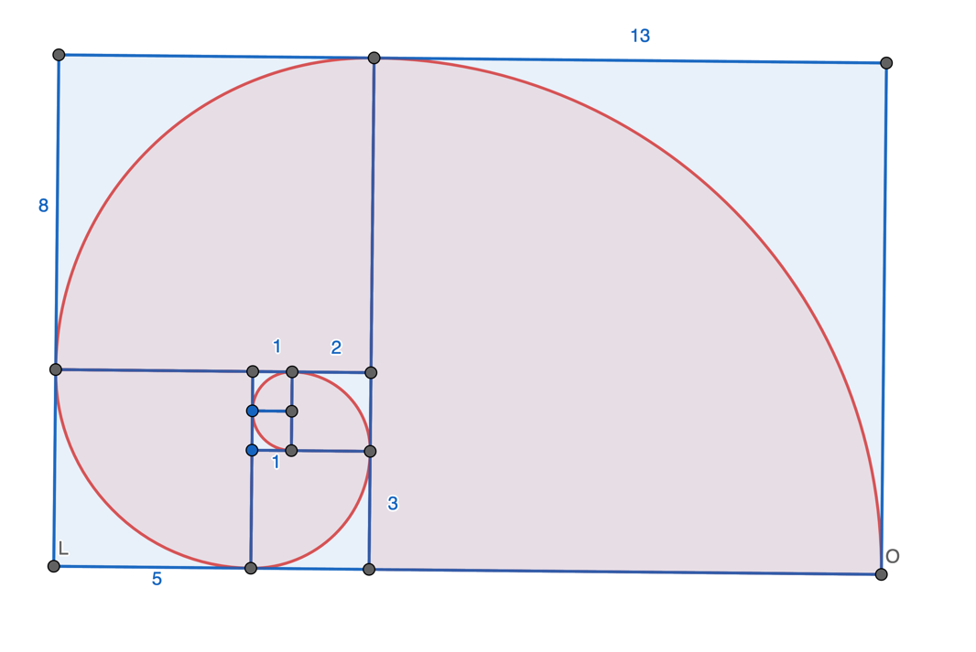

Figure 2: Fibonacci sequence depicted as squares laid out in a spiral pattern

As a further exploration, consider the ratio of consecutive terms in the sequence. At the limit, they go to the Golden Mean.