**Homework:** Review problems of linear & quadratic functions and models

**1a.** The diagram shows the straight line , which intersects the -axis at  and the -axis at  .

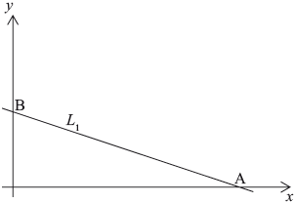

Write down the coordinates of M, the midpoint of line segment AB. *[2 marks]*

**1b.** Calculate the gradient of . *[2 marks]*

**1c.** The line  is parallel to  and passes through the point .

Find the equation of . Give your answer in the form . *[2 marks]*

|  |
| --- |
|  |

**2a.** The equation of the line  is .

Write down

(i) the gradient of ;

(ii) the -intercept of . *[2 marks]*

**2b.** The line  is parallel to  and passes through the point .

Write down the equation of . *[2 marks]*

**2c.** Find the -coordinate of the point where  crosses the -axis. *[2 marks]*

|  |
| --- |
|  |

**3a.** The number of apartments in a housing development has been increasing by a constant amount every year. At the end of the first year the number of apartments was 150, and at the end of the sixth year the number of apartments was 600.

The number of apartments, , can be determined by the equation , where is the time, in years.

Find the value of . *[2 marks]*

**3b.** State what  represents **in this context**. *[1 mark]*

**3c.** Find the value of . *[2 marks]*

**3d.** State what  represents **in this context**. *[1 mark]*

|  |
| --- |
|  |

**4a.** An iron bar is heated. Its length, , in millimetres can be modelled by a linear function, , where  is the temperature measured in degrees Celsius (°C).

At 150°C the length of the iron bar is 180 mm.

Write down an equation that shows this information. *[1 mark]*

**4b.** At 210°C the length of the iron bar is 181.5 mm.

Write down an equation that shows this second piece of information. *[1 mark]*

**4c.** Hence, find the length of the iron bar at 40°C. *[4 marks]*

|  |
| --- |
|  |

**5a.** The graph of the quadratic function  intersects the *y*-axis at point A (0, 5) and has its vertex at point B (4, 13).

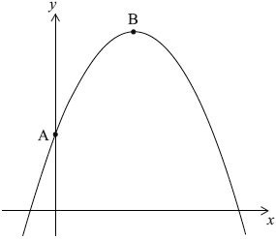

Write down the value of . *[1 mark]*

**5b.** By using the coordinates of the vertex, B, or otherwise, write down **two** equations in  and . *[3 marks]*

**5c.** Find the value of  and of . *[2 marks]*

**6a.** Consider the quadratic function, , where  and  are positive integers.

The graph of  passes through the point .

Calculate the value of . *[2 marks]*

**6b.** The vertex of the function is .

Find the value of . *[2 marks]*

**6c.** The vertex of the function is .

Write down the range of . *[2 marks]*

|  |
| --- |
|  |

**7a.** The surface of a red carpet is shown below. The dimensions of the carpet are in metres.

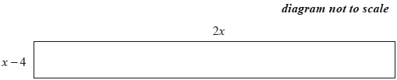

Write down an expression for the area, , in , of the carpet. *[1 mark]*

**7b.** The area of the carpet is .

Calculate the value of . *[3 marks]*

**7c.** The area of the carpet is .

Hence, write down the value of the length and of the width of the carpet, in metres. *[2 marks]*

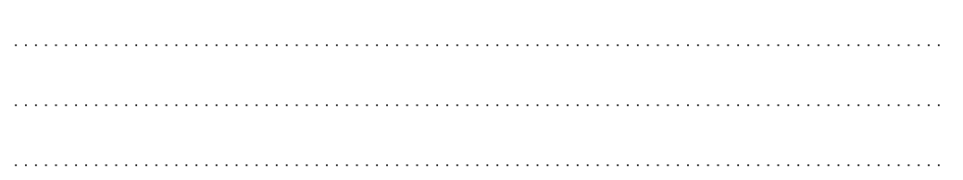

**8a.** The table shows the distance, in km, of eight regional railway stations from a city centre terminus and the price, in , of a return ticket from each regional station to the terminus.

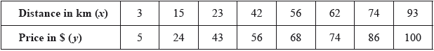

Draw a scatter diagram for the above data. Use a scale of  cm to represent  km on the -axis and  cm to represent  on the -axis. *[4 marks]*

**8b.** *[2 marks]*

Use your graphic display calculator to find

(i) , the mean of the distances;

(ii) , the mean of the prices.

**8c.** *[1 mark]*

Plot and label the point  on your scatter diagram.

**8d.** *[3 marks]*

Use your graphic display calculator to find

(i) the product–moment correlation coefficient, 

(ii) the equation of the regression line  on .

**8e.** *[2 marks]*

Draw the regression line  on  on your scatter diagram.

**8f.** *[3 marks]*

A ninth regional station is  km from the city centre terminus.

Use the equation of the regression line to estimate the price of a return ticket to the city centre terminus from this regional station. **Give your answer correct to the nearest** .

**8g.** *[1 mark]*

Give a reason why it is valid to use your regression line to estimate the price of this return ticket.

**8h.** *[2 marks]*

The actual price of the return ticket is .

**Using your answer to part (f)**, calculate the percentage error in the estimated price of the ticket.

**9a.** As part of his IB Biology field work, Barry was asked to measure the circumference of trees, in centimetres, that were growing at different distances, in metres, from a river bank. His results are summarized in the following table.

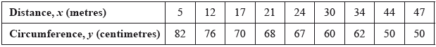

State whether *distance from the river bank* is a continuous **or** discrete variable. *[1 mark]*

**9b.** As part of his IB Biology field work, Barry was asked to measure the circumference of trees, in centimetres, that were growing at different distances, in metres, from a river bank. His results are summarized in the following table.

**On graph paper,** draw a scatter diagram to show Barry’s results. Use a scale of 1 cm to represent 5 m on the *x*-axis and 1 cm to represent 10 cm on the *y*-axis. *[4 marks]*

**9c.** As part of his IB Biology field work, Barry was asked to measure the circumference of trees, in centimetres, that were growing at different distances, in metres, from a river bank. His results are summarized in the following table.

Write down

(i) the mean distance, , of the trees from the river bank;

(ii) the mean circumference, , of the trees. *[2 marks]*

**9d.** As part of his IB Biology field work, Barry was asked to measure the circumference of trees, in centimetres, that were growing at different distances, in metres, from a river bank. His results are summarized in the following table.

Plot and label the point  on your graph. *[2 marks]*

**9e.** As part of his IB Biology field work, Barry was asked to measure the circumference of trees, in centimetres, that were growing at different distances, in metres, from a river bank. His results are summarized in the following table.

Write down

(i) the Pearson’s product–moment correlation coefficient, , for Barry’s results;

(ii) the equation of the regression line  on , for Barry’s results. *[4 marks]*

**9f.** As part of his IB Biology field work, Barry was asked to measure the circumference of trees, in centimetres, that were growing at different distances, in metres, from a river bank. His results are summarized in the following table.

Draw the regression line  on  on your graph. *[2 marks]*

**9g.** As part of his IB Biology field work, Barry was asked to measure the circumference of trees, in centimetres, that were growing at different distances, in metres, from a river bank. His results are summarized in the following table.

**Use the equation of the regression line**  on  to estimate the circumference of a tree that is 40 m from the river bank. *[2 marks]*