**Test: Statistics**

**1a.** Let  and  be independent events, where  and .

Find . *[2 marks]*

**1b.** Find . *[2 marks]*

**1c.** ***Copy*** the Venn diagram onto your answer sheet and shade the region that represents .

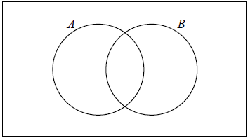 *[1 mark]*

**1d.** Find . *[2 marks]*

**2a.** A factory makes lamps. The probability that a lamp is defective is 0.05. A random sample of 30 lamps is tested.

Find the probability that there is at least one defective lamp in the sample. *[4 marks]*

**2b.** Given that there is at least one defective lamp in the sample, find the probability that there are at most two defective lamps. *[4 marks]*

**3a.** The following table shows the amount of fuel (litres) used by a car to travel certain distances (km).

|  |  |  |  |  |  |
| --- | --- | --- | --- | --- | --- |
| **Distance** (*x* km) | 40 | 75 | 120 | 150 | 195 |
| **Amount of fuel** (*y* litres) | 3.6 | 6.5 | 9.9 | 13.1 | 16.2 |

This data can be modelled by the regression line with equation .

Write down the value of  and of . *[2 marks]*

**3b.** Explain what the gradient  represents. *[1 mark]*

**3c.** Use the model to estimate the amount of fuel the car would use if it is driven  km. *[2 marks]*

**4a.** The vectors ***a*** =  and ***b*** = 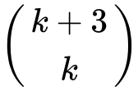 are perpendicular to each other.

Find the value of . *[4 marks]*

**4b.** Given that ***c*** = ***a*** + 2***b***, find ***c***. *[3 marks]*

**5a.** A standard die is rolled 36 times. The results are shown in the following table.



Write down the standard deviation. *[2 marks]*

**5b.** Write down the median score. *[1 mark]*

**5c.** Find the interquartile range. *[3 marks]*

**6a.** Consider a function  such that 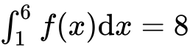.

Find 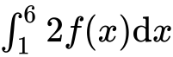. *[2 marks]*

**6b.** Find 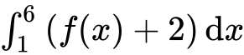. *[4 marks]*

**7a.** A van can take either Route A or Route B for a particular journey.

If Route A is taken, the journey time may be assumed to be normally distributed with mean 46 minutes and a standard deviation 10 minutes.

If Route B is taken, the journey time may be assumed to be normally distributed with mean  minutes and standard deviation 12 minutes.

For Route A, find the probability that the journey takes **more** than  minutes. *[2 marks]*

**7b.** For Route B, the probability that the journey takes **less** than  minutes is .

Find the value of  . *[3 marks]*

**7c.** The van sets out at 06:00 and needs to arrive before 07:00.

(i) Which route should it take?

(ii) Justify your answer. *[3 marks]*

**7d.** On five consecutive days the van sets out at 06:00 and takes Route B. Find the probability that

(i) it arrives before 07:00 on all five days;

(ii) it arrives before 07:00 on at least three days. *[5 marks]*

**8a.** The weekly wages (in dollars) of 80 employees are displayed in the cumulative frequency curve below.

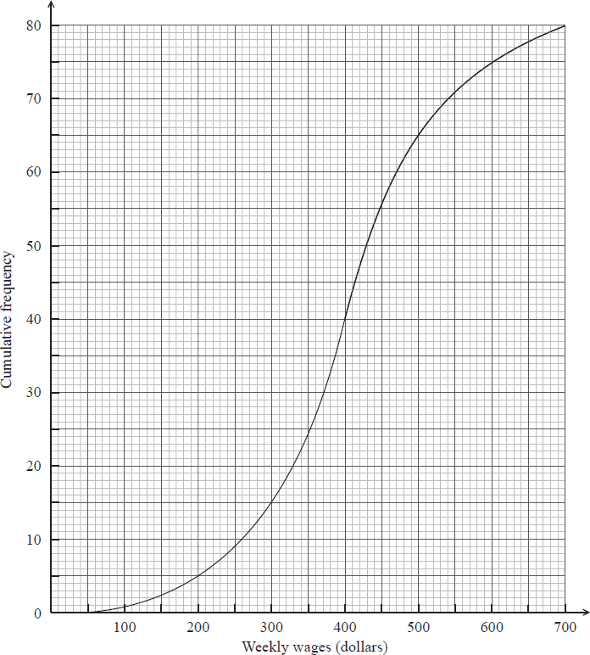

(i) Write down the median weekly wage.

(ii) Find the interquartile range of the weekly wages. *[4 marks]*

**8b.** The box-and-whisker plot below displays the weekly wages of the employees.

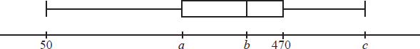

Write down the value of

(i)  ;

(ii)  ;

(iii)  . *[3 marks]*

**8c.** Employees are paid  per hour.

Find the median number of **hours** worked per week. *[3 marks]*

**8d.** Find the number of employees who work more than  hours per week. *[5 marks]*