**Do Now:** Probability exam problems

**1a.** In a group of 20 girls, 13 take history and 8 take economics. Three girls take both history and economics, as shown in the following Venn diagram. The values ***p*** and ***q*** represent numbers of girls.

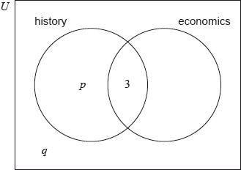

Find the value of ***p***; *[2 marks]*

**1b.** Find the value of ***q***. *[2 marks]*

**1c.** A girl is selected at random. Find the probability that she takes economics but not history. *[2 marks]*

|  |  |
| --- | --- |
| *Working:* |  |

**(Total 6 marks)**

1. A bag contains two red sweets and three green sweets. Jacques takes one sweet from the bag, notes its colour, then eats it. He then takes another sweet from the bag.

Complete the tree diagram below to show all probabilities.



(a) What is the probability two red sweets are taken from the bag?

(b) What is the probability at least one red sweet is taken from the bag?

(c) Assuming at least one red sweet is drawn, what is the probability both sweets are red?

|  |  |
| --- | --- |
| *Working:* |  |

**(Total 4 marks)**