# 1215-Probability-distributions

**1a.** *[3 marks]*

The following table shows the probability distribution of a discrete random variable .

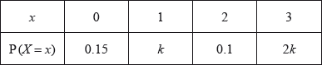

Find the value of .

## Markscheme

evidence of using  ***(M1)***

correct substitution ***A1***

*eg*

 ***A1 N2***

***[3 marks]***

## Examiners report

[N/A]

**1b.** *[2 marks]*

Find .

## Markscheme

correct substitution ***(A1)***

*eg*

 ***A1 N2***

***[2 marks]***

***Total [5 marks]***

## Examiners report

[N/A]

**2a.** *[2 marks]*

Adam travels to school by car () or by bicycle (). On any particular day he is equally likely to travel by car or by bicycle.

The probability of being late () for school is  if he travels by car.

The probability of being late for school is  if he travels by bicycle.

This information is represented by the following tree diagram.

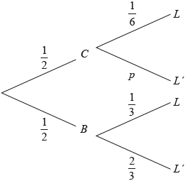

Find the value of .

## Markscheme

correct working ***(A1)***

*eg*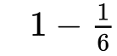

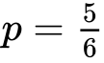 ***A1 N2***

***[2 marks]***

## Examiners report

Parts (a) and (b) of this question were answered correctly by nearly all candidates, and the majority earned full marks on part (c), as well. Unfortunately, there were a number of candidates who made arithmetic errors when multiplying or adding fractions.

**2b.** *[2 marks]*

Find the probability that Adam will travel by car and be late for school.

## Markscheme

multiplying along correct branches ***(A1)***

*eg*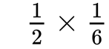

 ***A1 N2***

***[2 marks]***

## Examiners report

Parts (a) and (b) of this question were answered correctly by nearly all candidates, and the majority earned full marks on part (c), as well. Unfortunately, there were a number of candidates who made arithmetic errors when multiplying or adding fractions. Candidates were not as successful in parts (d) and (e) of this question. Although many knew that conditional probability was necessary in part (d), many did not know to use their values from parts (b) and (c), and started from scratch with brand new, and often incorrect, calculations for the numerator and denominator. A majority of candidates did not recognize that binomial probability was needed in part (e), not realizing that there were three ways for Adam to be "late exactly once". A very common incorrect solution to part (e) was 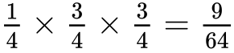.

**2c.** *[4 marks]*

Find the probability that Adam will be late for school.

## Markscheme

multiplying along the other branch ***(M1)***

*eg*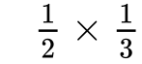

adding probabilities of their  mutually exclusive paths ***(M1)***

*eg*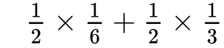

correct working ***(A1)***

*eg*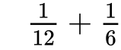

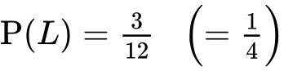 ***A1 N3***

***[4 marks]***

## Examiners report

Parts (a) and (b) of this question were answered correctly by nearly all candidates, and the majority earned full marks on part (c), as well. Unfortunately, there were a number of candidates who made arithmetic errors when multiplying or adding fractions. Candidates were not as successful in parts (d) and (e) of this question. Although many knew that conditional probability was necessary in part (d), many did not know to use their values from parts (b) and (c), and started from scratch with brand new, and often incorrect, calculations for the numerator and denominator. A majority of candidates did not recognize that binomial probability was needed in part (e), not realizing that there were three ways for Adam to be "late exactly once". A very common incorrect solution to part (e) was .

**2d.** *[3 marks]*

Given that Adam is late for school, find the probability that he travelled by car.

## Markscheme

recognizing conditional probability (seen anywhere) ***(M1)***

*eg*

correct substitution of **their** values into formula ***(A1)***

*eg*

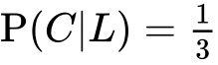 ***A1 N2***

***[3 marks]***

## Examiners report

Parts (a) and (b) of this question were answered correctly by nearly all candidates, and the majority earned full marks on part (c), as well. Unfortunately, there were a number of candidates who made arithmetic errors when multiplying or adding fractions. Candidates were not as successful in parts (d) and (e) of this question. Although many knew that conditional probability was necessary in part (d), many did not know to use their values from parts (b) and (c), and started from scratch with brand new, and often incorrect, calculations for the numerator and denominator. A majority of candidates did not recognize that binomial probability was needed in part (e), not realizing that there were three ways for Adam to be "late exactly once". A very common incorrect solution to part (e) was .

**2e.** *[4 marks]*

Adam will go to school three times next week.

Find the probability that Adam will be late exactly once.

## Markscheme

valid approach ***(M1)***

*eg*  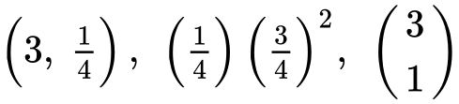, three ways it could happen

correct substitution ***(A1)***

*eg* 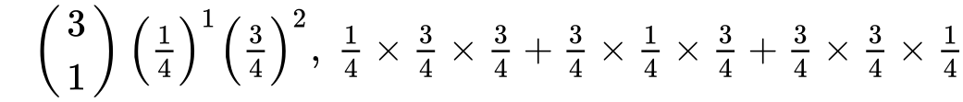

correct working ***(A1)***

*eg*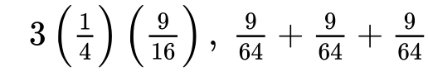

 ***A1 N2***

***[4 marks]***

***Total [15 marks]***

## Examiners report

Parts (a) and (b) of this question were answered correctly by nearly all candidates, and the majority earned full marks on part (c), as well. Unfortunately, there were a number of candidates who made arithmetic errors when multiplying or adding fractions. Candidates were not as successful in parts (d) and (e) of this question. Although many knew that conditional probability was necessary in part (d), many did not know to use their values from parts (b) and (c), and started from scratch with brand new, and often incorrect, calculations for the numerator and denominator. A majority of candidates did not recognize that binomial probability was needed in part (e), not realizing that there were three ways for Adam to be "late exactly once". A very common incorrect solution to part (e) was .

**3a.** *[3 marks]*

The following table shows the probability distribution of a discrete random variable *X* .



Find the value of *k* .

## Markscheme

evidence of summing to 1  ***(M1)***

*e.g.* 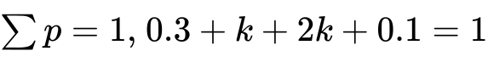

correct working ***(A1)***

*e.g.* 

 ***A1 N2***

***[3 marks]***

## Examiners report

Overall, this question was very well done. A few candidates left this question blank, or used methods which would indicate they were unfamiliar with discrete random variables. In part (b), there were a good number of candidates who set up their work correctly, but then had trouble adding or multiplying decimals without a calculator. A common type of error for these candidates was  .

**3b.** *[3 marks]*

Find  .

## Markscheme

correct substitution into formula  ***(A1)***

*e.g.* 

correct working

*e.g.* ***(A1)***

= 3.3 ***A1 N2***

***[3 marks]***

## Examiners report

Overall, this question was very well done. A few candidates left this question blank, or used methods which would indicate they were unfamiliar with discrete random variables. In part (b), there were a good number of candidates who set up their work correctly, but then had trouble adding or multiplying decimals without a calculator. A common type of error for these candidates was  .

**4a.** *[6 marks]*

The following table shows the probability distribution of a discrete random variable , in terms of an angle .



Show that .

## Markscheme

evidence of summing to 1 ***(M1)***

*eg*

correct equation ***A1***

*eg*

correct equation in  ***A1***

*eg*

evidence of valid approach to solve quadratic ***(M1)***

*eg*factorizing equation set equal to 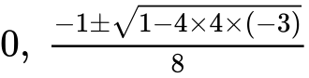

correct working, clearly leading to required answer ***A1***

*eg*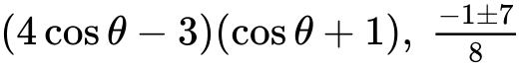

correct reason for rejecting  ***R1***

*eg* is a probability (value must lie between 0 and 1), 

**Note:** Award ***R0*** for  without a reason.

 ***AG N0***

## Examiners report

[N/A]

**4b.** *[3 marks]*

Given that , find .

## Markscheme

valid approach ***(M1)***

*eg*sketch of right triangle with sides 3 and 4, 

correct working

***(A1)***

*eg*missing side 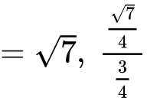

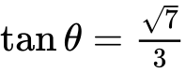 ***A1*** ***N2***

***[3 marks]***

## Examiners report

[N/A]

**5a.** *[2 marks]*

In a large university the probability that a student is left handed is 0.08. A sample of 150 students is randomly selected from the university. Let  be the expected number of left-handed students in this sample.

Find .

## Markscheme

evidence of binomial distribution (may be seen in part (b)) ***(M1)***

*eg*

 ***A1*** ***N2***

***[2 marks]***

## Examiners report

[N/A]

**5b.** *[2 marks]*

Hence, find the probability that exactly  students are left handed;

## Markscheme

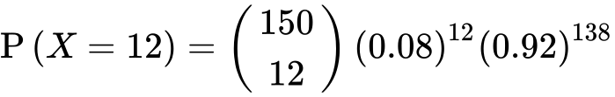 ***(A1)***

0.119231

probability  ***A1*** ***N2***

***[2 marks]***

## Examiners report

[N/A]

**5c.** *[2 marks]*

Hence, find the probability that fewer than  students are left handed.

## Markscheme

recognition that  ***(M1)***

0.456800

 ***A1*** ***N2***

***[2 marks]***

## Examiners report

[N/A]

**6.** *[2 marks]*

The following table shows a probability distribution for the random variable , where .

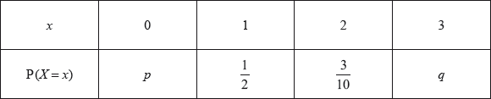

A bag contains white and blue marbles, with at least three of each colour. Three marbles are drawn from the bag, without replacement. The number of blue marbles drawn is given by the random variable .

A game is played in which three marbles are drawn from the bag of ten marbles, without replacement. A player wins a prize if three white marbles are drawn.

Jill plays the game nine times. Find the probability that she wins exactly two prizes.

## Markscheme

valid approach ***(M1)***

*eg*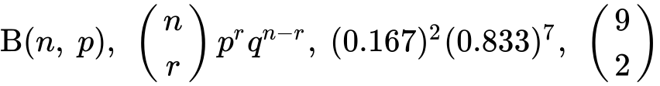

0.279081

0.279 ***A1*** ***N2***

***[2 marks]***

## Examiners report

[N/A]

**7a.** *[2 marks]*

The random variable *X* has the following probability distribution, with  .

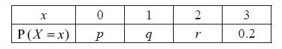

Find the value of *r* .

## Markscheme

attempt to substitute  ***(M1)***

e.g. 

 ***A1 N2***

***[2 marks]***

## Examiners report

The majority of candidates were successful in earning full marks on this question.

**7b.** *[6 marks]*

Given that  , find the value of *p* and of *q* .

## Markscheme

correct substitution into  (seen anywhere) ***(A1)***

e.g. 

correct equation ***A1***

e.g.  , 

 ***A1 N1***

evidence of choosing  ***M1***

e.g.  , 

correct working ***(A1)***

 ,  , 

 ***A1 N2***

**Note**: Exception to the ***FT*** rule. Award ***FT*** marks on an incorrect value of *q*, even if *q* is an inappropriate value. Do not award the final ***A*** mark for an inappropriate value of *p*.

***[6 marks]***

## Examiners report

In part (b), a small number of candidates did not use the correct formula for  , even though this formula is given in the formula booklet. There were also a few candidates who incorrectly assumed that  , forgetting that the sum of the probabilities must equal 1. There were a few candidates who left this question blank, which raises concerns about whether they had been exposed to probability distributions during the course.

**8a.** *[4 marks]*

The probability of obtaining “tails” when a biased coin is tossed is . The coin is tossed ten times. Find the probability of obtaining **at least** four tails.

## Markscheme

evidence of recognizing binomial distribution ***(M1)***

e.g.  ,  , 

**EITHER**

  ***(A1)***

evidence of using complement ***(M1)***

e.g.  any probability, 



 ***A1 N3***

**OR**

summing the probabilities from  to   ***(M1)***

correct expression or values ***(A1)***

e.g. 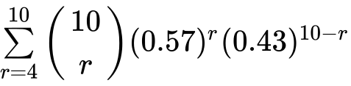 , 

0.919424

 ***A1 N3***

***[4 marks]***

## Examiners report

This was an accessible problem that created some difficulties for candidates. Most were able to recognize the binomial nature of the problem but were confused by the phrase "at least four tails" which was often interpreted as the complement of four or less. Poor algebraic manipulation also led to unnecessary errors that the calculator approach would have avoided.

**8b.** *[3 marks]*

The probability of obtaining “tails” when a biased coin is tossed is 0.57. The coin is tossed ten times. Find the probability of obtaining the fourth tail on the tenth toss.

## Markscheme

evidence of valid approach ***(M1)***

e.g. three tails in nine tosses, 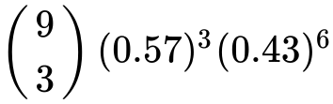

correct calculation

e.g. 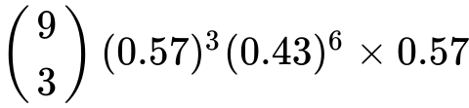 ,  ***(A1)***



 ***A1 N2***

***[3 marks]***

## Examiners report

This was an accessible problem that created some difficulties for candidates. Most were able to recognize the binomial nature of the problem but were confused by the phrase "at least four tails" which was often interpreted as the complement of four or less. Poor algebraic manipulation also led to unnecessary errors that the calculator approach would have avoided.

**9a.** *[3 marks]*

The histogram below shows the time *T* seconds taken by 93 children to solve a puzzle.

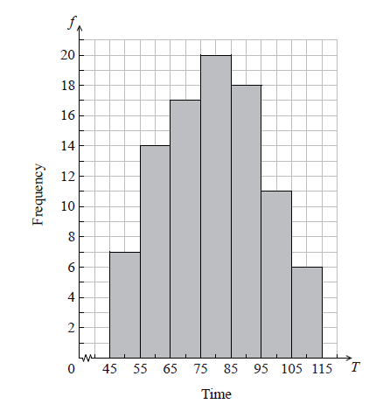

The following is the frequency distribution for *T* .



(i) Write down the value of *p* and of *q* .

(ii) Write down the median class.

## Markscheme

(i)  ,  ***A1A1 N2***

(ii)  ***A1 N1***

***[3 marks]***

## Examiners report

Parts (a) and (b) were generally well done. The terms "median" and "median class" were often confused.

**9b.** *[2 marks]*

A child is selected at random. Find the probability that the child takes less than 95 seconds to solve the puzzle.

## Markscheme

evidence of valid approach ***(M1)***

e.g. adding frequencies

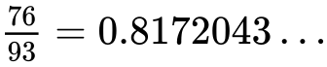

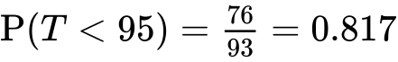 ***A1 N2***

***[2 marks]***

## Examiners report

Parts (a) and (b) were generally well done. The terms "median" and "median class" were often confused.

**9c.** *[2 marks]*

Consider the class interval  .

(i) Write down the interval width.

(ii) Write down the mid-interval value.

## Markscheme

(i) 10 ***A1 N1***

(ii) 50 ***A1 N1***

***[2 marks]***

## Examiners report

In part (c) some candidates had problems with the term "interval width" and there were some rather interesting mid-interval values noted.

**9d.** *[4 marks]*

Hence find an estimate for the

(i) mean;

(ii) standard deviation.

## Markscheme

(i) evidence of approach using mid-interval values (may be seen in part (ii)) ***(M1)***



 ***A2 N3***

(ii) 

 ***A1 N1***

***[4 marks]***

## Examiners report

In part (d), candidates often ignored the "hence" command and estimated values from the graph rather than from the information in part (c).

**9e.** *[2 marks]*

John assumes that *T* is normally distributed and uses this to estimate the probability that a child takes less than 95 seconds to solve the puzzle.

Find John’s estimate.

## Markscheme

e.g. standardizing, 



 ***A1 N2***

***[2 marks]***

## Examiners report

Those who correctly obtained the mean and standard deviation had little difficulty with part (e) although candidates often used unfamiliar calculator notation as their working or used the mid-interval value as the mean of the distribution.

**10a.** *[4 marks]*

A factory makes lamps. The probability that a lamp is defective is 0.05. A random sample of 30 lamps is tested.

Find the probability that there is at least one defective lamp in the sample.

## Markscheme

evidence of recognizing binomial (seen anywhere) ***(M1)***

e.g. , 

finding  ***(A1)***

appropriate approach ***(M1)***

e.g. complement, summing probabilities



probability is  ***A1 N3***

***[4 marks]***

## Examiners report

Although candidates seemed more confident in attempting binomial probabilities than in previous years, some of them failed to recognize the binomial nature of the question in part (a). Many knew that the complement was required, but often used  or  instead of  .

**10b.** *[4 marks]*

A factory makes lamps. The probability that a lamp is defective is 0.05. A random sample of 30 lamps is tested.

Given that there is at least one defective lamp in the sample, find the probability that there are at most two defective lamps.

## Markscheme

identifying correct outcomes (seen anywhere) ***(A1)***

*e.g.*  , 1 or 2 defective, 

recognizing conditional probability (seen anywhere) ***R1***

*e.g.*  ,  , P(at most 2|at least 1)

appropriate approach involving conditional probability ***(M1)***

*e.g.* 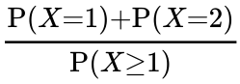 , 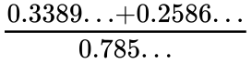 , 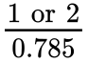



probability is  ***A1 N2***

***[4 marks]***

## Examiners report

Part (b) was poorly answered. While some candidates recognized that it was a conditional probability, very few were able to correctly apply the formula, identify the outcomes and follow on to achieve the correct result.

Only a few could find the intersection of the events correctly. Several thought the numerator was a product (i.e. ), and then cancelled common factors with the denominator. Others realized that  and  were required but multiplied their probabilities.

This was the most commonly missed out question from Section A.

**11.** *[6 marks]*

The random variable X has the following probability distribution.

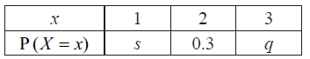

Given that  , find *q* .

## Markscheme

correct substitution into  (seen anywhere) ***A1***

e.g.  , 

recognizing  (seen anywhere) ***(M1)***

correct substitution into  ***A1***

e.g. 

attempt to solve simultaneous equations ***(M1)***

correct working ***(A1)***

e.g.  , 

 ***A1 N4***

***[6 marks]***

## Examiners report

Candidates generally earned either full marks or only one mark on this question. The most common error was where candidates only wrote the equation for  , and tried to rearrange that equation to solve for *q*. The candidates who also knew that the sum of the probabilities must be equal to 1 were very successful in solving the resulting system of equations.

Printed for Bronx Early College Academy

© International Baccalaureate Organization 2017

International Baccalaureate® - Baccalauréat International® - Bachillerato Internacional®