BECA / Huson / 12.1 IB Math SL Name:

19 December 2017

**Homework**: **Binomial distribution and review**

**1a.** The random variable *X* has the following probability distribution, with  .  
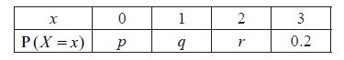

Find the value of *r* .

## Markscheme

attempt to substitute  ***(M1)***

e.g. 

 ***A1 N2*** *[2 marks]*

**1b.** Given that  , find the value of *p* and of *q* . *[6 marks]*

## Markscheme

correct substitution into  (seen anywhere) ***(A1)***

e.g. 

correct equation ***A1***

e.g.  , 

 ***A1 N1***

evidence of choosing  ***M1***

e.g.  , 

correct working ***(A1)***

 ,  , 

 ***A1 N2***

**Note**: Exception to the ***FT*** rule. Award ***FT*** marks on an incorrect value of *q*, even if *q* is an inappropriate value. Do not award the final ***A*** mark for an inappropriate value of *p*.

**2.** The random variable X has the following probability distribution.

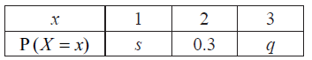

Given that  , find *q* . *[6 marks]*

## Markscheme

correct substitution into  (seen anywhere) ***A1***

e.g.  , 

recognizing  (seen anywhere) ***(M1)***

correct substitution into  ***A1***

e.g. 

attempt to solve simultaneous equations ***(M1)***

correct working ***(A1)***

e.g.  , 

 ***A1 N4***

***[6 marks]***

## Examiners report

Candidates generally earned either full marks or only one mark on this question. The most common error was where candidates only wrote the equation for  , and tried to rearrange that equation to solve for *q*. The candidates who also knew that the sum of the probabilities must be equal to 1 were very successful in solving the resulting system of equations.

**3a.** The following diagram shows the graph of a function . There is a local minimum point at , where .

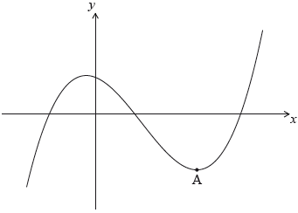

The derivative of  is given by .

Find the -coordinate of . *[5 marks]*

## Markscheme

recognizing that the local minimum occurs when  ***(M1)***

valid attempt to solve  ***(M1)***

*eg*factorization, formula

correct working ***A1***

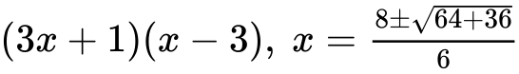

 ***A2 N3***

**Note:** Award ***A1*** if both values 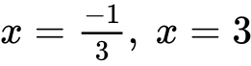 are given.

***[5 marks]***

## Examiners report

The majority of candidates approached part (a) correctly, and most recognized that only one solution was possible within the given domain.

**3b.** The -intercept of the graph is at (). Find an expression for .

The graph of a function  is obtained by reflecting the graph of  in the -axis, followed by a translation of 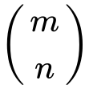. *[6 marks]*

|  |
| --- |
|  |

## Markscheme

valid approach ***(M1)***



(do not penalize for missing “”) ***A1A1A1***

 ***(A1)***

 ***A1 N6***

***[6 marks]***

## Examiners report

Nearly all candidates answered part (b) correctly, earning all the available marks for integrating the polynomial and solving for .

**4a.** Let  be a family of lines with equation given by  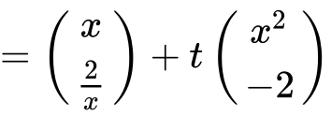, where .

Write down the equation of . *[2 marks]*

|  |
| --- |
|  |

## Markscheme

attempt to substitute  ***(M1)***

*eg****r*** 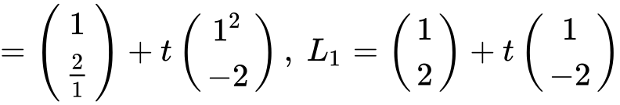

correct equation (vector or Cartesian, but do not accept “”)

*eg****r*** 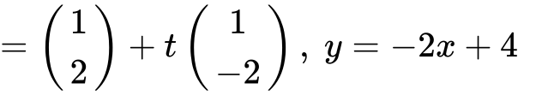(must be an equation) ***A1 N2***

***[2 marks]***

## Examiners report

In part (a), most candidates correctly substituted 1 for , although many of them did not earn full marks for their work here, as they wrote their vector equation using , not understanding that  is the name of the line, and not a vector.

**4b.** A line  crosses the -axis at a point .

Show that  has coordinates 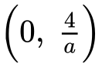. *[6 marks]*

## Markscheme

appropriate approach ***(M1)***

*eg*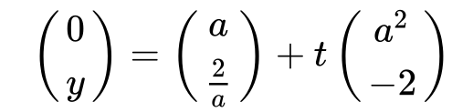

correct equation for -coordinate ***A1***

*eg*

 ***A1***

substituting **their** parameter to find  ***(M1)***

*eg*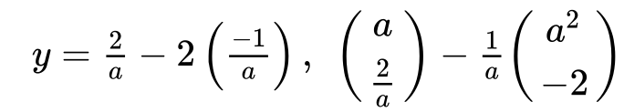

correct working ***A1***

*eg*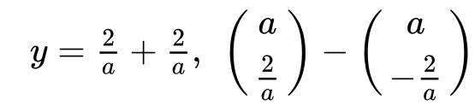

finding correct expression for  ***A1***

*eg*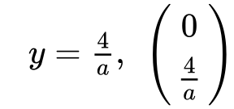 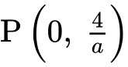 ***AG N0***

***[6 marks]***

## Examiners report

Very few candidates answered parts (b) and (c) correctly, often working backwards from the given answer, which is not appropriate in "show that" questions. In these types of questions, candidates are required to clearly show their working and reasoning, which will hopefully lead them to the given answer.

**4c.** The line  crosses the -axis at . Let .

Show that 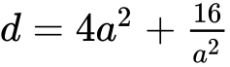. *[2 marks]*

## Markscheme

valid approach ***M1***

*eg*distance formula, Pythagorean Theorem, 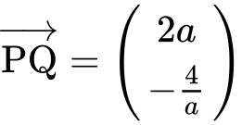

correct simplification ***A1***

*eg*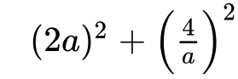

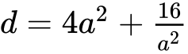 ***AG N0***

***[2 marks]***

**4d.** There is a minimum value for . Find the value of  that gives this minimum value. *[7 marks]*

## Markscheme

recognizing need to find derivative ***(M1)***

*eg*

correct derivative ***A2***

*eg*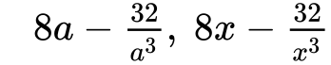

setting **their** derivative equal to  ***(M1)***

*eg*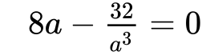

correct working ***(A1)***

*eg*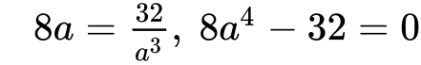

working towards solution ***(A1)***

*eg*

 ***A1 N3***

***[7 marks]***

***Total [17 marks]***

## Examiners report

Fortunately, a good number of candidates recognized the need to find the derivative of the given expression for  in part (d) of the question, and so were able to earn at least some of the available marks in the final part.

**5a.** Part of the graph of  is shown below.

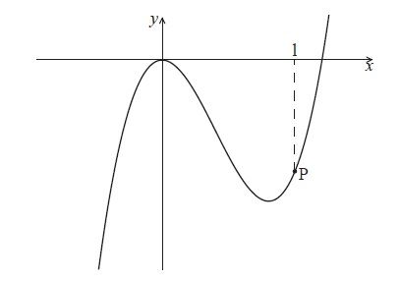

The point P lies on the graph of  . At P, *x* = 1.

Find  . *[2 marks]*

## Markscheme

 ***A1A1 N2***

**Note:** Award ***A1***for each correct term.

***[2 marks]***

## Examiners report

A majority of candidates answered part (a) correctly, and a good number earned full marks on both parts of this question. In part (b), some common errors included setting the derivative equal to zero, or substituting 3 for *x* in their derivative. There were also a few candidates who incorrectly tried to work with  , rather than  , in part (b).

**5b.** The graph of  has a gradient of  at the point P. Find the value of  . *[4 marks]*

## Markscheme

setting their derivative equal to 3 (seen anywhere) ***A1***

e.g. 

attempt to substitute  into  ***(M1)***

e.g. 

correct substitution into  ***(A1)***

e.g.  , 

 ***A1 N2***

***[4 marks]***

**6a.** In this question, you are given that 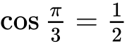 , and 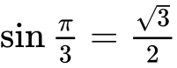 .

The displacement of an object from a fixed point, O is given by  for  .

Find  . *[3 marks]*

## Markscheme

 ***A1A2 N3***

**Note**: Award ***A1*** for 1, ***A2*** for  .

***[3 marks]***

## Examiners report

The derivative in part (a) was reasonably well done, but errors here often caused trouble in later parts. Candidates occasionally attempted to use the double angle identity for  before differentiating, but they rarely were successful in then applying the product rule.

**6b.** In this interval, there are only two values of *t* for which the object is not moving. One value is  .

Find the other value. *[4 marks]*

## Markscheme

evidence of valid approach ***(M1)***

e.g. setting 

correct working ***A1***

e.g.  , 

 ,  ,  ***(A1)***

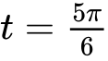 ***A1 N3***

***[4 marks]***

## Examiners report

In part (b), most candidates understood that they needed to set their derivative equal to zero, but fewer were able to take the next step to solve the resulting double angle equation. Again, some candidates over-complicated the equation by using the double angle identity. Few ended up with the correct answer  .

**6c.** Show that  between these two values of *t* . *[3 marks]*

## Markscheme

evidence of valid approach ***(M1)***

e.g. choosing a value in the interval 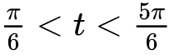

correct substitution ***A1***

e.g. 

 ***A1***

 ***AG N0***

***[3 marks]***

## Examiners report

In part (c), many candidates knew they needed to test a value between  and their value from part (b), but fewer were able to successfully complete that calculation. Some candidates simply tested their boundary values while others unsuccessfully attempted to make use of the second derivative.

**6d.** Find the distance travelled between these two values of *t* . *[5 marks]*

## Markscheme

evidence of approach using *s* or integral of  ***(M1)***

e.g.  ; 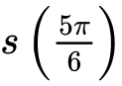 , 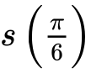 ; 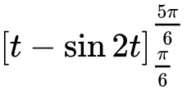

substituting values and subtracting ***(M1)***

e.g. 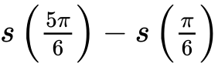 , 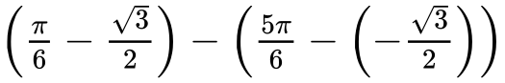

correct substitution ***A1***

e.g. 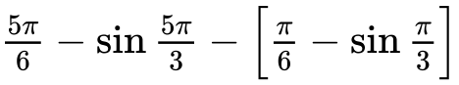 , 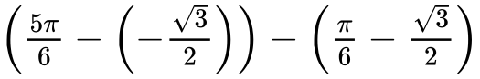

distance is 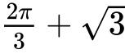 ***A1A1 N3***

**Note**: Award ***A1*** for  , ***A1*** for  .

***[5 marks]***

## Examiners report

Although many candidates did not attempt part (d), those who did often demonstrated a good understanding of how to use the displacement function *s* or the integral of their derivative from part (a). Candidates who had made an error in part (b) often could not finish, as  could not be evaluated at their value without a calculator. Of those who had successfully found the other boundary of  , a common error was giving the incorrect sign of the value of  . Again, this part was a good discriminator between the grade 6 and 7 candidates.

**7a.** Consider the following sequence of figures.

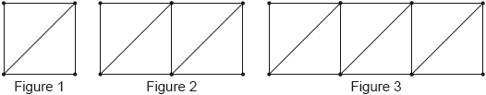

Figure 1 contains 5 line segments.

Given that Figure  contains 801 line segments, show that . *[3 marks]*

## Markscheme

recognizing that it is an arithmetic sequence ***(M1)***

*eg*

correct equation ***A1***

*eg*

correct working (do not accept substituting ) ***A1***

*eg*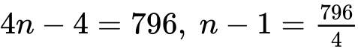

 ***AG N0***

***[3 marks]***

## Examiners report

Most candidates recognized that the series was arithmetic but many worked backwards using  rather than creating and solving an equation of their own to produce the given answer.

**7b.** Find the total number of line segments in the first 200 figures. *[3 marks]*

## Markscheme

recognition of sum ***(M1)***

*eg*

correct working for AP ***(A1)***

*eg*

 ***A1 N2***

***[3 marks]***

## Examiners report

Almost all students answered (b) correctly.

**8a.** Let  and . Write the following expressions in terms of  and .

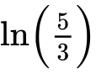. *[2 marks]*

## Markscheme

correct approach ***(A1)***

*eg*

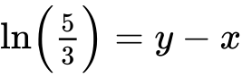 ***A1 N2***

***[2 marks]***

## Examiners report

Most candidates were able to earn some or all the marks on this question. Part (a) was answered correctly by nearly all candidates.

**8b.** . *[4 marks]*

## Markscheme

recognizing factors of 45 (may be seen in log expansion) ***(M1)***

*eg*

correct application of  ***(A1)***

*eg*

correct working ***(A1)***

*eg*

 ***A1 N3***

***[4 marks]***

## Examiners report

Most candidates were able to earn some or all the marks on this question. In part (b), the majority of candidates knew they needed to factor 45, though some did not apply the log rules correctly to earn all the available marks here.

**9.** Three consecutive terms of a geometric sequence are , 6 and .

Find the possible values of . *[6 marks]*

## Markscheme

**METHOD 1**

valid approach ***(M1)***

*eg*

correct equation in terms of  only ***A1***

*eg*

correct working ***(A1)***

*eg*

valid attempt to solve **their** quadratic equation ***(M1)***

*eg*factorizing, formula, completing the square

evidence of correct working ***(A1)***

*eg*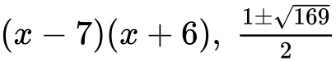

 ***A1 N4***

**METHOD 2 (finding *r* first)**

valid approach ***(M1)***

*eg*

correct equation in terms of  only ***A1***

*eg*

evidence of correct working ***(A1)***

*eg*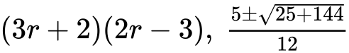

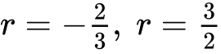 ***A1***

substituting their values of  to find  ***(M1)***

*eg*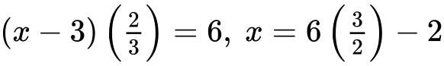

 ***A1 N4***

***[6 marks]***

## Examiners report

Nearly all candidates attempted to set up an expression, or pair of expressions, for the common ratio of the geometric sequence. When done correctly, these expressions led to a quadratic equation which was solved correctly by many candidates.