**Homework: Post-test challenge-problem set**

**1.** The equation  has two distinct real roots. Find the possible values of *k* . *[6 marks]*

**2a.** At a large school, students are required to learn at least one language, Spanish or French. It is known that  of the students learn Spanish, and  learn French.

Find the percentage of students who learn **both** Spanish and French. *[2 marks]*

**2b.** Find the percentage of students who learn Spanish, but not French. *[2 marks]*

**2c.** At this school,  of the students are girls, and  of the girls learn Spanish.

A student is chosen at random. Let *G* be the event that the student is a girl, and let *S* be the event that the student learns Spanish.

(i) Find  .

(ii) Show that *G* and *S* are **not** independent. *[5 marks]*

**2d.** At this school,  of the students are girls, and  of the girls learn Spanish.

A boy is chosen at random. Find the probability that he learns Spanish. *[6 marks]*

**3a.** Consider the function  .

Sketch the graph of *f* , for  . *[4 marks]*

**3b.** This function can also be written as  .

Write down the value of *p* . *[1 mark]*

**3c.** The graph of *g* is obtained by reflecting the graph of *f* in the *x*-axis, followed by a translation of 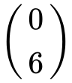 .

Show that  . *[4 marks]*

**3d.** The graphs of *f* and *g* intersect at two points.

Write down the *x*-coordinates of these two points. *[3 marks]*

**4a.** The following diagram shows the graph of a quadratic function *f* , for  .

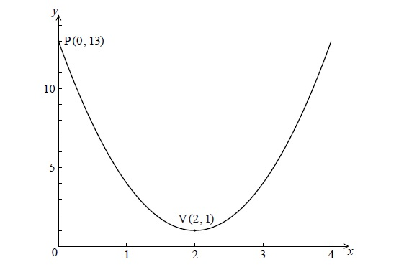

The graph passes through the point P(0, 13) , and its vertex is the point V(2, 1) .

The function can be written in the form  .

(i) Write down the value of *h* and of *k* .

(ii) Show that  . *[4 marks]*

**4b.** Find  , giving your answer in the form  . *[3 marks]*

**5a.** Consider an infinite geometric sequence with  and  .

(i) Find  .

(ii) Find the sum of the infinite sequence. *[4 marks]*

**5b.** Consider an arithmetic sequence with *n* terms, with first term () and eighth term () .

(i) Find the common difference.

(ii) Show that  . *[5 marks]*

**5c.** The sum of the infinite geometric sequence is equal to twice the sum of the arithmetic sequence. Find *n*. *[5 marks]*