**Homework:** Graphing equations

1a) Fill in the table and then graph each function on the grid below. Mark each point and then draw a smooth curve through the points. Label each parabola with the function equation. Label the vertex of each parabola as an ordered pair.

$$f\left(x\right)=x^{2}$$

$$g\left(x\right)=x^{2}+(-9)$$

|  |  |  |  |  |  |  |  |  |  |
| --- | --- | --- | --- | --- | --- | --- | --- | --- | --- |
| *x* | *−*4 | *−*3 | *−*2 | *−*1 | 0 | 1 | 2 | 3 | 4 |
| *f*(*x*) |  |  |  |  |  |  |  |  |  |
| *g*(*x*) |  |  |  |  |  |  |  |  |  |

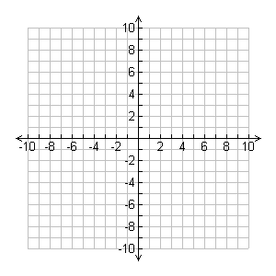

2a) Draw and label the axes on the graph. Draw a line through the points (-8, 0) and (0, 8).

b) What is the equation of the line you have drawn?

c) Plot the following equation by first calculating the *x*-intercept and *y*-intercept:

$$3x+2y=6$$

*x*-intercept, when *y*=0, then $x=\frac{c}{a}=$

*y*-intercept, when *x*=0, then $y=\frac{c}{b}=$



d) Label the intersection of the two lines as an ordered pair. Check by substitution that it satisfies each equation.

3a) Graph each equation on the grid below. Mark the solution set as coordinate pairs.



(make a t-chart of x,y pairs for the parabola)

3b) What is the vertex of the parabola?

3c) What is the equation of the axis of symmetry?

Restate each equation in the form that can be graphed in a calculator, i.e. *y* = an expression.

Example:



Answer:  (or  is fine too)

4)  5) 

6)  7) 

8)  9) 

Factor the expressions in #8 & 9.