**Homework: Function graphs**

**1a.** The following diagram shows the graph of , the derivative of .

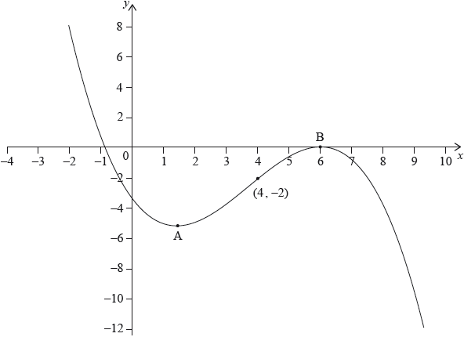

The graph of  has a local minimum at A, a local maximum at B and passes through .

The point  lies on the graph of the function, .

Write down the gradient of the curve of  at P. *[1 mark]*

**1b.** Find the equation of the normal to the curve of  at P. *[3 marks]*

**1c.** Determine the concavity of the graph of  when  **and** justify your answer. *[2 marks]*

**2a.** The diagram below shows part of the graph of the gradient function,  .

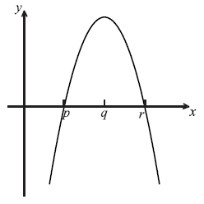

On the grid below, sketch a graph of  , clearly indicating the *x*-intercept. *[2 marks]*

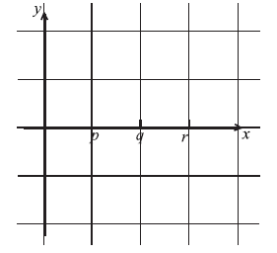

**2b.** Complete the table, for the graph of  .  *[2 marks]*

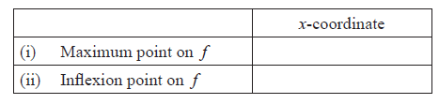

**2c.** Justify your answer to part (b) (ii). *[2 marks]*

**3a.** Let 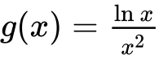 , for  .

Use the quotient rule to show that 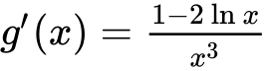 . *[4 marks]*

**3b.** The graph of *g* has a maximum point at A. Find the *x*-coordinate of A. *[3 marks]*

**4a.** Let  . *[3 marks]*

There are two points of inflexion on the graph of *f* . Write down the *x*-coordinates of these points.

**4b.** Let  . Explain why the graph of *g* has no points of inflexion. *[2 marks]*

**5a.** A function *f* is defined for  . The graph of *f* is given below.

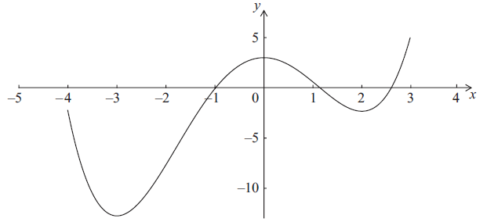

The graph has a local maximum when  , and local minima when  ,  .

Write down the *x*-intercepts of the graph of the **derivative** function,  . *[2 marks]*

**5b.** Write down all values of *x* for which  is positive. *[2 marks]*

**5c.** At point D on the graph of *f*, the *x*-coordinate is . Explain why  at D. *[2 marks]*

**6a.** Let 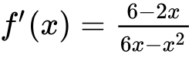, for .

The graph of  has a maximum point at P.

Find the -coordinate of P. *[3 marks]*

**6b.** The -coordinate of P is .

Find , expressing your answer as a single logarithm. *[8 marks]*

**6c.** The graph of  is transformed by a vertical stretch with scale factor . The image of P under this transformation has coordinates .

Find the value of  and of , where .

**7a.** Let 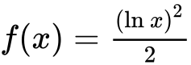, for .

Show that . *[2 marks]*

**7b.** There is a minimum on the graph of . Find the -coordinate of this minimum. *[3 marks]*

**7c.** Let . The following diagram shows parts of the graphs of  and *g*. *[2 marks]*

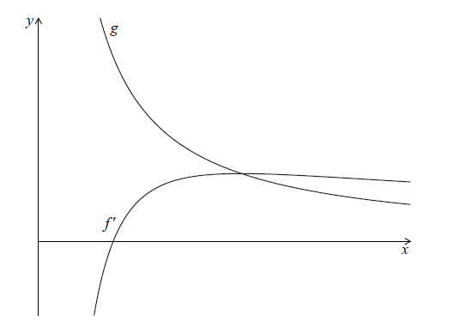

The graph of  has an *x*-intercept at .

Write down the value of .

**7d.** The graph of  intersects the graph of  when .

Find the value of . *[3 marks]*

**7e.** Let  be the region enclosed by the graph of , the graph of  and the line .

Show that the area of  is . *[5 marks]*