**Homework: Function Translations Review**

1. Submit an equation that will move the graph of the function y=x2 right 4 units.
2. The equation y = (x+3)2 – 2 moves the parent function y = x2 right 3 units and down 2 units.

True or False

1. Submit an equation that will move the graph of the function y = x2 down 7 units.
2. The equation y = (x-8)2 + 5 moves the parent function y = x2 right 8 units and down 5 units.

True or False

1. Submit an equation that will move the graph of the function y=x2 left 2 units and up 6 units.
2. Which equation will shift the graph of y = x2 left 5 units and up 6 units?
   1. y = (x+6)2-5
   2. y = (x+5)2-6
   3. y = (x+5)2+6
   4. y = (x-5)2+6
3. Submit an equation that will move the graph of the function y=x2 right 3 units up 2 units.
4. Which equation will shift the graph of y = x2 right 8 units and down 4 units?
   1. y = (x+8)2-4
   2. y = (x+4)2-8
   3. y = (x-4)2+8
   4. y = (x-8)2-4
5. Submit an equation that will move the graph of the function y=x2 left 7 units and down 3 units.
6. Which equation will shift the graph of y = x2 up 9 units?
   1. y = (x+9)2
   2. y = x2-9
   3. y = x2+9
   4. y = (x-9)2
7. Submit an equation that will move the graph of the function y=log(x) right 4 units and up 6 units.
8. The equation y = log(x-3) + 9 moves the parent function y = log(x) right 3 units and up 9 units.

True or False

1. Submit an equation that will move the vertex of the function y=x2 to the point (-3,1).
2. The equation y = (x+3)2 – 2 moves the vertex of the parent function y = x2 to:
   1. (3,2)
   2. (-3, -2)
   3. (-2, 3)
   4. (2, -3)
3. Submit an equation that will move the graph of the function y=abs(x) left 2 units and up 5 units.
4. The equation y = abs(x - 4) - 5 moves the parent function y = abs(x) right 5 units and down 4 units.

True or False

**Check for Understanding:**

1.

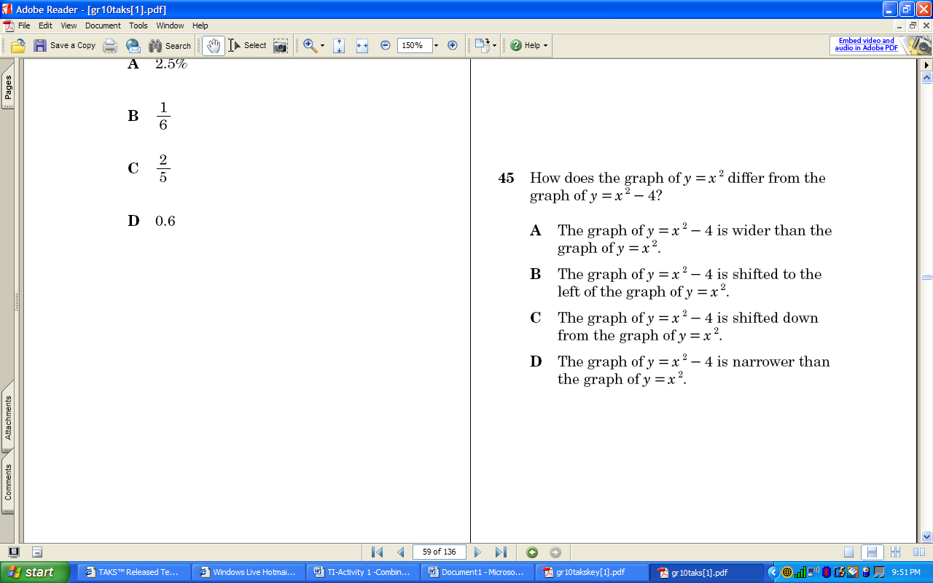

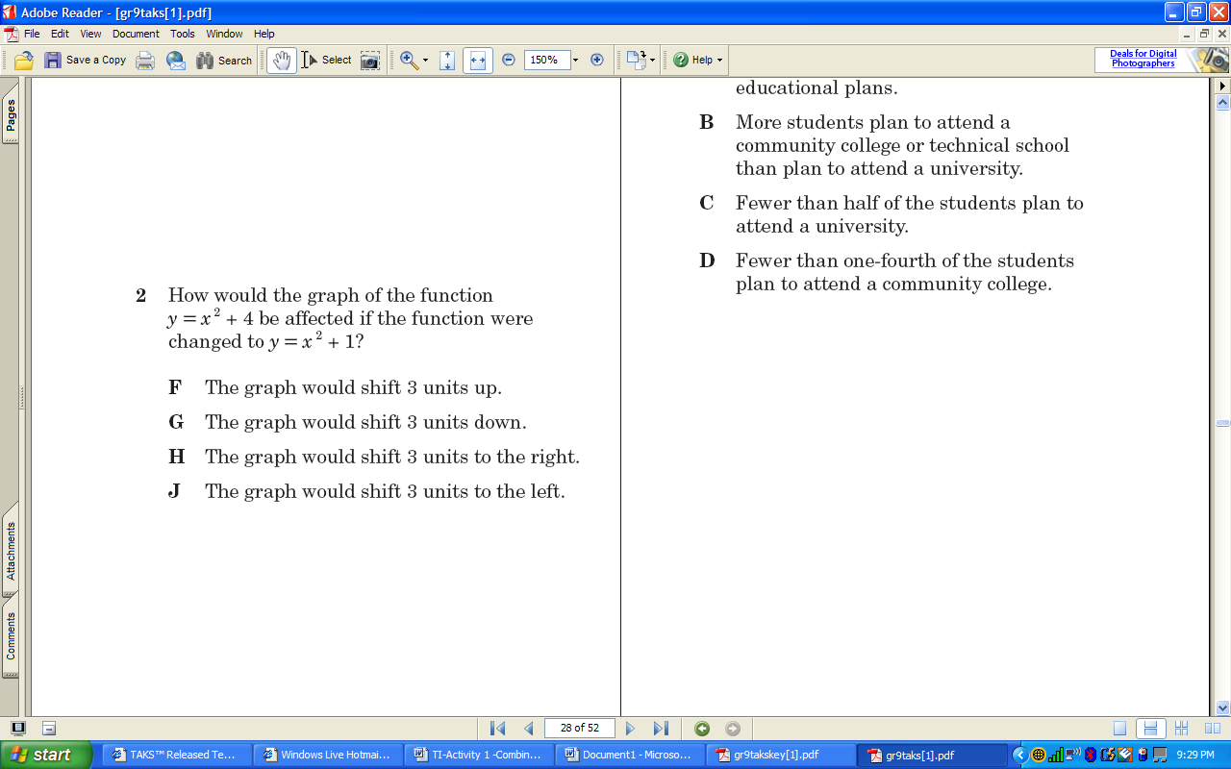

2.

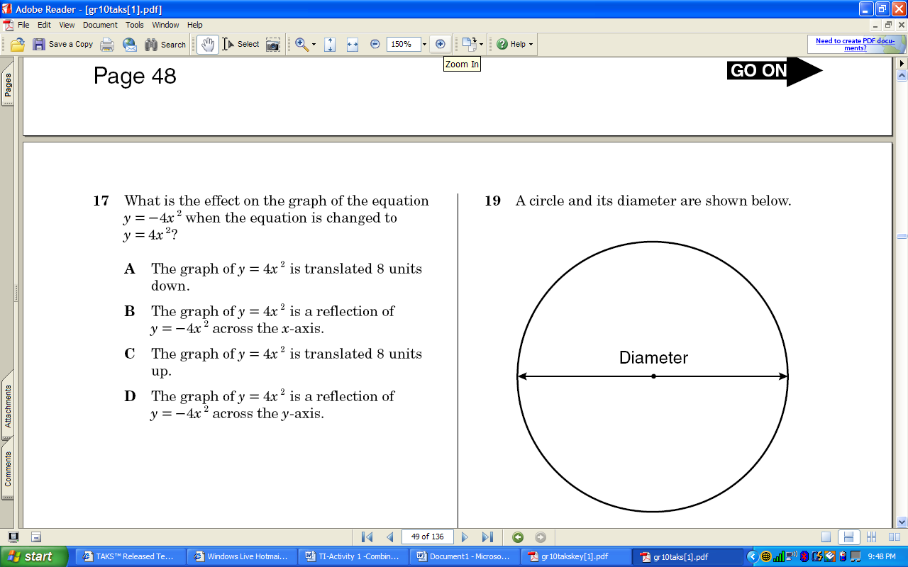

3.

**Review: Define a variable and write an equation for each situation. Then solve.**

1. Chip earns a base salary of $500 per month as a salesman. In addition to the salary, he earns $90 per product that he sells. If his goal is to earn $5000 per month, how many products does he need to sell?

2. A pizza shop charges $9 for a large cheese pizza. Additional toppings cost $1.25 per topping. Heather paid $15.25 for her large pizza. How many toppings did she order?

|  |  |  |  |
| --- | --- | --- | --- |
| 3. |  | 4. |  |
| 5. |  | 6. |  |