**Exit Note: Quadratic functions**

**1a.** Factorise the expression $x^{2}+x-12$.

*[2 marks]*

**1b.** A function is defined as $f\left(x\right)=x^{3}-2$ for .

(i) List the elements of the domain of .

(ii) Write down the range of .

*[2 marks]*

**2a.** Consider the quadratic function *y* = *f* (*x*) , where *f* (*x*) = 6 − 4*x* + *ax2*.

It is given that *f* (2) = 6 . Find the value of *a* .

*[2 marks]*

**2b.** Find the equation of the axis of symmetry of the graph of *y* = *f* (*x*) .

*[2 marks]*

**2c.** Write down the range of this quadratic function.

*[2 marks]*

**Homework: Quadratic functions**

**1a.** *y* = *f* (*x*) is a quadratic function. The graph of *f* (*x*) intersects the *y*-axis at the point A(0, –3) and the *x*-axis at the point B(3, 0). The vertex of the graph is at the point C(2, 1).

Write down the equation of the axis of symmetry. *[2 marks]*

**1b.** Sketch the graph of *y* = *f* (*x*) on the axes below for 0 ≤ *x* ≤ 4 . Mark clearly on the sketch the points A , B , and C.

*[3 marks]*

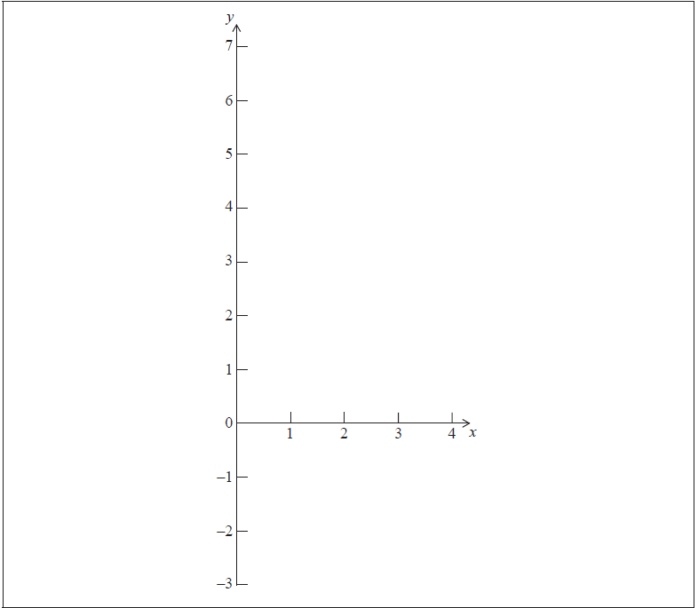**2a.** Factorise the expression .

*[2 marks]*

**2b.** A function is defined as  for .

(i) List the elements of the domain of .

(ii) Write down the range of .

*[2 marks]*

**3a.** Consider the quadratic function *y* = *f* (*x*) , where *f* (*x*) = 5 − *x* + *ax2*.

It is given that *f* (2) = −5 . Find the value of *a* .

*[2 marks]*

**3b.** Find the equation of the axis of symmetry of the graph of *y* = *f* (*x*) .

*[2 marks]*

**3c.** Write down the range of this quadratic function.

*[2 marks]*



5. At what interest rate, compounded annually, would you need to invest $100 in order to have $125 in 2 years?

Answer: (a) ________________________ **(Total 4 marks)**

6. In an experiment researchers found that a specific culture of bacteria increases in number according to the formula

*N* = 150 × 2*t*,

where *N* is the number of bacteria present and *t* is the number of hours since the experiment began.

Use this formula to calculate

(a) the number of bacteria present at the start of the experiment;

(b) the number of bacteria present after 3 hours;

(c) the number of hours it would take for the number of bacteria to reach 19 200.

**(Total 4 marks)**

Answers: (a)

(b)

(c)

