# Homework: Function graphs, inverses *Hint: many of these problems can be solved using calculator graphing tools.*

**1a.** Let  . The following diagram shows part of the curve of *f* .

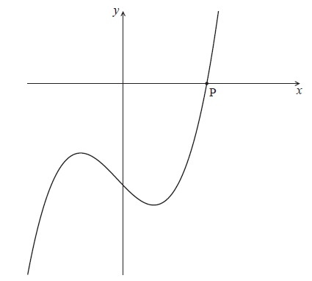

The curve crosses the *x*-axis at the point P.

Write down the *x*-coordinate of P. *[1 mark]*

**2a.** *[4 marks]*

Consider the function  .

Sketch the graph of *f* , for  .

**2b.** *[1 mark]*

This function can also be written as  .

Write down the value of *p* .

**2c.** *[4 marks]*

The graph of *g* is obtained by reflecting the graph of *f* in the *x*-axis, followed by a translation of 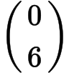 .

Show that  .

**2d.** *[3 marks]*

The graph of *g* is obtained by reflecting the graph of *f* in the *x*-axis, followed by a translation of  .

The graphs of *f* and *g* intersect at two points.

Write down the *x*-coordinates of these two points.

**3a.** The diagram below shows the graph of a function  , for  .

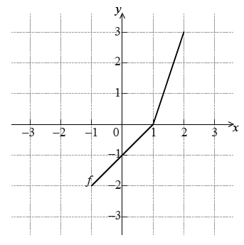

Write down the value of . *[1 mark]*

**3b.** Write down the value of  . *[2 marks]*

**3c.** Sketch the graph of  on the grid below. *[3 marks]*

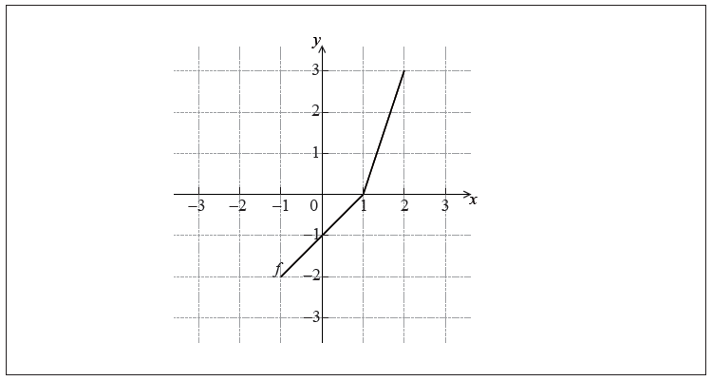

**4a.** *[1 mark]*

Write down the value of

(i) ;

**4b.** *[1 mark]*

(ii) ;

**4c.** *[1 mark]*

(iii) .

**4d.** *[3 marks]*

Hence, solve .

**5a.** The following diagram shows the graph of , for .

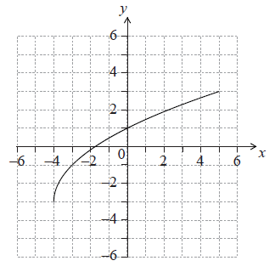

Write down the value of . *[1 mark]*

**5b.** Write down the value of . *[1 mark]*

**5c.** *[2 marks]*

Find the domain of .

**5d.** *[3 marks]*

On the grid above, sketch the graph of .

**6a.** *[3 marks]*

Let . Part of the graph of is shown in the following diagram.

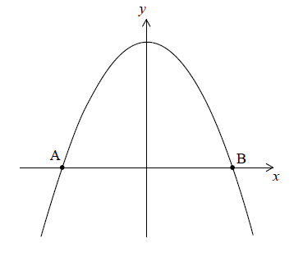

The graph crosses the -axis at the points  and .

Find the -coordinate of  and of .