# Pre-Exam_Function-operations+Quadratics

**1a.** *[6 marks]*

The diagram below shows part of the graph of  .

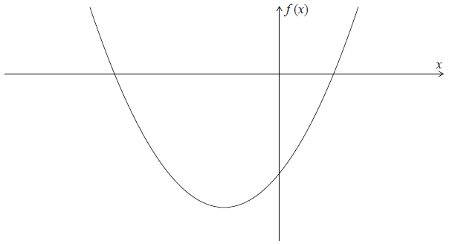

(a) Write down the -intercepts of the graph of  .

(b) Find the coordinates of the vertex of the graph of  .

## Markscheme

(a)  ,  (accept (, ), (, ) ) ***A1A1 N2***

***[2 marks]***

(b) **METHOD 1**

attempt to find -coordinate ***(M1)***

*eg* 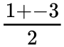 , 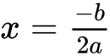 , 

correct value,  (may be seen as a coordinate in the answer) ***A1***

attempt to find **their** -coordinate ***(M1)***

*eg*  ,  , 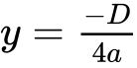

 ***A1***

vertex (, ) ***N3***

**METHOD 2**

attempt to complete the square ***(M1)***

*eg* 

attempt to put into vertex form ***(M1)***

*eg*  , 

vertex (, ) ***A1A1 N3***

***[4 marks]***

**1b.** *[2 marks]*

Write down the -intercepts of the graph of  .

## Markscheme

 ,  (accept (, ), (, ) ) ***A1A1 N2***

***[2 marks]***

**1c.** *[4 marks]*

Find the coordinates of the vertex of the graph of  .

## Markscheme

**METHOD 1**

attempt to find -coordinate ***(M1)***

*eg*  ,  , 

correct value,  (may be seen as a coordinate in the answer) ***A1***

attempt to find **their** -coordinate ***(M1)***

*eg*  ,  , 

 ***A1***

vertex (, ) ***N3***

**METHOD 2**

attempt to complete the square ***(M1)***

*eg* 

attempt to put into vertex form ***(M1)***

*eg*  , 

vertex (, ) ***A1A1 N3***

***[4 marks]***

**2a.** *[3 marks]*

Let  , for  .

Find  .

## Markscheme

**METHOD 1**

attempt to set up equation ***(M1)***

*eg*  , 

correct working ***(A1)***

*eg*  , 

 ***A1 N2***

**METHOD 2**

interchanging  and  (seen anywhere) ***(M1)***

*eg*  

correct working ***(A1)***

*eg*  , 

 ***A1 N2***

***[3 marks]***

**2b.** *[3 marks]*

Let  be a function such that  exists for all real numbers. Given that  , find  .

## Markscheme

recognizing  ***(M1)***

*eg* 

correct working ***(A1)***

*eg*  , 

 ***A1 N2***

**Note**: Award ***A0*** for multiple values, *eg*  .

***[3 marks]***

**3a.** *[3 marks]*

Let  and  .

Find  .

## Markscheme

interchanging  and  (seen anywhere) ***(M1)***

*eg* 

evidence of correct manipulation ***(A1)***

*eg* 

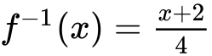 (accept 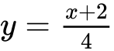 , 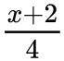 ,  ***A1 N2***

***[3 marks]***

**3b.** *[3 marks]*

Find  .

## Markscheme

**METHOD 1**

attempt to substitute  into  ***(M1)***

*eg* 

 ***(A1)***

 ***A1 N3***

**METHOD 2**

attempt to form composite function (in any order)  ***(M1)***

*eg*  

correct substitution

*eg*  , 

 ***A1 N3***

***[3 marks]***

**4a.** *[1 mark]*

The diagram below shows the graph of a function  , for  .

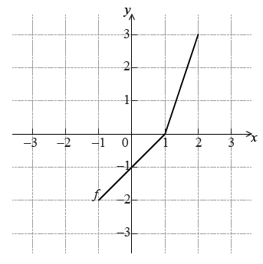

Write down the value of .

## Markscheme

 ***A1 N1***

***[1 mark]***

**4b.** *[2 marks]*

Write down the value of  .

## Markscheme

 ***A2 N2***

***[2 marks]***

**4c.** *[3 marks]*

Sketch the graph of  on the grid below.

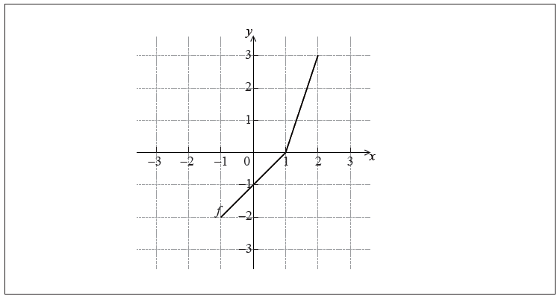

## Markscheme

**EITHER**

attempt to draw  on grid ***(M1)***

**OR**

attempt to reverse ***x*** and ***y*** coordinates ***(M1)***

*eg*  writing or plotting **at least two** of the points

 ,  ,  , 

**THEN**

correct graph ***A2 N3***

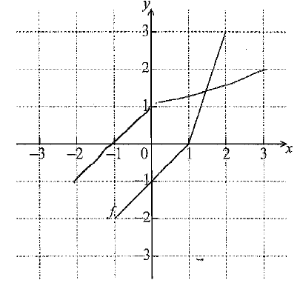

***[3 marks]***

**5a.** *[6 marks]*

Let  and  be functions such that  .

(a) The graph of  is mapped to the graph of  under the following transformations:

vertical stretch by a factor of  , followed by a translation 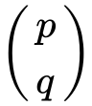 .

Write down the value of

(i)  ;

(ii)  ;

(iii)  .

(b) Let  . The point A(, ) on the graph of  is mapped to the point  on the graph of  . Find  .

## Markscheme

(a) (i)   ***A1 N1***

(ii)  ***A1 N1***

(iii)  ***A1 N1***

***[3 marks]***

(b) recognizing one transformation ***(M1)***

*eg*  horizontal stretch by  , reflection in -axis

 is (, ) ***A1A1 N3***

***[3 marks]***

***Total [6 marks]***

**5b.** *[3 marks]*

The graph of  is mapped to the graph of  under the following transformations:

vertical stretch by a factor of  , followed by a translation  .

Write down the value of

(i)  ;

(ii)  ;

(iii)  .

## Markscheme

(i)   ***A1 N1***

(ii)  ***A1 N1***

(iii)  ***A1 N1***

***[3 marks]***

**5c.** *[3 marks]*

Let  . The point A(, ) on the graph of  is mapped to the point  on the graph of  . Find  .

## Markscheme

recognizing one transformation ***(M1)***

*eg*  horizontal stretch by  , reflection in -axis

 is (, ) ***A1A1 N3***

***[3 marks]***

***Total [6 marks]***

**6.** *[6 marks]*

The equation  has two distinct real roots. Find the possible values of *k* .

## Markscheme

evidence of rearranged quadratic equation (may be seen in working) ***A1***

*e.g.*  , 

evidence of discriminant (must be seen explicitly, not in quadratic formula) ***(M1)***

*e.g*.  , 

recognizing that discriminant is greater than zero (seen anywhere, including answer)  ***R1***

*e.g*.  , 

correct working (accept equality) ***A1***

*e.g*.  ,  , 

both correct values (even if inequality never seen) ***(A1)***

*e.g*. 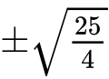 , 

correct interval ***A1******N3***

*e.g*.  , 

**Note:** Do not award the final mark for unfinished values, or for incorrect or reversed inequalities, including  ,  ,  .

**Special cases:**

If working shown, and candidates attempt to rearrange the quadratic equation to equal zero, but find an incorrect value of *c*, award ***A1M1R1A0A0A0***.

If working shown, and candidates do not rearrange the quadratic equation to equal zero, but find  or  , award ***A0M1R1A0A0A0***.

***[6 marks]***

**7a.** *[4 marks]*

Consider the function  .

Sketch the graph of *f* , for  .

## Markscheme

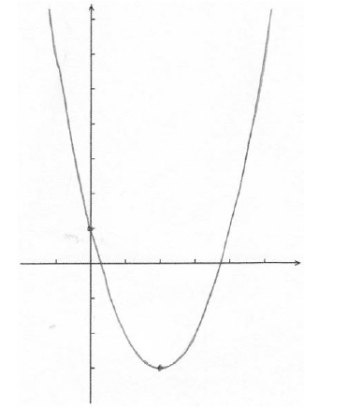 ***A1A1A1A1 N4***

**Note:** The shape **must** be an approximately correct upwards parabola.

**Only** if the shape is approximately correct, award the following:

***A1*** for vertex  , ***A1*** for *x*-intercepts between 0 and 1, and 3 and 4, ***A1*** for correct *y*-intercept , ***A1*** for correct domain .

Scale not required on the axes, but approximate positions need to be clear.

***[4 marks]***

**7b.** *[1 mark]*

This function can also be written as  .

Write down the value of *p* .

## Markscheme

 ***A1 N1***

***[1 mark]***

**7c.** *[4 marks]*

The graph of *g* is obtained by reflecting the graph of *f* in the *x*-axis, followed by a translation of 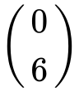 .

Show that  .

## Markscheme

correct vertical reflection, correct vertical translation ***(A1)(A1)***

e.g.  ,  ,  ,  , 

transformations in correct order ***(A1)***

e.g.  , 

simplification which clearly leads to given answer ***A1***

e.g.  , 

 ***AG N0***

**Note**: If working shown, award ***A1A1A0A0*** if transformations correct, but done in reverse order, e.g. .

***[4 marks]***

**7d.** *[3 marks]*

The graph of *g* is obtained by reflecting the graph of *f* in the *x*-axis, followed by a translation of  .

The graphs of *f* and *g* intersect at two points.

Write down the *x*-coordinates of these two points.

## Markscheme

valid approach  ***(M1)***

e.g. sketch, 

 , 

 (exact),  ;  ***A1A1 N3***

***[3 marks]***

**7e.** *[3 marks]*

The graph of  is obtained by reflecting the graph of  in the *x*-axis, followed by a translation of  .

Let *R* be the region enclosed by the graphs of *f* and *g* .

Find the area of *R* .

## Markscheme

attempt to substitute limits or functions into area formula (accept absence of  ) ***(M1)***

e.g.  , 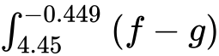 , 

approach involving subtraction of integrals/areas (accept absence of  )  ***(M1)***

e.g.  , 



  ***A1 N3***

***[3 marks]***

**8a.** *[3 marks]*

Let  and  .

Find  .

## Markscheme

interchanging *x* and *y* (seen anywhere) ***(M1)***

e.g. 

correct manipulation ***(A1)***

e.g. 

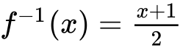 ***A1 N2***

***[3 marks]***

**8b.** *[3 marks]*

Find  .

## Markscheme

**METHOD 1**

attempt to find or  or  ***(M1)***

 ***(A1)***

 ***A1 N2***

***[3 marks]***

**METHOD 2**

attempt to form composite (in any order) ***(M1)***

e.g.  , 

  ***(A1)***

 ***A1 N2***

***[3 marks]***

**9a.** *[2 marks]*

The diagram below shows the graph of a function  , for  .

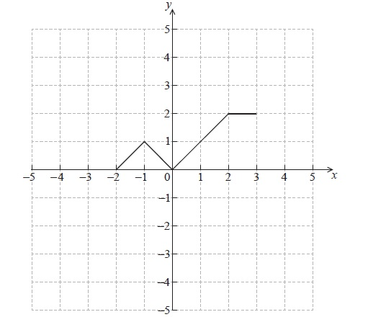

Sketch the graph of  on the grid below.

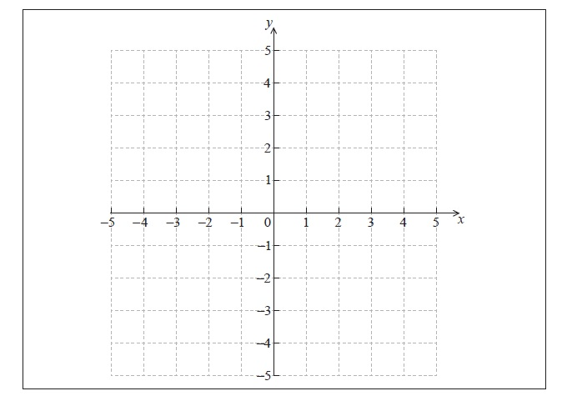

## Markscheme

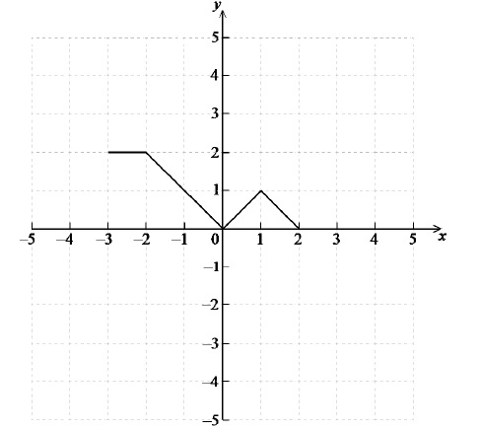 ***A2 N2***

***[2 marks]***

**9b.** *[4 marks]*

The graph of *f* is transformed to obtain the graph of *g* . The graph of *g* is shown below.

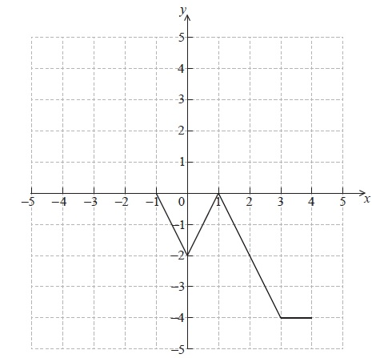

The function *g* can be written in the form  . Write down the value of *a* and of *b* .

## Markscheme

 ***A2A2 N4***

**Note**: Award ***A1*** for  , ***A1*** for  .

***[4 marks]***

**10.** *[7 marks]*

Consider the equation  , where *k* is a real number.

Find the values of *k* for which the equation has two **equal** real solutions.

## Markscheme

**METHOD 1**

evidence of valid approach ***(M1)***

e.g.  , quadratic formula

correct substitution into  (may be seen in formula) ***(A1)***

e.g.  ,  , 

setting **their** discriminant equal to zero ***M1***

e.g. 

attempt to solve the quadratic ***(M1)***

e.g.  , factorizing

correct working ***A1***

e.g.  , 

 ,  (do not accept inequalities) ***A1A1 N2***

***[7 marks]***

**METHOD 2**

recognizing perfect square ***(M1)***

e.g.  , 

correct expansion ***(A1)(A1)***

e.g.  , 

equating coefficients of *x* ***A1A1***

e.g.  , 

 ,  ***A1A1 N2***

***[7 marks]***

**11a.** *[4 marks]*

Let  .

(i) Write down the coordinates of the vertex.

(ii) Hence or otherwise, express the function in the form  .

## Markscheme

(i)  or  ,  ***A1A1 N2***

(ii) evidence of valid approach ***(M1)***

e.g. graph, completing the square, equating coefficients

 ***A1 N2***

***[4 marks]***

**11b.** *[3 marks]*

Solve the equation  .

## Markscheme

evidence of valid approach ***(M1)***

e.g. graph, quadratic formula

 , 

 ,  ***A1A1 N3***

***[3 marks]***

**12a.** *[1 mark]*

Let  be a quadratic function. Part of the graph of  is shown below.

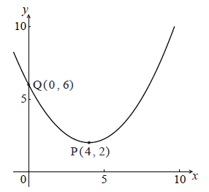

The vertex is at P(, ) and the *y*-intercept is at Q(, ) .

Write down the equation of the axis of symmetry.

## Markscheme

 (must be an equation) ***A1 N1***

***[1 mark]***

**12b.** *[2 marks]*

The function *f* can be written in the form  .

Write down the value of *h* and of *k* .

## Markscheme

 ,  ***A1A1 N2***

***[2 marks]***

**12c.** *[3 marks]*

The function *f* can be written in the form  .

Find *a* .

## Markscheme

attempt to substitute coordinates of any point on the graph into *f* ***(M1)***

e.g.  ,  , 

correct equation (do **not** accept an equation that results from  ) ***(A1)***

e.g.  , 

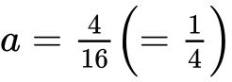 ***A1 N2***

***[3 marks]***

**13a.** *[3 marks]*

Let  and  .

Find  .

## Markscheme

interchanging *x* and *y* (may be seen at any time) ***(M1)***

evidence of correct manipulation ***(A1)***

e.g. 

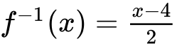 (accept 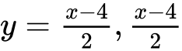 ) ***A1 N2***

***[3 marks]***

**13b.** *[2 marks]*

Find  .

## Markscheme

attempt to form composite (in any order) ***(M1)***

e.g. 

 ***A1*** ***N2***

**13c.** *[2 marks]*

Find  .

## Markscheme

correct substitution ***(A1)***

e.g.  , 

 (accept 176) ***A1 N2***

***[2 marks]***

**14a.** *[1 mark]*

Jose takes medication. After *t* minutes, the concentration of medication left in his bloodstream is given by  , where *A* is in milligrams per litre.

Write down  .

## Markscheme

 ***A1 N1***

***[1 mark]***

**14b.** *[2 marks]*

Find the concentration of medication left in his bloodstream after 50 minutes.

## Markscheme

substitution into formula ***(A1)***

e.g.  , 

 ***A1 N2***

***[2 marks]***

**14c.** *[5 marks]*

At 13:00, when there is no medication in Jose’s bloodstream, he takes his first dose of medication. He can take his medication again when the concentration of medication reaches 0.395 milligrams per litre. What time will Jose be able to take his medication again?

## Markscheme

set up equation ***(M1)***

e.g. 

attempting to solve  ***(M1)***

e.g. graph, use of logs

correct working ***(A1)***

e.g. sketch of intersection, 

 ***A1***

correct time 18:33 or 18:34 (accept 6:33 or 6:34 but nothing else) ***A1 N3***

***[5 marks]***

**15.** *[4 marks]*

Let  , where  . The function *v* is obtained when the graph of *f* is transformed by

a stretch by a scale factor of  parallel to the *y*-axis,

followed by a translation by the vector 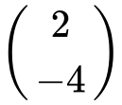 .

Find  , giving your answer in the form  .

## Markscheme

applies vertical stretch parallel to the *y*-axis factor of  ***(M1)***

e.g. multiply by  , 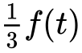 , 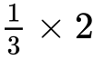

applies horizontal shift 2 units to the right ***(M1)***

e.g.  , 

applies a vertical shift 4 units down ***(M1)***

e.g. subtracting 4,  , 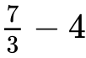

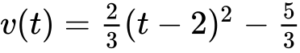 ***A1 N4***

***[4 marks]***

Printed for Bronx Early College Academy

© International Baccalaureate Organization 2017

International Baccalaureate® - Baccalauréat International® - Bachillerato Internacional®