**Function Composition and Inverse Problems**

**1a.** Let  and  .

Find  . *[3 marks]*

**1b.** Find  . *[3 marks]*

**2a.** Let  for  . Part of the graph of *f* is shown below.

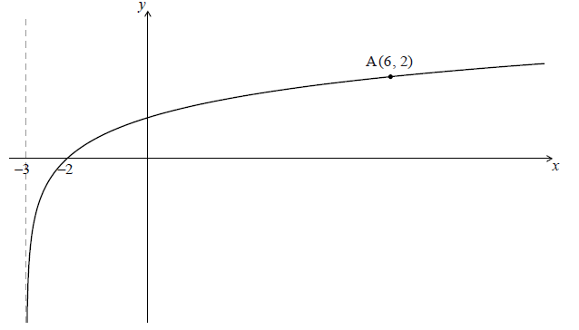

The graph passes through A(6, 2) , has an *x*-intercept at (−2, 0) and has an asymptote at  .

Find *p* . *[4 marks]*

**2b.** The graph of *f* is reflected in the line  to give the graph of *g* .

(i) Write down the *y*-intercept of the graph of *g* .

(ii) Sketch the graph of *g* , noting clearly any asymptotes and the image of A. *[5 marks]*

**2c.** The graph of  is reflected in the line  to give the graph of  .

Find  . *[4 marks]*

**3a.** Let  and  .

Find  . *[3 marks]*

**3b.** Find  . *[2 marks]*

**3c.** Find  . *[2 marks]*