**Classwork assessment: Function graphs**

**1a.** The following diagram shows part of the graph of .

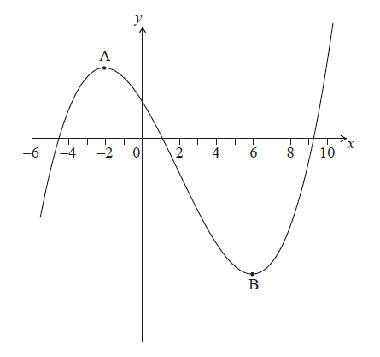

The graph has a local maximum at , where , and a local minimum at , where .

On the graph above, sketch the graph of . *[4 marks]*

**1b.** Write down the following in order from least to greatest: . *[2 marks]*

**2a.** The following diagram shows the graph of a function . There is a local minimum point at , where . *[5 marks]*

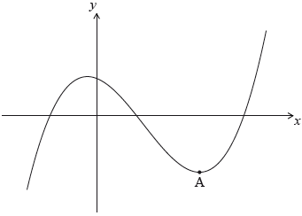

The derivative of  is given by .

Find the -coordinate of .

**2b.** The -intercept of the graph is at (). Find an expression for . *[6 marks]*

**2c.** The graph of a function  is obtained by reflecting the graph of  in the -axis, followed by a translation of 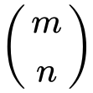.

Find the -coordinate of the local minimum point on the graph of . *[2 marks]*