**Homework: Function graphs**

**1a.** A function  has its derivative given by , where  is a constant.

Find . *[2 marks]*

**1b.** The graph of  has a point of inflexion when .

Show that . *[3 marks]*

**1c.** Find . *[2 marks]*

**1d.** Find the equation of the tangent to the curve of  at , giving your answer in the form . *[4 marks]*

**1e.** Given that , explain why the graph of  has a local maximum when . *[3 marks]*

**2a.** The following diagram shows the graph of a function . There is a local minimum point at , where .

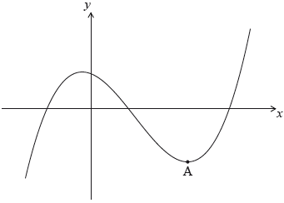

The derivative of  is given by .

Find the -coordinate of . *[5 marks]*

**2b.** The -intercept of the graph is at (). Find an expression for . *[6 marks]*

**3a.** Let . The following diagram shows part of the graph of .

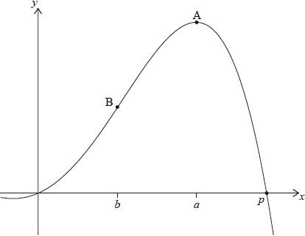

There are -intercepts at  and at . There is a maximum at A where , and a point of inflexion at B where .

Find the value of . *[2 marks]*

**3b.** Write down the coordinates of A. *[2 marks]*

**3c.** Write down the rate of change of  at A. *[1 mark]*

**3d.** Find the coordinates of B. *[4 marks]*

**3e.** Find the rate of change of  at B. *[3 marks]*

**3f.** Let  be the region enclosed by the graph of  , the -axis, the line  and the line . The region  is rotated 360° about the -axis. Find the volume of the solid formed. *[3 marks]*

**4a.** Let , for  x  . The following diagram shows the graph of , the derivative of .

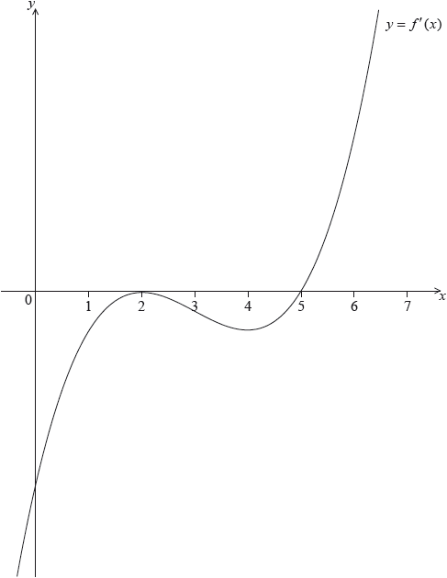

The graph of  has a local maximum when , a local minimum when , and it crosses the *-*axis at the point .

Explain why the graph of  has a local minimum when . *[2 marks]*

**4b.** Find the set of values of  for which the graph of  is concave down. *[2 marks]*

**4c.** The following diagram shows the shaded regions ,  and .

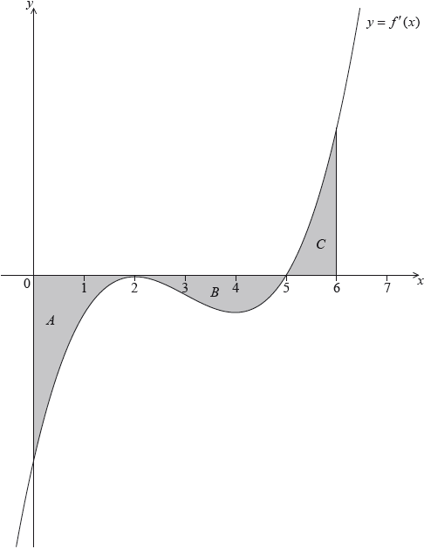

The regions are enclosed by the graph of , the -axis, the -axis, and the line .

The area of region  is 12, the area of region  is 6.75 and the area of region  is 6.75.

Given that , find . *[5 marks]*

**4d.** Let . Given that , find the equation of the tangent to the graph of  at the point where . *[6 marks]*

**5a.** The following diagram shows the graph of , for .

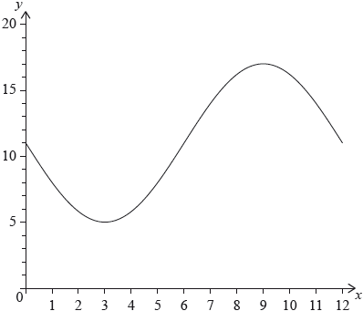

The graph of  has a minimum point at  and a maximum point at .

(i) Find the value of .

(ii) Show that .

(iii) Find the value of . *[6 marks]*

**5b.** The graph of  is obtained from the graph of  by a translation of 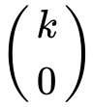. The maximum point on the graph of  has coordinates .

(i) Write down the value of .

(ii) Find . *[3 marks]*

**5c.** The graph of  changes from concave-up to concave-down when . *[6 marks]*

(i) Find .

(ii) Hence or otherwise, find the maximum positive rate of change of .