**Homework: Review-problems** (answer on lined paper)

**1a.** Let  and , for .

Write down . *[1 mark]*

**1b.** Find . *[2 marks]*

**1c.** Find . *[2 marks]*

**2a.** In an arithmetic sequence .

Write down the value of the common difference. *[1 mark]*

**2b.** Find the first term. *[3 marks]*

**2c.** Find the sum of the first 50 terms of the sequence. *[2 marks]*

**3a.** Let  . The following diagram shows part of the curve of *f*.

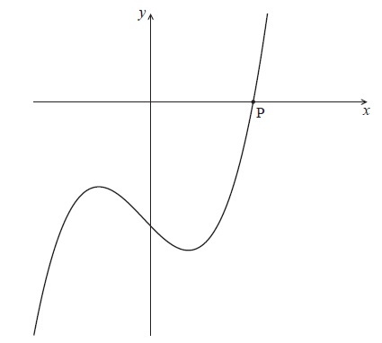

The curve crosses the *x*-axis at the point P.

Write down the *x*-coordinate of P. *[1 mark]*

**3b.** Write down the gradient of the curve at P. *[2 marks]*

**3c.** Find the equation of the normal to the curve at P, giving your equation in the form  .

*[3 marks]*

**4a.** The following figures consist of rows and columns of squares. The figures form a continuing pattern.

Figure 1 has two rows and one column. Figure 2 has three rows and two columns.

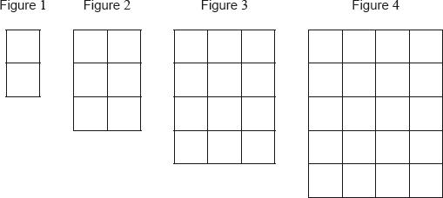

Figure 5 has  rows and  columns.

Write down the value of ; *[1 mark]*

**4b.** Write down the value of . *[1 mark]*

**4c.** Each small square has an area of . Let  be the total area of Figure . The following table gives the first five values of .



Find the value of . *[2 marks]*

**4d.** Find an expression for  in terms of . *[2 marks]*

**5a.** Consider the following frequency table.

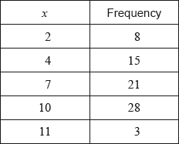

Write down the mode. *[1 mark]*

**5b.** Find the value of the range. *[2 marks]*

**5c.** Find the mean. *[2 marks]*

**5d.** Find the variance. *[2 marks]*

**6a.** Let .

Write down the -intercept of the graph of . *[1 mark]*

**6b.** Solve . *[3 marks]*

**7a.** Let .

Write down the amplitude of . *[1 mark]*

**7b.** Find the period of . *[2 marks]*

**7c.** On the following grid, sketch the graph of , for . *[4 marks]*

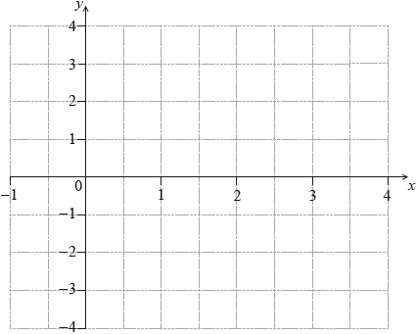

**8a.** Let  and  be independent events, where  and .

Find . *[2 marks]*

**8b.** Find . *[2 marks]*

**8c.** On the following Venn diagram, shade the region that represents .

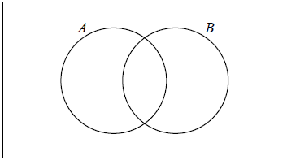 *[1 mark]*

**8d.** Find . *[2 marks]*

**9a.** Let  .

Write down  . *[1 mark]*

**9b.** The tangent to the graph of *f* at the point  has gradient *m* .

(i) Show that  .

(ii) Find *b* . *[4 marks]*

**9c.** Hence, write down the equation of this tangent. *[1 mark]*

**10a.** The following diagram shows  , where RQ = 9 cm,  and  .

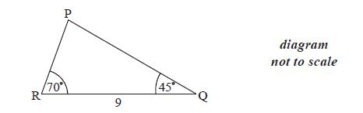

Find  . *[1 mark]*

**10b.** Find PR. *[3 marks]*

**10c.** Find the area of  . *[2 marks]*

**11a.** Events *A* and *B* are such that  ,  and  .

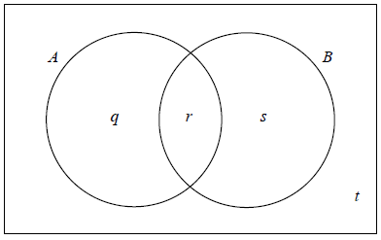

The values *q*, *r*, *s* and *t* represent probabilities.

Write down the value of *t* . *[1 mark]*

**11b.** (i) Show that  .

(ii) Write down the value of *q* and of *s* . *[3 marks]*

**11c.** (i) Write down  .

(ii) Find  . *[3 marks]*

**12a.** Let 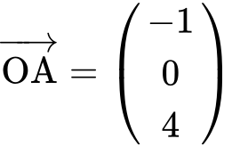 and 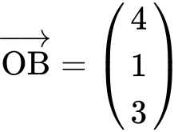.

(i) Find .

(ii) Find 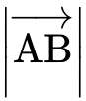. *[4 marks]*

**12b.** The point C is such that 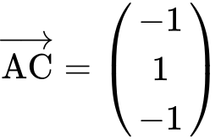.

Show that the coordinates of C are . *[1 mark]*

**12c.** The following diagram shows triangle ABC. Let D be a point on [BC], with acute angle .

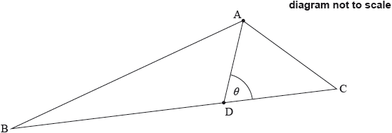

Write down an expression in terms of  for

(i) angle ADB;

(ii) area of triangle ABD. *[2 marks]*

**12d.** Given that 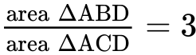, show that 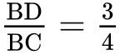. *[5 marks]*

**12e.** Hence or otherwise, find the coordinates of point D. *[4 marks]*

**13a.** The probability distribution of a discrete random variable *X* is given by

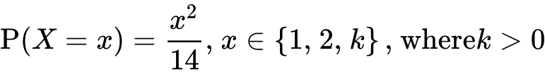

Write down  . *[1 mark]*

**13b.** Show that  . *[4 marks]*

**13c.** Find  . *[2 marks]*