**Final Exam**: Quadratic, exponential, & logarithmic functions; probability

*For credit, answers must be clearly written on lined paper using standard IB notation.*

**1a.** Let  and , for .

Find . *[2 marks]*

**1b.** Find $g\left(-3\right)$. *[1 mark]*

**2a.** A quadratic function *f* can be written in the form . The graph of *f* has axis of symmetry *x* = 2 and *y*-intercept at $\left(0, -6\right)$.

Find the value of . *[3 marks]*

**2b.** Find the value of . *[3 marks]*

**3a.** Two events  and  are such that  and .

Given that  and  are mutually exclusive, find . *[2 marks]*

**4a.** Let *x* = ln 2 and *y* = ln 7. Write the following expressions in terms of *x* and *y.*

$\ln\left(\frac{7}{2}\right)$*[2 marks]*

**4b.** ln 28. *[4 marks]*

**5a.** Ludmila takes a loan of 10 000 dollars from a bank for two years at a nominal annual interest rate of 7.5%, **compounded half yearly**.

Write down the number of times interest is added to the loan in the two years. *[1 mark]*

**5b.** Calculate the **exact** amount of money that Ludmila must repay at the end of the two years. *[3 marks]*

**6a.** Let  and , for .

Find *f* (5). *[2 marks]*

**6b.** Find . *[2 marks]*

**6c.** Solve . *[3 marks]*

**7a.** Find the value of  . *[3 marks]*

**7b.** Find the value of  . *[4 marks]*

**8a.** Let  and  be independent events, where  and .

Find . *[2 marks]*

**8b.** Find . *[2 marks]*

**8c.** Using the answer sheet, shade the region representing given expression on the Venn diagram. *[1 mark]*

**8d.** Find . *[2 marks]*

**9a.** Let  . Part of the graph of *f* is shown below.

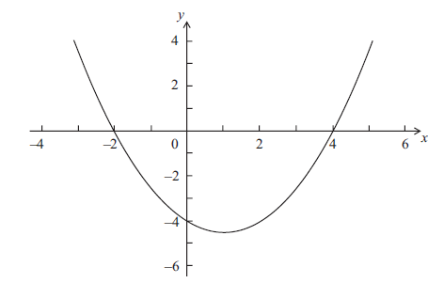

The graph passes through the points (−2, 0), (0, − 4) and (4, 0) .

Write down the value of *q* and of *r*. *[2 marks]*

**9b.** Write down the **equation** of the axis of symmetry. *[1 mark]*

**9c.** Find the value of *p*. *[3 marks]*

**10a.** Let  for  . Part of the graph of *f* is shown below.  
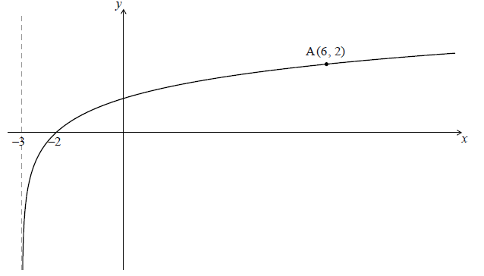

The graph passes through A(6, 2) , has an *x*-intercept at (−2, 0) and has an asymptote at  .

Find *p* . *[4 marks]*

**10b.** The graph of *f* is reflected in the line  to give the graph of *g* .

(i) Write down the *y*-intercept of the graph of *g* . *[1 mark]*

(ii) Sketch the graph of *g* on graph paper, noting clearly any asymptotes and the image of A. *[4 marks]*

**11a.** Adam travels to school by car () or by bicycle (). On any particular day he is equally likely to travel by car or by bicycle.

The probability of being late () for school is  if he travels by car.

The probability of being late for school is  if he travels by bicycle.

This information is represented by the following tree diagram.

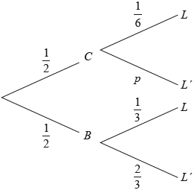

Find the value of . *[2 marks]*

**11b.** Find the probability that Adam will travel by car and be late for school. *[2 marks]*

**11c.** Find the probability that Adam will be late for school. *[4 marks]*

**11d.** Given that Adam is late for school, find the probability that he travelled by car. *[3 marks]*

**Final Exam**: Quadratic, exponential, & logarithmic functions; probability

*Answer sheet for graphs*

**8c.** Shade the region that represents on the Venn diagram.

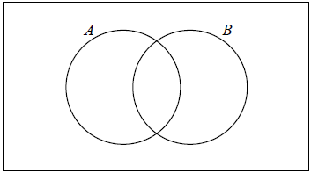

**10b.** The graph of *f* is reflected in the line  to give the graph of *g* .

(ii) Sketch the graph of *g* on graph paper, noting clearly any asymptotes and the image of A. *[4 marks]*



**Final Exam**: Quadratic, exponential, & logarithmic functions; probability

*Answer sheet for graphs*

**8c.** Shade the region that represents on the Venn diagram.



**10b.** The graph of *f* is reflected in the line  to give the graph of *g* .

(ii) Sketch the graph of *g* on graph paper, noting clearly any asymptotes and the image of A. *[4 marks]*

