# 1-2-P1-Algebra-logs

**1a.** *[2 marks]*

Find the value of each of the following, giving your answer as an integer.



**1b.** *[2 marks]*



**1c.** *[3 marks]*



**2a.** *[2 marks]*

Let  and . Write the following expressions in terms of  and .

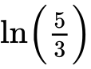.

**2b.** *[4 marks]*

.

**3a.** *[2 marks]*

Let  and  .

Find  .

**3b.** *[2 marks]*

Find 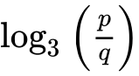 .

**3c.** *[3 marks]*

Find  .

**4a.** *[2 marks]*

Given that  and , write down the value of  and of .

**4b.** *[4 marks]*

Hence or otherwise solve .

**5a.** *[3 marks]*

Write the expression  in the form , where .

**5b.** *[3 marks]*

Hence or otherwise, solve .

**6a.** *[1 mark]*

Write down the value of

(i)     ;

**6b.** *[1 mark]*

(ii)     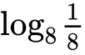;

**6c.** *[1 mark]*

(iii)     .

**6d.** *[3 marks]*

Hence, solve 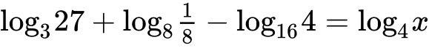.

**7a.** *[1 mark]*

Find  .

**7b.** *[4 marks]*

Given that 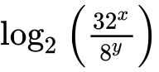 can be written as  , find the value of *p* and of *q*.

**8a.** *[4 marks]*

Let  and  .

Express  in the form  , where  .

**8b.** *[3 marks]*

The graph of *g* is a transformation of the graph of *f* . Give a full geometric description of this transformation.

**9.** *[7 marks]*

Solve , for .

**10.** *[7 marks]*

Solve  , for  .

**11a.** *[3 marks]*

Let  .

(i)     Show that  .

(ii)    Write down the domain of  .

**11b.** *[4 marks]*

Solve the equation  .

**12a.** *[3 marks]*

Find the value of  .

**12b.** *[4 marks]*

Find the value of  .

**13a.** *[2 marks]*

Let  , for  .

Show that  .

**13b.** *[1 mark]*

Write down the range of  .

**13c.** *[4 marks]*

Let  , for  .

Find the value of  , giving your answer as an integer.

**14a.** *[3 marks]*

Let  .

Given that  , find the value of  .

**14b.** *[4 marks]*

Find 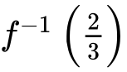 .

**15a.** *[3 marks]*

Let 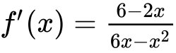, for .

The graph of  has a maximum point at P.

Find the -coordinate of P.

**15b.** *[8 marks]*

The -coordinate of P is .

Find , expressing your answer as a single logarithm.

**15c.**

The graph of  is transformed by a vertical stretch with scale factor . The image of P under this transformation has coordinates .

Find the value of  and of , where .

**16a.** *[2 marks]*

The first two terms of an infinite geometric sequence, in order, are

, where .

Find .

**16b.** *[2 marks]*

Show that the sum of the infinite sequence is .

**16c.** *[4 marks]*

The first three terms of an arithmetic sequence, in order, are

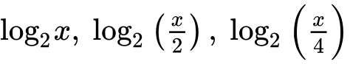, where .

Find , giving your answer as an integer.

**16d.** *[2 marks]*

Let  be the sum of the first 12 terms of the arithmetic sequence.

Show that .

**16e.** *[3 marks]*

Given that  is equal to half the sum of the infinite geometric sequence, find , giving your answer in the form , where .

**17a.** *[4 marks]*

Let  . The line *L* is the tangent to the curve of *f* at (4, 6) .

Find the equation of *L* .

**17b.** *[6 marks]*

Let 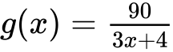 , for  . The following diagram shows the graph of *g* .

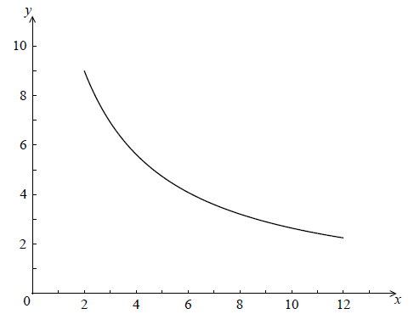

Find the area of the region enclosed by the curve of *g* , the *x*-axis, and the lines  and  . Give your answer in the form  , where  .

**17c.** *[3 marks]*

The graph of *g* is reflected in the *x*-axis to give the graph of *h* . The area of the region enclosed by the lines *L* ,  ,  and the *x*-axis is 120  .

Find the area enclosed by the lines *L* ,  ,  and the graph of *h* .

Printed for Bronx Early College Academy

© International Baccalaureate Organization 2019

International Baccalaureate® - Baccalauréat International® - Bachillerato Internacional®