Homework: Exponential function practice

**1a.** Jose takes medication. After *t* minutes, the concentration of medication left in his bloodstream is given by  , where *A* is in milligrams per litre.

Write down  . *[1 mark]*

**1b.** Find the concentration of medication left in his bloodstream after 50 minutes. *[2 marks]*

**1c.** At 13:00, when there is no medication in Jose’s bloodstream, he takes his first dose of medication. He can take his medication again when the concentration of medication reaches 0.395 milligrams per litre. What time will Jose be able to take his medication again? *[5 marks]*

**2a.** Given that  and , write down the value of  and of . *[2 marks]*

**2b.** Hence or otherwise solve . *[4 marks]*

**3a.** Let , for .

On the following grid, sketch the graph of . *[3 marks]*

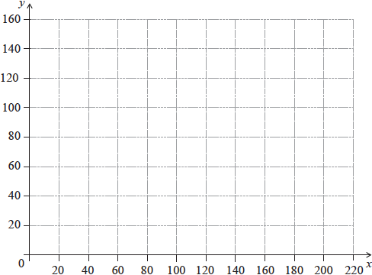

**3b.** Robin and Pat are planning a wedding banquet. The cost per guest,  dollars, is modelled by the function , for , where  is the number of guests.

Calculate the **total** cost for  guests. *[3 marks]*

**4.** A farmer wishes to create a rectangular enclosure, ABCD, of area 525 m, as shown below.

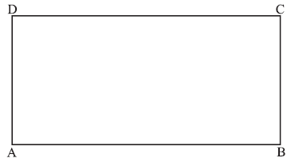

The fencing used for side AB costs  per metre. The fencing for the other three sides costs  per metre. The farmer creates an enclosure so that the cost is a minimum. Find this minimum cost.  
 *[7 marks]*