**Classwork/homework:** You may work on these problems together. Put answers on the board (make a list so I can give credit when I get back). All students must have their own solutions written up (due Monday).

**1a.** *[4 marks]*

Let  .

(i) Write down the coordinates of the vertex.

(ii) Hence or otherwise, express the function in the form  .

**1b.** *[3 marks]*

Solve the equation  .

**2a.** *[2 marks]*

The number of bacteria in two colonies,  and , starts increasing at the same time.

The number of bacteria in colony  after  hours is modelled by the function .

Find the number of bacteria in colony  after four hours.

**2c.** *[3 marks]*

How long does it take for the number of bacteria in colony  to reach ?

**2d.** *[3 marks]*

The number of bacteria in colony  after  hours is modelled by the function .

After four hours, there are  bacteria in colony . Find the value of .

**2e.** *[4 marks]*

The number of bacteria in colony  first exceeds the number of bacteria in colony  after  hours, where . Find the value of .

**3a.** The following diagram shows two ships A and B. At noon, ship A was 15 km due north of ship B. Ship A was moving south at 15 km h and ship B was moving east at 11 km h.

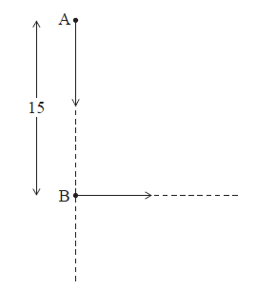

Find the distance between the ships

(i) at 13:00;

(ii) at 14:00.

**4a.** *[3 marks]*

Let  and  .

Find  .

**4b.** *[2 marks]*

Find  .

**4c.** *[2 marks]*

Find  .

**5a.** *[1 mark]*

Jose takes medication. After *t* minutes, the concentration of medication left in his bloodstream is given by  , where *A* is in milligrams per litre.

Write down  .

**5b.** *[2 marks]*

Find the concentration of medication left in his bloodstream after 50 minutes.

**5c.** *[5 marks]*

At 13:00, when there is no medication in Jose’s bloodstream, he takes his first dose of medication. He can take his medication again when the concentration of medication reaches 0.395 milligrams per litre. What time will Jose be able to take his medication again?

**6a.** *[3 marks]*

Consider  , for  and  , for  . The graph of *f* is given below.

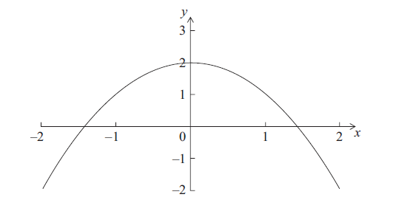

On the diagram above, sketch the graph of *g*.

**6b.** *[2 marks]*

Solve  .

**6c.** *[2 marks]*

Write down the set of values of *x* such that  .

**7a.** *[2 marks]*

Let  ,  and  .

Find  .

**7b.** *[3 marks]*

Find  .

**8a.** *[6 marks]*

A city is concerned about pollution, and decides to look at the number of people using taxis. At the end of the year 2000, there were 280 taxis in the city. After *n* years the number of taxis, *T*, in the city is given by



(i) Find the number of taxis in the city at the end of 2005.

(ii) Find the year in which the number of taxis is double the number of taxis there were at the end of 2000.

**8b.** *[6 marks]*

At the end of 2000 there were  people in the city who used taxis.

After *n* years the number of people, *P*, in the city who used taxis is given by

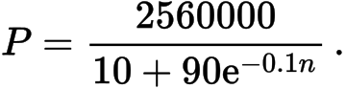

(i) Find the value of

*P*

at the end of 2005, giving your answer to the nearest whole number.

(ii) After seven complete years, will the value of *P* be double its value at the end of 2000? Justify your answer.

**8c.** *[5 marks]*

Let *R* be the ratio of the number of people using taxis in the city to the number of taxis. The city will reduce the number of taxis if  .

(i) Find the value of *R* at the end of 2000.

(ii) After how many complete years will the city first reduce the number of taxis?

**9.** *[7 marks]*

A farmer wishes to create a rectangular enclosure, ABCD, of area 525 m, as shown below.

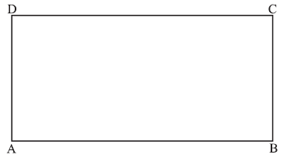

The fencing used for side AB costs  per metre. The fencing for the other three sides costs  per metre. The farmer creates an enclosure so that the cost is a minimum. Find this minimum cost.

**10.** *[5 marks]*

Solve the equation  , for  .

**11a.** *[3 marks]*

Let  , for  .

Find the *x*-intercepts of the graph of *f* .

**11b.** *[3 marks]*

On the grid below, sketch the graph of *f* .

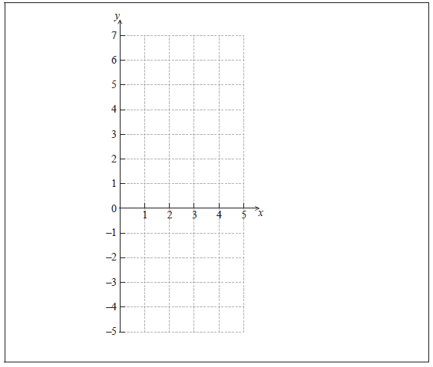

**12a.** *[5 marks]*

A rock falls off the top of a cliff. Let  be its height above ground in metres, after  seconds.

The table below gives values of  and  .

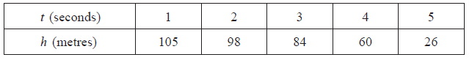

Jane thinks that the function  is a suitable model for the data. Use Jane’s model to

(i) write down the height of the cliff;

(ii) find the height of the rock after 4.5 seconds;

(iii) find after how many seconds the height of the rock is .

**12b.** *[3 marks]*

Kevin thinks that the function  is a better model for the data. Use Kevin’s model to find when the rock hits the ground.

**12c.** *[6 marks]*

(i) On graph paper, using a scale of 1 cm to 1 second, and 1 cm to 10 m, plot the data given in the table.

(ii) By comparing the graphs of *f* and *g* with the plotted data, explain which function is a better model for the height of the falling rock.