# BECA / Huson / IB Math SL Name:

# 15 November 2017

## Homework: Function operations and quadratics review - Markscheme

**1a.** *[1 mark]*

Write down the value of

(i) ;

## Markscheme

(i)  ***A1 N1***

***[1 mark]***

**1b.** *[1 mark]*

(ii) 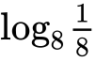;

## Markscheme

(ii) 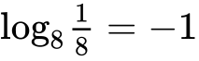 ***A1 N1***

***[1 mark]***

**1c.** *[1 mark]*

(iii) .

## Markscheme

(iii)  ***A1 N1***

***[1 mark]***

**1d.** *[3 marks]*

Hence, solve 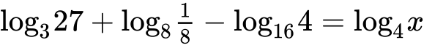.

## Markscheme

correct equation with **their** three values ***(A1)***

*eg* 

correct working involving powers ***(A1)***

*eg* 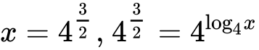

 ***A1 N2***

***[3 marks]***

**2a.** *[2 marks]* The following diagram shows the graph of a function , for .

The points  and  lie on the graph of . There is a minimum point at .

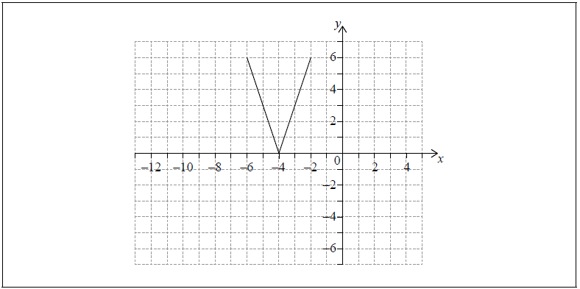

Write down the range of .

## Markscheme

correct interval ***A2*** ***N2***

*eg*, from 0 to 6

***[2 marks]***

**2b.** *[2 marks]* Let .

On the grid above, sketch the graph of .

## Markscheme

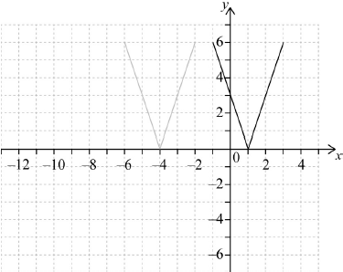 ***M1A1*** ***N2***

**Note:** Award ***M1*** for a horizontal shift of the whole shape, 5 units to the left or right and ***A1*** for the correct graph. ***[2 marks]***

**2c.** *[2 marks]*

Write down the domain of .

## Markscheme

correct interval ***A2*** ***N2***

*eg*, from  to 3

***[2 marks]***

**3a.** *[1 mark]*

Let  and , for .

Write down .

## Markscheme

 ***A1 N1***

***[1 mark]***

**3b.** *[2 marks]*

Find .

## Markscheme

attempt to form composite (in any order) ***(M1)***

*eg*

 ***A1 N2***

***[2 marks]***

**3c.** *[2 marks]*

Find .

## Markscheme

interchanging  and  (may be seen at any time) ***(M1)***

*eg*

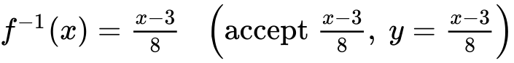 ***A1 N2***

***[2 marks]***

**4a.** *[2 marks]* Let  and , for .

Find .

## Markscheme

attempt to substitute  ***(M1)***

*eg*

 ***A1 N2***

***[2 marks]***

**4b.** *[2 marks]* Find .

## Markscheme

attempt to form composition (in any order) ***(M1)***

*eg*

 ***A1 N2*** ***[2 marks]***

**4c.** *[3 marks]*

Solve .

## Markscheme

valid approach ***(M1)***

*eg* 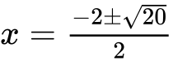, 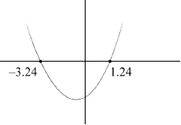



 ***A1A1 N3***

***[3 marks]***

**5a.** *[3 marks]*

Let , for .

Find .

## Markscheme

interchanging  and  (seen anywhere) ***(M1)***

*eg*

evidence of correct manipulation ***(A1)***

*eg*

 ***A1 N2***

**Notes:** If working shown, and they do not interchange  and , award ***A1A1M0*** for .

If no working shown, award ***N1*** for .

**5b.** *[3 marks]*

Let  be a function so that . Find .

## Markscheme

**METHOD 1**

attempt to form composite (in any order) ***(M1)***

*eg*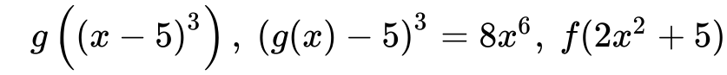

correct working ***(A1)***

*eg*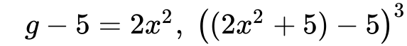

 ***A1 N2***

**METHOD 2**

recognising inverse relationship ***(M1)***

*eg*

correct working

*eg* ***(A1)***

 ***A1 N2***

**6a.** *[2 marks]*

The following diagram shows part of the graph of a quadratic function .

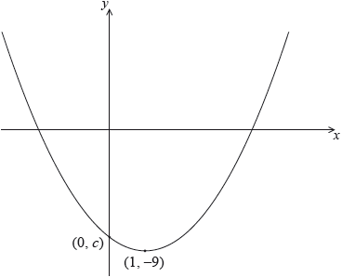

The vertex is at , and the graph crosses the *y*-axis at the point .

The function can be written in the form .

Write down the value of  and of .

## Markscheme

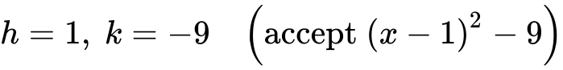 ***A1A1 N2*** ***[2 marks]***

**6b.** *[5 marks]*

Let . The graph of  is obtained by a reflection of the graph of  in the -axis, followed by a translation of 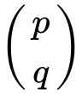.

Find the value of  and of .

## Markscheme

evidence of correct reflection ***A1***

*eg*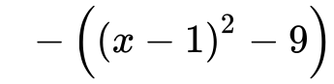, vertex at , *y*-intercept at 

valid attempt to find horizontal shift ***(M1)***

*eg*

 ***A1 N2***

valid attempt to find vertical shift ***(M1)***

*eg*

 ***A1 N2***

**Notes:** An error in finding the reflection may still allow the correct values of  and  to be found, as the error may not affect subsequent working. In this case, award ***A0*** for the reflection, ***M1A1*** for , and ***M1A1*** for .

If no working shown, award ***N0*** for .

***[5 marks]***