# BECA / Huson / IB Math SL Name:

# 6 December 2018

# **Homework: Exponential functions & quadratics review**

**1a.** *[6 marks]*

A city is concerned about pollution, and decides to look at the number of people using taxis. At the end of the year 2000, there were 280 taxis in the city. After *n* years the number of taxis, *T*, in the city is given by



(i) Find the number of taxis in the city at the end of 2005.

(ii) Find the year in which the number of taxis is double the number of taxis there were at the end of 2000.

**1b.** *[6 marks]*

At the end of 2000 there were  people in the city who used taxis.

After *n* years the number of people, *P*, in the city who used taxis is given by

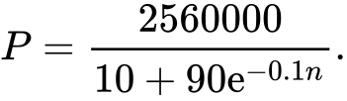

(i) Find the value of *P* at the end of 2005, giving your answer to the nearest whole number.

(ii) After seven complete years, will the value of *P* be double its value at the end of 2000? Justify your answer.

**1c.** *[5 marks]*

Let *R* be the ratio of the number of people using taxis in the city to the number of taxis. The city will reduce the number of taxis if  .

(i) Find the value of *R* at the end of 2000.

(ii) After how many complete years will the city first reduce the number of taxis?

**2a.** *[1 mark]*

Jose takes medication. After *t* minutes, the concentration of medication left in his bloodstream is given by  , where *A* is in milligrams per litre.

Write down  .

**2b.** *[2 marks]*

Find the concentration of medication left in his bloodstream after 50 minutes.

**2c.** *[5 marks]*

At 13:00, when there is no medication in Jose’s bloodstream, he takes his first dose of medication. He can take his medication again when the concentration of medication reaches 0.395 milligrams per litre. What time will Jose be able to take his medication again?

**3a.** *[3 marks]*

A quadratic function  can be written in the form . The graph of  has axis of symmetry  and -intercept at 

Find the value of .

**3b.** *[3 marks]*

Find the value of .

**3c.** *[8 marks]*

The line  is a tangent to the curve of . Find the values of .

**4a.** Let  and , for .

Show that . *[2 marks]*

**4b.** On the following grid, sketch the graph of , for . *[3 marks]*

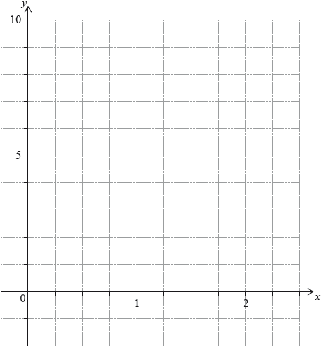

**4c.** *[3 marks]*

The equation  has exactly two solutions, for . Find the possible values of .

**5a.** *[1 mark]*

Let . The following diagram shows part of the graph of .

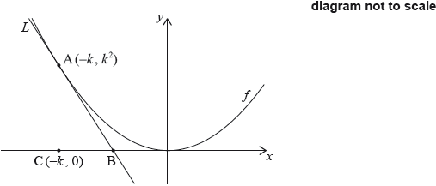

The line  is the tangent to the graph of  at the point , and intersects the -axis at point B. The point C is .

Write down .

**5b.** *[2 marks]*

Find the gradient of .

**5c.** *[5 marks]*

Show that the -coordinate of B is .

**5d.** *[2 marks]*

Find the area of triangle ABC, giving your answer in terms of .