# **3.4 Periodic-functions, trigonometry SPICY** (Paper 2, with calculator)

**1a.** *[2 marks]*

At Grande Anse Beach the height of the water in metres is modelled by the function , where  is the number of hours after 21:00 hours on 10 December 2017. The following diagram shows the graph of  , for .

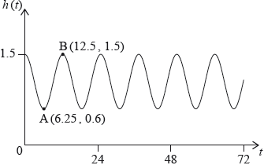

The point  represents the first low tide and  represents the next high tide.

How much time is there between the first low tide and the next high tide?

**1b.** *[2 marks]*

Find the difference in height between low tide and high tide.

**1c.** *[2 marks]*

Find the value of ;

**1d.** *[3 marks]*

Find the value of ;

**1e.** *[2 marks]*

Find the value of .

**1f.** *[3 marks]*

There are two high tides on 12 December 2017. At what time does the second high tide occur?

**2a.** *[2 marks]*

The following diagram shows a waterwheel with a bucket. The wheel rotates at a constant rate in an anticlockwise (counter-clockwise) direction.

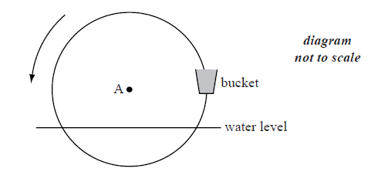

The diameter of the wheel is 8 metres. The centre of the wheel, A, is 2 metres above the water level. After *t* seconds, the height of the bucket above the water level is given by  .

Show that  .

**2b.** *[2 marks]*

The wheel turns at a rate of one rotation every 30 seconds.

Show that  .

**2c.** *[6 marks]*

In the first rotation, there are two values of *t* when the bucket is **descending** at a rate of  .

Find these values of *t* .

**2d.** *[4 marks]*

In the first rotation, there are two values of *t* when the bucket is **descending** at a rate of  .

Determine whether the bucket is underwater at the second value of *t* .

**3a.** *[3 marks]*

The following graph shows the depth of water, *y* metres , at a point P, during one day. The time *t* is given in hours, from midnight to noon.

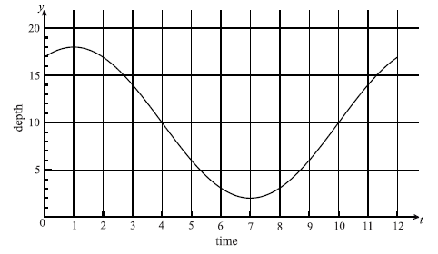

Use the graph to write down an estimate of the value of *t* when

(i)     the depth of water is minimum;

(ii)    the depth of water is maximum;

(iii)   the depth of the water is increasing most rapidly.

**3b.** *[6 marks]*

The depth of water can be modelled by the function  .

(i)     Show that  .

(ii)    Write down the value of *C*.

(iii)   Find the value of *B*.

**3c.** *[2 marks]*

A sailor knows that he cannot sail past P when the depth of the water is less than 12 m . Calculate the values of *t* between which he cannot sail past P.

**4a.** *[3 marks]*

Let  and  for  .

On the same diagram, sketch the graphs of *f* and *g* .

**4b.** *[4 marks]*

Consider the graph of  . Write down

(i)     the *x*-intercept that lies between  and  ;

(ii)    the period;

(iii)   the amplitude.

**4c.** *[3 marks]*

Consider the graph of *g* . Write down

(i)     the two *x*-intercepts;

(ii)    the equation of the axis of symmetry.

**4d.** *[5 marks]*

Let *R* be the region enclosed by the graphs of *f* and *g* . Find the area of *R*.

**5a.** *[2 marks]*

The following diagram represents a large Ferris wheel at an amusement park.

The points P, Q and R represent different positions of a seat on the wheel.

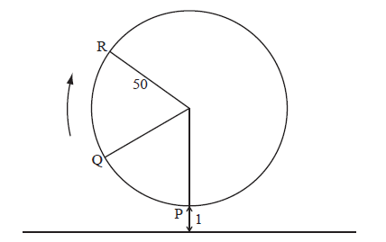

The wheel has a radius of 50 metres and rotates clockwise at a rate of one revolution every 30 minutes.

A seat starts at the lowest point P, when its height is one metre above the ground.

Find the height of a seat above the ground after 15 minutes.

**5b.** *[5 marks]*

After six minutes, the seat is at point Q. Find its height above the ground at Q.

**5c.** *[6 marks]*

The height of the seat above ground after *t* minutes can be modelled by the function .

Find the value of *b* and of *c* .

**5d.** *[3 marks]*

The height of the seat above ground after *t* minutes can be modelled by the function .

Hence find the value of *t* the first time the seat is  above the ground.

**6a.** *[3 marks]*

Let  , for  .

Sketch the graph of *f* .

**6b.** *[3 marks]*

Write down

(i)     the amplitude;

(ii)    the period;

(iii)   the *x*-intercept that lies between  and 0.

**6c.** *[3 marks]*

Hence write  in the form  .

**6d.** *[2 marks]*

Write down one value of *x* such that  .

**6e.** *[2 marks]*

Write down the two values of *k* for which the equation  has exactly two solutions.

**6f.** *[5 marks]*

Let  , for  . There is a value of *x*, between  and , for which the gradient of *f* is equal to the gradient of *g*. Find this value of *x*.

**7a.** *[3 marks]*

Let 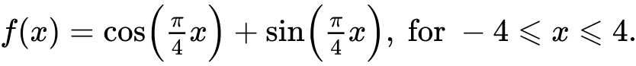

Sketch the graph of .

**7b.** *[5 marks]*

Find the values of  where the function is decreasing.

**7c.** *[3 marks]*

The function  can also be written in the form 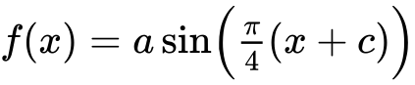, where , and . Find the value of ;

**7d.** *[4 marks]*

The function  can also be written in the form , where , and . Find the value of .

**8a.** A Ferris wheel with diameter  metres rotates clockwise at a constant speed. The wheel completes  rotations every hour. The bottom of the wheel is  metres above the ground.

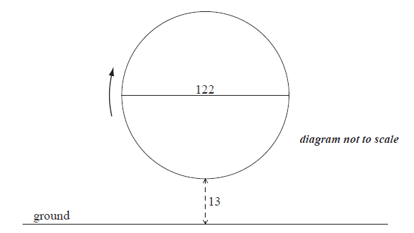

A seat starts at the bottom of the wheel.

Find the maximum height above the ground of the seat. *[2 marks]*

**8b.** *[2 marks]*

After ***t***minutes, the height  metres above the ground of the seat is given by



(i)     Show that the period of  is  minutes.

(ii)     Write down the **exact** value of  .

**8c.** *[3 marks]*

Find the value of  .

**8d.** *[4 marks]*

Sketch the graph of  , for  .

**8e.** *[5 marks]*

In one rotation of the wheel, find the probability that a randomly selected seat is at least  metres above the ground.

**9a.** *[4 marks]*

Consider the following circle with centre O and radius *r* .

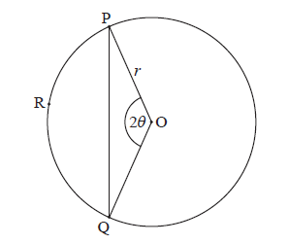

The points P, R and Q are on the circumference,  , for  .

Use the cosine rule to show that  .

**9b.** *[5 marks]*

Let *l* be the length of the arc PRQ .

Given that  , find the value of  .

**9c.** *[4 marks]*

Consider the function  , for  .

(i)     Sketch the graph of *f* .

(ii)    Write down the root of  .

**9d.** *[3 marks]*

Use the graph of *f* to find the values of  for which  .

**10a.** Let , be a periodic function with 

The following diagram shows the graph of .

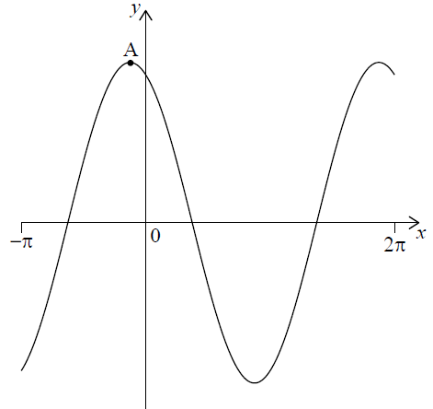

There is a maximum point at A. The minimum value of  is −13 .

Find the coordinates of A. *[2 marks]*

**10b.** For the graph of , write down the amplitude. *[1 mark]*

**10c.** For the graph of , write down the period. *[1 mark]*

**10d.** Hence, write  in the form . *[3 marks]*

**10e.** A ball on a spring is attached to a fixed point O. The ball is then pulled down and released, so that it moves back and forth vertically.

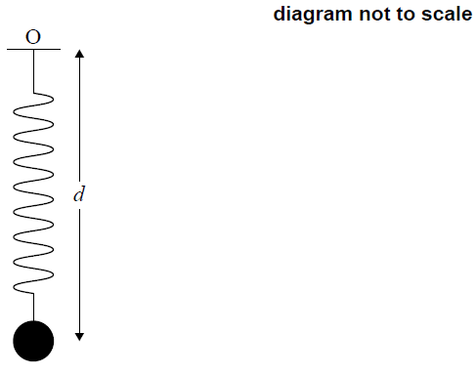

The distance, *d* centimetres, of the centre of the ball from O at time *t* seconds, is given by



Find the maximum speed of the ball. *[3 marks]*

**10f.** Find the first time when the ball’s speed is changing at a rate of 2 cm s−2. *[5 marks]*

**11a.** **Note: In this question, distance is in millimetres.**

Let , for .

Show that . *[3 marks]*

**11b.** The graph of  passes through the origin. Let  be any point on the graph of  with -coordinate , where . A straight line  passes through all the points .

Find the coordinates of  and of . *[3 marks]*

**11c.** Find the equation of . *[3 marks]*

**11d.** Show that the distance between the -coordinates of  and  is . *[2 marks]*

**11e.** Diagram 1 shows a saw. The length of the toothed edge is the distance AB.

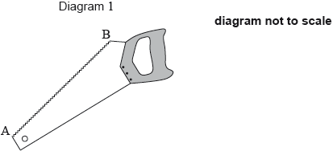

The toothed edge of the saw can be modelled using the graph of  and the line . Diagram 2 represents this model.

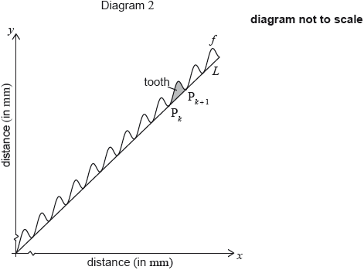

The shaded part on the graph is called a tooth. A tooth is represented by the region enclosed by the graph of  and the line , between  and . A saw has a toothed edge which is 300 mm long. Find the number of complete teeth on this saw. *[6 marks]*

**12a.** *[6 marks]*

The following diagram shows the graph of , for .

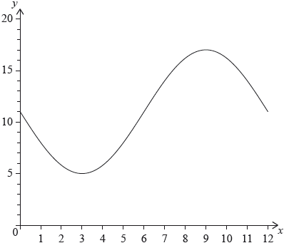

The graph of  has a minimum point at  and a maximum point at .

(i)     Find the value of .

(ii)     Show that .

(iii)     Find the value of .

**12b.** *[3 marks]*

The graph of  is obtained from the graph of  by a translation of 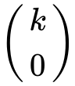. The maximum point on the graph of  has coordinates .

(i)     Write down the value of .

(ii)     Find .

**12c.** *[6 marks]*

The graph of  changes from concave-up to concave-down when .

(i)     Find .

(ii)     Hence or otherwise, find the maximum positive rate of change of .

**13a.** *[5 marks]*

The diagram below shows a plan for a window in the shape of a trapezium.

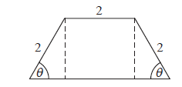

Three sides of the window are  long. The angle between the sloping sides of the window and the base is  , where  .

Show that the area of the window is given by  .

**13b.** *[4 marks]*

Zoe wants a window to have an area of . Find the two possible values of  .

**13c.** *[7 marks]*

John wants two windows which have the same area *A* but different values of  .

Find all possible values for *A* .