Homework: Trig exam problems

**1a.** The following diagram shows a circle with centre  and radius .

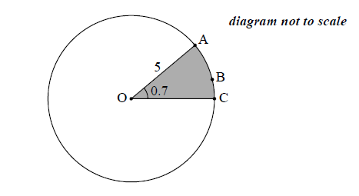

The points ,  and  lie on the circumference of the circle, and  radians.

Find the length of the arc . *[2 marks]*

**1b.** Find the perimeter of the shaded sector. *[2 marks]*

**1c.** Find the area of the shaded sector. *[2 marks]*

**2a.** The following diagram shows a triangle ABC.

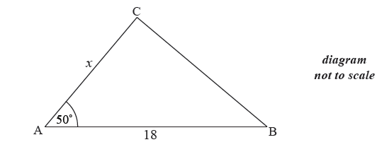

The area of triangle ABC is  cm2 , AB  cm , AC  cm and  .

Find  . *[3 marks]*

**2b.** Find BC. *[3 marks]*

**3a.** In triangle ,  and . The area of the triangle is .

Find the two possible values for . *[4 marks]*

**3b.** Given that  is obtuse, find . *[3 marks]*

**4a.** Let , for . The following diagram shows the graph of .

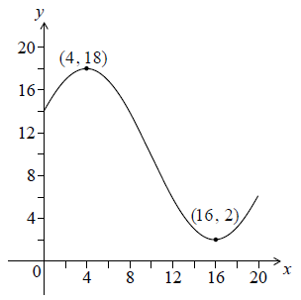

The graph has a maximum at  and a minimum at .

Write down the value of . *[2 marks]*

**4b.** Find . *[2 marks]*

**4c.** Find . *[2 marks]*

**4d.** Solve . *[2 marks]*

**5a.** Let 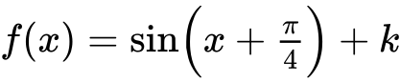. The graph of *f* passes through the point 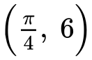.

Find the value of . *[3 marks]*

**5b.** Find the minimum value of . *[2 marks]*

**5c.** Let . The graph of *g* is translated to the graph of  by the vector 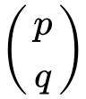.

Write down the value of  and of . *[2 marks]*

**6a.** *[3 marks]*

Consider a circle with centre  and radius  cm. Triangle  is drawn such that its vertices are on the circumference of the circle.

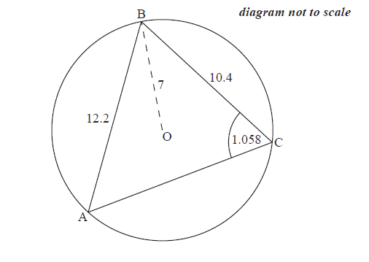

 cm,  cm and  radians.

Find .

**6b.** *[5 marks]*

Find .

**6c.** *[6 marks]*

Hence or otherwise, find the length of arc .

**7a.** *[2 marks]*

A Ferris wheel with diameter  metres rotates clockwise at a constant speed. The wheel completes  rotations every hour. The bottom of the wheel is  metres above the ground.

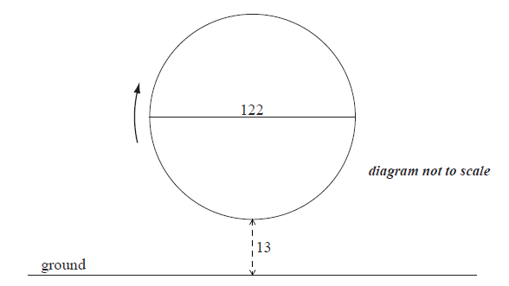

A seat starts at the bottom of the wheel.

Find the maximum height above the ground of the seat.

**7b.** *[2 marks]*

After ***t***minutes, the height  metres above the ground of the seat is given by



(i) Show that the period of  is  minutes.

(ii) Write down the **exact** value of  .

**7c.** *[3 marks]*

Find the value of  .

**7d.** *[4 marks]*

Sketch the graph of  , for  .

**7e.** *[5 marks]*

In one rotation of the wheel, find the probability that a randomly selected seat is at least  metres above the ground.

**8a.** *[5 marks]*

The following diagram shows two ships A and B. At noon, ship A was 15 km due north of ship B. Ship A was moving south at 15 km h–1 and ship B was moving east at 11 km h–1.

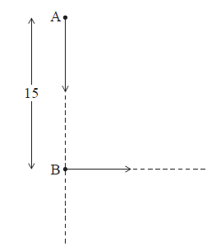

Find the distance between the ships

(i) at 13:00;

(ii) at 14:00.

**8b.** *[6 marks]*

Let  be the distance between the ships *t* hours after noon, for  .

Show that  .

**8c.** *[3 marks]*

Sketch the graph of  .

**8d.** *[3 marks]*

Due to poor weather, the captain of ship A can only see another ship if they are less than 8 km apart. Explain why the captain cannot see ship B between noon and 16:00.