**Homework: Function operations** (these are calculator-intensive problems)

**1a.** The following diagram shows the graph of a function , with domain .

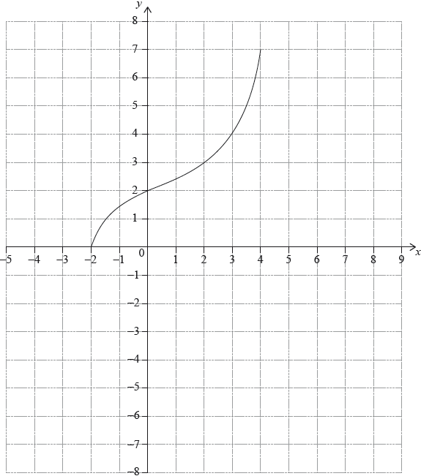

The points  and  lie on the graph of .

Write down the range of . *[1 mark]*

**1b.** Write down ;

*[1 mark]*

**1c.** Write down .

*[1 mark]*

**1d.** On the grid, sketch the graph of . *[3 marks]*

**2a.** Let 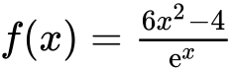, for .

Find the -intercept of the graph of . *[2 marks]*

**2b.** The graph of  has a maximum at the point A. Write down the coordinates of A. *[2 marks]*

**2c.** On the following grid, sketch the graph of .

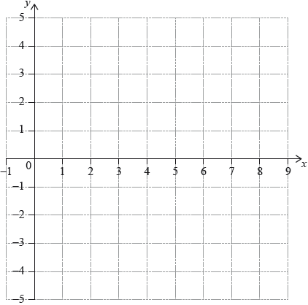*[3 marks]*

**3.** Let , for . The graph of  passes through the point , where .

Find the value of . *[2 marks]*

**4a.** Let  and , for .

Find . *[2 marks]*

**4b.** Find . *[3 marks]*

**5a.** Consider the graph of 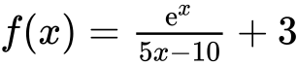, for .

Find the -intercept. *[2 marks]*

**5b.** Find the equation of the vertical asymptote. *[2 marks]*

**5c.** Find the minimum value of  for . *[2 marks]*

**6a.** The following diagram shows the graph of a function , for .

The points  and  lie on the graph of . There is a minimum point at .

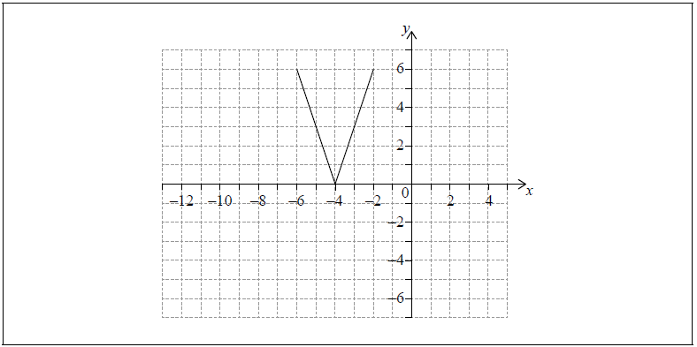

Write down the range of . *[2 marks]*

**6b.** Let .

On the grid above, sketch the graph of . *[2 marks]*

**6c.** Write down the domain of . *[2 marks]*

**7a.** Let  and , for .

Show that . *[2 marks]*

**7b.** On the following grid, sketch the graph of , for .

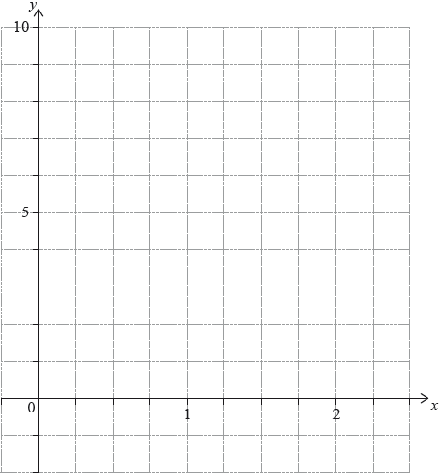*[3 marks]*

**7c.** The equation  has exactly two solutions, for . Find the possible values of *k.* *[3 marks]*

**8a.** Let .

Find the equation of the axis of symmetry of the graph of . *[2 marks]*

**8b.** The function can also be expressed in the form .

(i) Write down the value of .

(ii) Find the value of . *[4 marks]*

**9a.** Let  and , for .

Find . *[2 marks]*

**9b.** Find . *[2 marks]*

**9c.** Solve . *[3 marks]*