Chris Huson

IB Math SL

Dr. Huson

2 April 2018

How transformations of the reciprocal function are related to their inverses:

A graphical and algebraic exploration [proposal draft]

The reciprocal function, $f\left(x\right)=\frac{1}{x}$, is one of the simplest functions and yet has several interesting characteristics. It is its own inverse, and it has two asymptotes. While on the one hand it is easy to work with, for example translating it horizontally and vertically, it is also quite tricky algebraically because of the fractions, which a lot of students have not mastered. These features make the reciprocal function a good means to explore two important function operations: translation and finding the inverse. Therefore, the aim of this exploration is to investigate how the reciprocal function and its translations in the horizontal and vertical directions are related to their functional inverses, determining general rules and patterns.

The rest of this paper is organized as follows. First, I define the reciprocal function and show how horizontal and vertical translations can be applied. In this and other sections of the investigation, both algebraic and graphical representations are shown and compared. Then I derive the function’s inverse function. I hope to find general rules for how the translations are changed when the inverse is taken. In other words, I plan to show how a translated reciprocal function is related to its inverse, thus achieving my aim. Finally, the conclusion summarizes the results briefly and adds some additional comments.

**The parent reciprocal function and its asymptotes**

The reciprocal function is defined by Buchanan et al. (143) as

$$f\left(x\right)=\frac{k}{x}$$

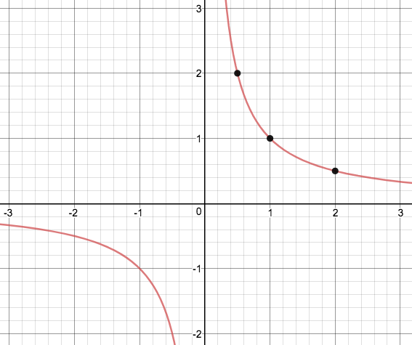 where *k* is a constant. In the simplest case, $k=1$, which is what I will assume here. The graph of the reciprocal function is shown in Figure 1. Three example ordered pairs are shown in Table 1 and highlighted as points in the graph. As is shown in the graph and table, as *x* increases, *f(x)* decreases, approaching zero. In other words, as $x→∞, f\left(x\right)→0.$ Thus, for large values of *x* the

Figure : Graph of the reciprocal function, showing three example points

|  |  |
| --- | --- |
| *x* | *f(x)* |
| $$\frac{1}{2}$$ | 2 |
| 1 | 1 |
| 2 |  |

Table : Three ordered pairs of the reciprocal function

reciprocal function approaches a straight, horizontal line, an asymptote, $y=0.$ All four “legs” of the reciprocal function have similar “end behavior.” End behavior is “the appearance of a graph as it is followed further and further in either direction” (142). Algebraically,

$$x→-∞, f\left(x\right)→0$$

Therefore, the four legs of the parent reciprocal function approach two asymptotes,

This can also be seen graphically in Figure 1. The legs straighten out and approach the asymptotes, but never touch them.

**Translations of the reciprocal function**

Translation, horizontally 3 to the right, vertically 2 upward

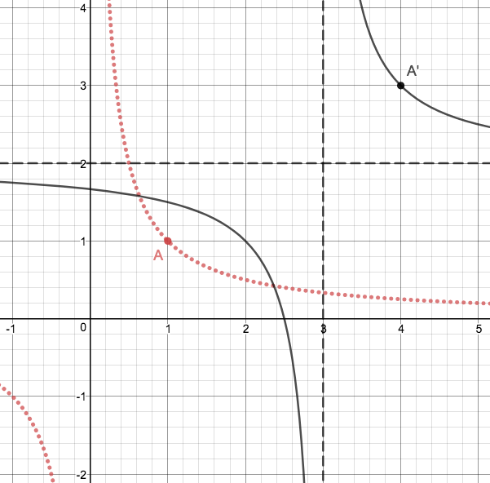

The inverse function

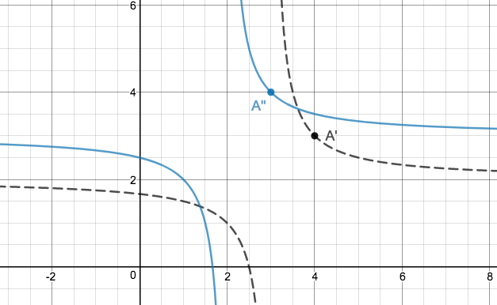

Works Cited

Buchanan, Laurie, et al. *Mathematics Standard Level: Course Companion*. Oxford, 2012.