Homework: Mixed practice, extended-response (76 marks). ***Paper 1, No Calculator***

**1a.** A line  passes through the points  and .

(i) Show that 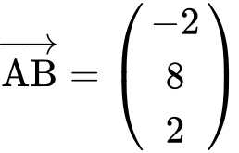.

(ii) Write down a vector equation for . *[3 marks]*

**1b.** A line  has equation 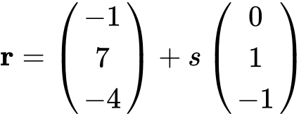. The lines  and  intersect at a point .

Show that the coordinates of  are . *[5 marks]*

**1c.** A point  lies on line  so that 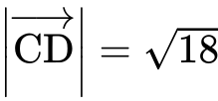 and 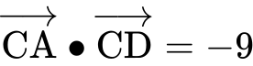. Find . *[7 marks]*

**2a.** Let  and 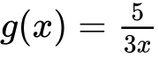, for .

Find . *[2 marks]*

**2b.** Show that 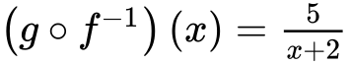. *[2 marks]*

**2c.** Let 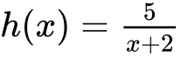, for . The graph of *h* has a horizontal asymptote at .

Find the -intercept of the graph of . *[2 marks]*

**2d.** Hence, sketch the graph of . *[3 marks]*

**2e.** For the graph of , write down the -intercept; *[1 mark]*

**2f.** For the graph of , write down the equation of the vertical asymptote. *[1 mark]*

**2g.** Given that , find the value of . *[3 marks]*

**3a.** Consider  .

Find the value of  . *[2 marks]*

**3b.** Find the set of values of  for which  is increasing. *[5 marks]*

**3c.** The second derivative is given by 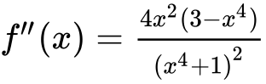 .

The equation  has only three solutions, when  ,   .

(i) Find  .

(ii) **Hence**, show that there is no point of inflexion on the graph of  at  . *[5 marks]*

**3d.** There is a point of inflexion on the graph of  at   .

Sketch the graph of  , for  . *[3 marks]*

**4a.** Jar A contains three red marbles and five green marbles. Two marbles are drawn from the jar, one after the other, without replacement.

Find the probability that

(i) none of the marbles are green;

(ii) exactly one marble is green. *[5 marks]*

**4b.** Find the expected number of green marbles drawn from the jar. *[3 marks]*

**4c.** Jar B contains six red marbles and two green marbles. A fair six-sided die is tossed. If the score is  or , a marble is drawn from jar A. Otherwise, a marble is drawn from jar B.

(i) Write down the probability that the marble is drawn from jar B.

(ii) Given that the marble was drawn from jar B, write down the probability that it is red. *[2 marks]*

**4d.** Given that the marble is red, find the probability that it was drawn from jar A. *[6 marks]*

**5a.** Let  , for  .

Find  . *[3 marks]*

**5b.** Let  be a quadratic function such that  . The line  is the axis of symmetry of the graph of  .

Find  . *[3 marks]*

**5c.** The function  can be expressed in the form  .

(i) Write down the value of  .

(ii) Find the value of  . *[4 marks]*

**5d.** Find the value of  for which the tangent to the graph of  is parallel to the tangent to the graph of  . *[6 marks]*