BECA / Huson / 12.1 IB Math SL Name:

31 October 2017

**Homework: Calculus exam problems**

**1a.** Let , for  x  . The following diagram shows the graph of , the derivative of .

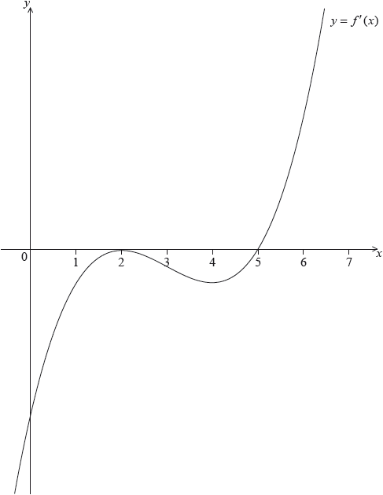

The graph of  has a local maximum when , a local minimum when , and it crosses the *-*axis at the point .

Explain why the graph of  has a local minimum when . *[2 marks]*

**1b.** Find the set of values of  for which the graph of  is concave down. *[2 marks]*

**2a.** A function  has its derivative given by , where  is a constant.

Find . *[2 marks]*

**2b.** The graph of  has a point of inflexion when .

Show that . *[3 marks]*

**2c.** Find . *[2 marks]*

**2d.** Find the equation of the tangent to the curve of  at , giving your answer in the form . *[4 marks]*

**2e.** Given that , explain why the graph of  has a local maximum when . *[3 marks]*

**3a.** *[2 marks]*

Let 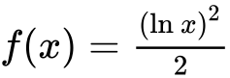, for .

Show that .

**3b.** *[3 marks]*

There is a minimum on the graph of . Find the -coordinate of this minimum.

**3c.** *[2 marks]*

Let . The following diagram shows parts of the graphs of  and *g*.

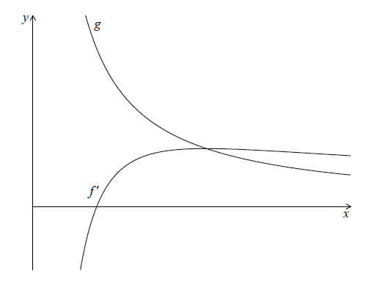

The graph of  has an *x*-intercept at .

Write down the value of .

**3d.** *[3 marks]*

The graph of  intersects the graph of  when .

Find the value of .

**3e.** *[5 marks]*

The graph of  intersects the graph of  when .

Let  be the region enclosed by the graph of , the graph of  and the line .

Show that the area of  is .

**4a.** *[2 marks]*

Consider  .

Find the value of  .

**4b.** *[5 marks]*

Find the set of values of  for which  is increasing.

**4c.** *[5 marks]*

The second derivative is given by 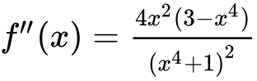 .

The equation  has only three solutions, when  ,   .

(i) Find  .

(ii) **Hence**, show that there is no point of inflexion on the graph of  at  .

**4d.** *[3 marks]*

There is a point of inflexion on the graph of  at   .

Sketch the graph of  , for  .

Printed for Bronx Early College Academy

© International Baccalaureate Organization 2017

International Baccalaureate® - Baccalauréat International® - Bachillerato Internacional®