BECA / Huson / 12.1 IB Math SL Name:

17 November 2017

**Homework: Calculus review - Markscheme**

**1.** *[7 marks]*

Let 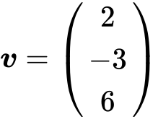 and 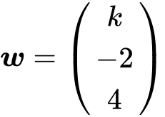 , for  . The angle between ***v*** and ***w*** is  .

Find the value of  .

## Markscheme

correct substitutions for  ;  ;  ***(A1)(A1)(A1)***

e.g.  ,  ; 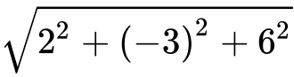 ,  ; 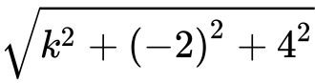 , 

evidence of substituting into the formula for scalar product ***(M1)***

e.g. 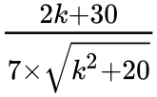

correct substitution ***A1***

e.g. 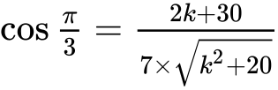

 ***A2 N5***

***[7 marks]***

## Examiners report

For the most part, this question was well done and candidates had little difficulty finding the scalar product, the appropriate magnitudes and then correctly substituting into the formula for the angle between vectors. However, few candidates were able to solve the resulting equation using their GDCs to obtain the correct answer. Problems arose when candidates attempted to solve the resulting equation analytically.

**2a.** *[3 marks]*

The following diagram shows the obtuse-angled triangle ABC such that 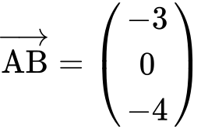 and 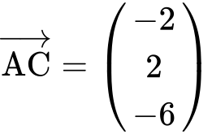 .

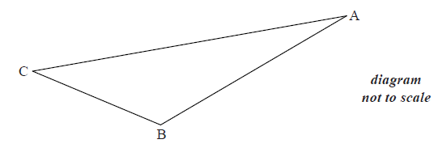

(i) Write down  .

(ii) Find  .

## Markscheme

(i) 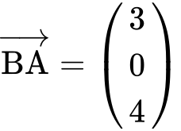 ***A1 N1***

(ii) evidence of combining vectors ***(M1)***

e.g. 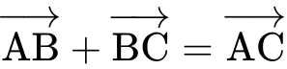 , 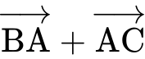 , 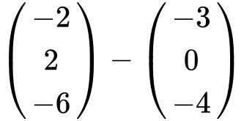

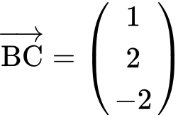 ***A1 N2***

***[3 marks]***

## Examiners report

Many candidates answered (a) correctly, although some reversed the vectors when finding  , while others miscopied the vectors from the question paper.

**2b.** *[7 marks]*

(i) Find  .

(ii) Hence, find  .

## Markscheme

(i) **METHOD 1**

finding 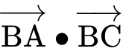 , 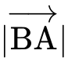 , 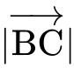

e.g. 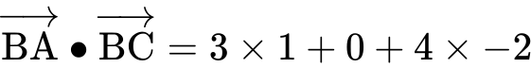 , 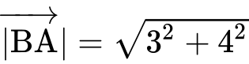 , 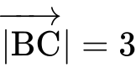

substituting into formula for  ***M1***

e.g. 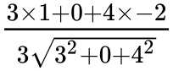 , 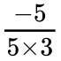

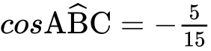 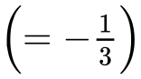 ***A1 N3***

**METHOD 2**

finding 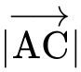 , 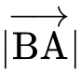 ,  ***(A1)(A1)(A1)***

e.g. 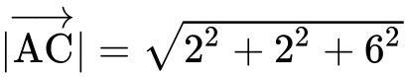 , 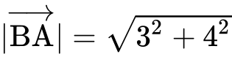 , 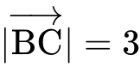

substituting into cosine rule ***M1***

e.g. 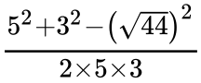 , 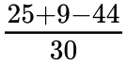

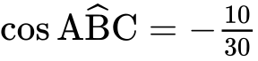  ***A1 N3***

(ii) evidence of using Pythagoras ***(M1)***

e.g. right-angled triangle with values, 

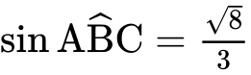 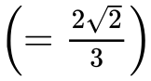 ***A1 N2***

***[7 marks]***

## Examiners report

Students had no difficulty finding the scalar product and magnitudes of the vectors used in finding the cosine. However, few recognized that  is the vector to apply in the formula to find the cosine value. Most used  to obtain a positive cosine, which neglects that the angle is obtuse and thus has a negative cosine. Surprisingly few students could then take a value for cosine and use it to find a value for sine. Most left (bii) blank entirely.

**2c.** *[6 marks]*

The point D is such that 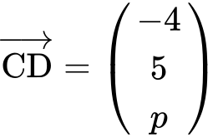 , where  .

(i) Given that 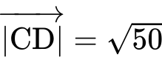 , show that  .

(ii) Hence, show that 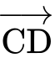 is perpendicular to  .

## Markscheme

(i) attempt to find an expression for 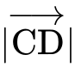 ***(M1)***

e.g. 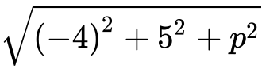 , 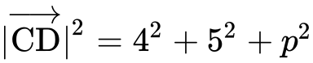

correct equation ***A1***

e.g. 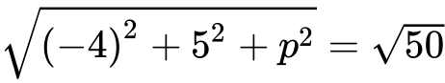 , 

 ***A1***

 ***AG N0***

(ii) evidence of scalar product ***(M1)***

e.g. 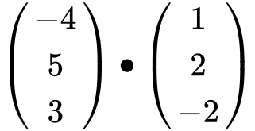 , 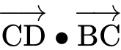

correct substitution

e.g.  ,  ***A1***

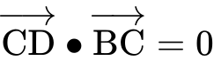 ***A1***

 is perpendicular to  ***AG N0***

***[6 marks]***

## Examiners report

Part (c) proved accessible for many candidates. Some created an expression for  and then substituted the given  to obtain  , which does not satisfy the "show that" instruction. Many students recognized that the scalar product must be zero for vectors to be perpendicular, and most provided the supporting calculations.

**3.** *[6 marks]*

Let . The line  is the tangent to the curve of  at .

Find the equation of  in the form .

## Markscheme

recognising need to differentiate (seen anywhere) ***R1***

*eg* 

attempt to find the gradient when  ***(M1)***

*eg* 

 ***(A1)***

attempt to substitute coordinates (in any order) into equation of a straight line ***(M1)***

*eg* 

correct working ***(A1)***

*eg* 

 ***A1 N3***

***[6 marks]***

**4a.** *[2 marks]*

Let 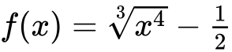.

Find .

## Markscheme

expressing  as  ***(M1)***

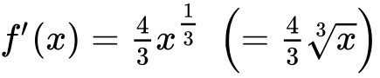 ***A1 N2***

***[2 marks]***

**4b.** *[4 marks]*

Find .

## Markscheme

attempt to integrate  ***(M1)***

*eg* 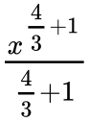

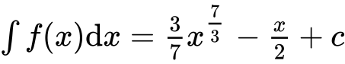 ***A1A1A1 N4***

***[4 marks]***

**5a.** *[3 marks]*

The population of deer in an enclosed game reserve is modelled by the function , where  is in months, and  corresponds to 1 January 2014.

Find the number of deer in the reserve on 1 May 2014.

## Markscheme

 ***(A1)***

correct substitution into formula ***(A1)***

*eg* 



969 (deer) (must be an integer) ***A1 N3***

***[3 marks]***

**5b.** *[2 marks]*

Find the rate of change of the deer population on 1 May 2014.

## Markscheme

evidence of considering derivative ***(M1)***

*eg* 



 (deer per month) ***A1 N2***

***[2 marks]***

**5c.** *[1 mark]*

Interpret the answer to part (i) with reference to the deer population size on 1 May 2014.

## Markscheme

(the deer population size is) **increasing** ***A1 N1***

***[1 mark]***

**6a.** *[2 marks]*

Let 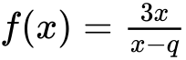, where .

Write down the equations of the vertical and horizontal asymptotes of the graph of .

## Markscheme

 (must be equations) ***A1A1 N2***

***[2 marks]***

**6b.** *[2 marks]*

The vertical and horizontal asymptotes to the graph of  intersect at the point .

Find the value of .

## Markscheme

recognizing connection between point of intersection and asymptote ***(R1)***

*eg* 

 ***A1 N2***

***[2 marks]***

**6c.** *[4 marks]*

The vertical and horizontal asymptotes to the graph of  intersect at the point .

The point  lies on the graph of . Show that 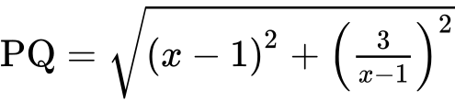.

## Markscheme

correct substitution into distance formula ***A1***

*eg* 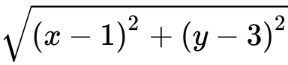

attempt to substitute 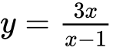 ***(M1)***

*eg* 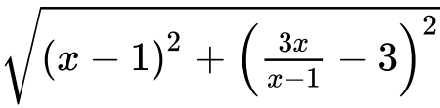

correct simplification of 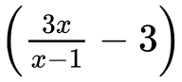 ***(A1)***

*eg* 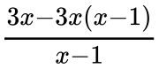

correct expression clearly leading to the required answer ***A1***

*eg* 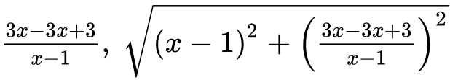

 ***AG N0***

***[4 marks]***

**6d.** *[6 marks]*

The vertical and horizontal asymptotes to the graph of  intersect at the point .

Hence find the coordinates of the points on the graph of  that are closest to .

## Markscheme

recognizing that closest is when  is a minimum ***(R1)***

*eg* sketch of , 

 (seen anywhere) ***A1A1***

attempt to find *y*-coordinates ***(M1)***

*eg* 



 ***A1A1 N4***

***[6 marks]***

**7a.** *[6 marks]*

The following diagram shows the graph of , for .

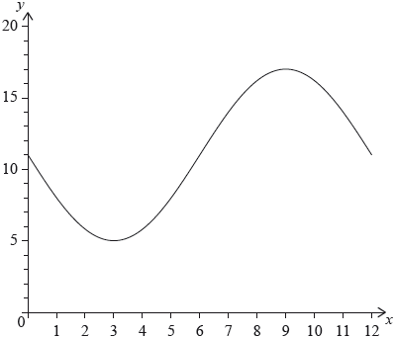

The graph of  has a minimum point at  and a maximum point at .

(i) Find the value of .

(ii) Show that .

(iii) Find the value of .

## Markscheme

(i) valid approach ***(M1)***

*eg*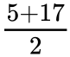

 ***A1 N2***

(ii) valid approach ***(M1)***

*eg*period is 12, per 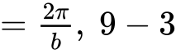

 ***A1***

 ***AG N0***

(iii) **METHOD 1**

valid approach ***(M1)***

*eg*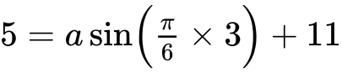, substitution of points

 ***A1 N2***

**METHOD 2**

valid approach ***(M1)***

*eg*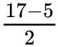, amplitude is 6

 ***A1 N2***

***[6 marks]***

**7b.** *[3 marks]*

The following diagram shows the graph of , for .



The graph of  has a minimum point at  and a maximum point at .

The graph of  is obtained from the graph of  by a translation of 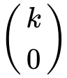. The maximum point on the graph of  has coordinates .

(i) Write down the value of .

(ii) Find .

## Markscheme

(i)  ***A1 N1***

(ii) 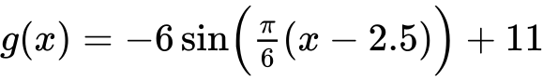 ***A2 N2***

***[3 marks]***

**7c.** *[6 marks]*

The following diagram shows the graph of , for .



The graph of  has a minimum point at  and a maximum point at .

The graph of  changes from concave-up to concave-down when .

(i) Find .

(ii) Hence or otherwise, find the maximum positive rate of change of .

## Markscheme

(i) **METHOD 1** Using 

recognizing that a point of inflexion is required ***M1***

*eg*sketch, recognizing change in concavity

evidence of valid approach ***(M1)***

*eg*, sketch, coordinates of max/min on 

 (exact) ***A1 N2***

**METHOD 2** Using 

recognizing that a point of inflexion is required ***M1***

*eg*sketch, recognizing change in concavity

evidence of valid approach involving translation ***(M1)***

*eg*, sketch, 

 (exact) ***A1 N2***

(ii) valid approach involving the derivative of  or  (seen anywhere) ***(M1)***

*eg*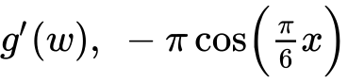, max on derivative, sketch of derivative

attempt to find max value on derivative ***M1***

*eg*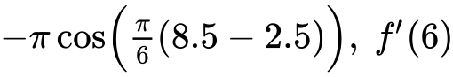, dot on max of sketch

3.14159

max rate of change  (exact), 3.14 ***A1 N2***

***[6 marks]***

**8a.** *[2 marks]*

Line  passes through points  and  .

Find  .

## Markscheme

appropriate approach ***(M1)***

e.g. 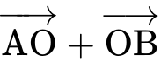 , 

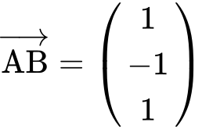 ***A1 N2***

***[2 marks]***

## Examiners report

Finding  was generally well done, although some candidates reversed the subtraction.

**8b.** *[2 marks]*

Find an equation for  in the form  .

## Markscheme

any correct equation in the form  ***A2 N2***

where  is a scalar multiple of 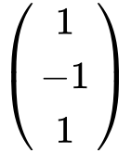

e.g. 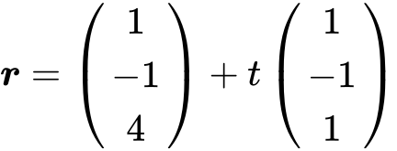 , 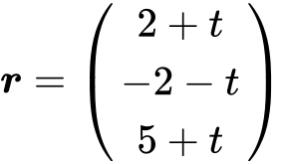 , 

***[2 marks]***

## Examiners report

In part (b) not all the candidates recognized that  was the direction vector of the line, as some used the position vector of point B as the direction vector.

**8c.** *[7 marks]*

Line  has equation 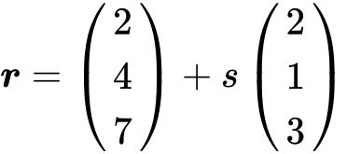 .

Find the angle between  and  .

## Markscheme

choosing correct direction vectors 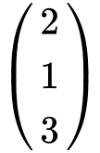 ,   ***(A1)(A1)***

finding scalar product and magnitudes ***(A1)(A1)(A1)***

scalar product  

magnitudes 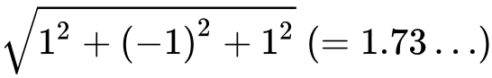 , 

substitution into 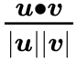 (accept 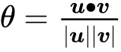 , but not 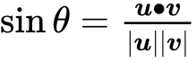 ) ***M1***

e.g. 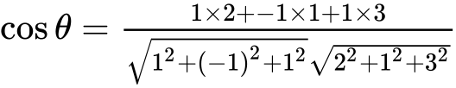 , 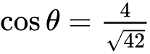

  ***A1 N5***

***[7 marks]***

## Examiners report

Many candidates successfully used scalar product and magnitudes in part (c), although a large number did choose vectors other than the direction vectors and many did not state clearly which vectors they were using.

**8d.** *[6 marks]*

The lines  and  intersect at point C. Find the coordinates of C.

## Markscheme

**METHOD 1** (from  )

appropriate approach ***(M1)***

e.g.  , 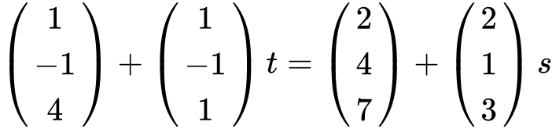

two **correct** equations ***A1A1***

e.g.  ,  , 

attempt to solve ***(M1)***

one correct parameter ***A1***

e.g.  , 

C is  ***A1 N3***

**METHOD 2** (from 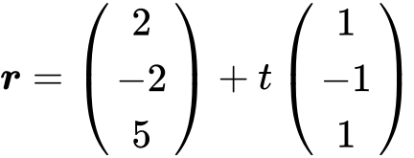 )

appropriate approach ***(M1)***

e.g.  , 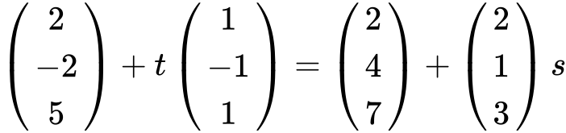

two **correct** equations ***A1A1***

e.g.  ,  , 

attempt to solve  ***(M1)***

one correct parameter ***A1***

e.g.  , 

C is  ***A1 N3***

***[6 marks]***

## Examiners report

Candidates who were comfortable on the first three parts often had little difficulty with the final part. While the resulting systems were easily solved algebraically, a surprising number of candidates did not check their solutions either manually or with technology. An occasionally seen error in the final part was using a midpoint to find C. Some candidates found the point of intersection in part (c) rather than in part (d), indicating a familiarity with the type of question but a lack of understanding of the concepts involved.

**9a.** *[6 marks]*

The diagram below shows part of the graph of  .

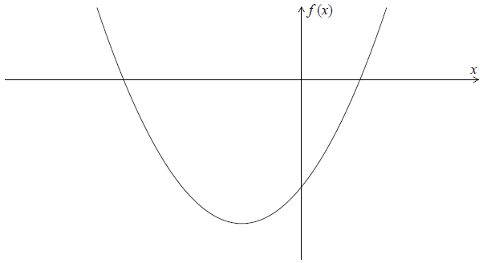

(a) Write down the -intercepts of the graph of  .

(b) Find the coordinates of the vertex of the graph of  .

## Markscheme

(a)  ,  (accept (, ), (, ) ) ***A1A1 N2***

***[2 marks]***

(b) **METHOD 1**

attempt to find -coordinate ***(M1)***

*eg* 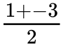 , 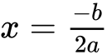 , 

correct value,  (may be seen as a coordinate in the answer) ***A1***

attempt to find **their** -coordinate ***(M1)***

*eg*  ,  , 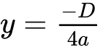

 ***A1***

vertex (, ) ***N3***

**METHOD 2**

attempt to complete the square ***(M1)***

*eg* 

attempt to put into vertex form ***(M1)***

*eg*  , 

vertex (, ) ***A1A1 N3***

***[4 marks]***

## Examiners report

Most candidates recognized the values of the x-intercepts from the factorized form of the function. Candidates also showed little difficulty finding the vertex of the graph, and employed a variety of techniques: averaging -intercepts, using  , completing the square.

**9b.** *[2 marks]*

Write down the -intercepts of the graph of  .

## Markscheme

 ,  (accept (, ), (, ) ) ***A1A1 N2***

***[2 marks]***

## Examiners report

Most candidates recognized the values of the x-intercepts from the factorized form of the function. Candidates also showed little difficulty finding the vertex of the graph, and employed a variety of techniques: averaging -intercepts, using  , completing the square.

**9c.** *[4 marks]*

Find the coordinates of the vertex of the graph of  .

## Markscheme

**METHOD 1**

attempt to find -coordinate ***(M1)***

*eg*  ,  , 

correct value,  (may be seen as a coordinate in the answer) ***A1***

attempt to find **their** -coordinate ***(M1)***

*eg*  ,  , 

 ***A1***

vertex (, ) ***N3***

**METHOD 2**

attempt to complete the square ***(M1)***

*eg* 

attempt to put into vertex form ***(M1)***

*eg*  , 

vertex (, ) ***A1A1 N3***

***[4 marks]***

## Examiners report

Most candidates recognized the values of the x-intercepts from the factorized form of the function. Candidates also showed little difficulty finding the vertex of the graph, and employed a variety of techniques: averaging -intercepts, using  , completing the square.

**10a.** *[3 marks]*

Let  , for  .

Find  .

## Markscheme

 ***A1A1A1 N3***

**Note**: Award ***A1*** for each term.

***[3 marks]***

## Examiners report

In part (a), most candidates were able to correctly find the derivative of the function.

**10b.** *[3 marks]*

Let  be a quadratic function such that  . The line  is the axis of symmetry of the graph of  .

Find  .

## Markscheme

recognizing  gives the point (, ) ***(R1)***

recognize symmetry  ***(M1)***

*eg* vertex, sketch

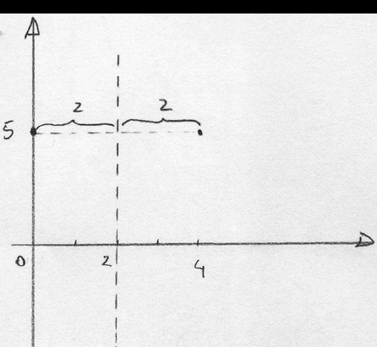

 ***A1 N3***

***[3 marks]***

## Examiners report

In part (b), many candidates did not understand the significance of the axis of symmetry and the known point (, ), and so were unable to find  using symmetry. A few used more complicated manipulations of the function, but many algebraic errors were seen.

**10c.** *[4 marks]*

The function  can be expressed in the form  .

(i) Write down the value of  .

(ii) Find the value of  .

## Markscheme

(i)   ***A1 N1***

(ii) substituting into  (not the vertex) ***(M1)***

*eg*   , 

working towards solution ***(A1)***

*eg*   , 

 ***A1 N2***

***[4 marks]***

## Examiners report

In part (c), a large number of candidates were able to simply write down the correct value of , as intended by the command term in this question. A few candidates wrote down the incorrect negative value. Most candidates attempted to substitute the  and  values of the known point correctly into the function, but again many arithmetic and algebraic errors kept them from finding the correct value for .

**10d.** *[6 marks]*

Find the value of  for which the tangent to the graph of  is parallel to the tangent to the graph of  .

## Markscheme



correct derivative of  ***A1A1***

*eg*   , 

evidence of equating both derivatives ***(M1)***

*eg*  

correct equation ***(A1)***

*eg*  

working towards a solution ***(A1)***

*eg*   , combining like terms

 ***A1 N0***

**Note**: Do not award final ***A1*** if additional values are given.

***[6 marks]***

## Examiners report

Part (d) required the candidates to find the derivative of , and to equate that to their answer from part (a). Although many candidates were able to simplify their equation to , many did not know how to solve for  at this point. Candidates who had made errors in parts (a) and/or (c) were still able to earn follow-through marks in part (d).