# 1213 Pretest Vector + calculus and review

**1a.** *[2 marks]*

Line  passes through points  and  .

Find  .

## Markscheme

appropriate approach ***(M1)***

e.g. 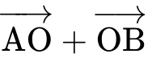 , 

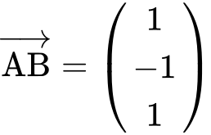 ***A1 N2***

***[2 marks]***

**1b.** *[2 marks]*

Find an equation for  in the form  .

## Markscheme

any correct equation in the form  ***A2 N2***

where  is a scalar multiple of 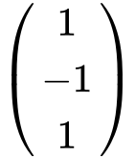

e.g. 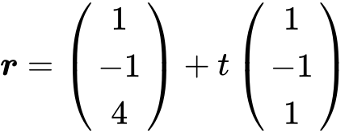 , 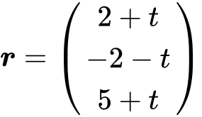 , 

***[2 marks]***

**1c.** *[7 marks]*

Line  has equation 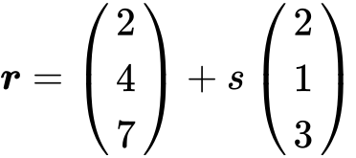 .

Find the angle between  and  .

## Markscheme

choosing correct direction vectors 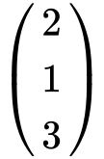 , 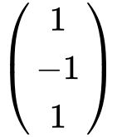  ***(A1)(A1)***

finding scalar product and magnitudes ***(A1)(A1)(A1)***

scalar product  

magnitudes 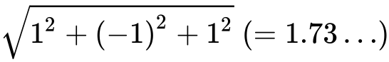 , 

substitution into 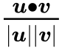 (accept 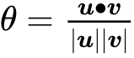 , but not 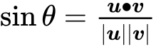 ) ***M1***

e.g. 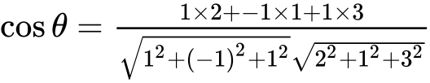 , 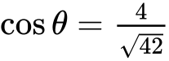

  ***A1 N5***

***[7 marks]***

**1d.** *[6 marks]*

The lines  and  intersect at point C. Find the coordinates of C.

## Markscheme

**METHOD 1** (from 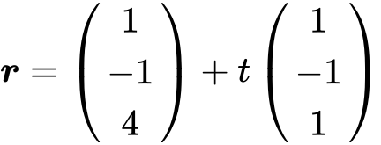 )

appropriate approach ***(M1)***

e.g.  , 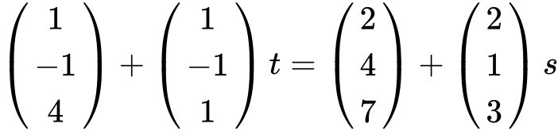

two **correct** equations ***A1A1***

e.g.  ,  , 

attempt to solve ***(M1)***

one correct parameter ***A1***

e.g.  , 

C is  ***A1 N3***

**METHOD 2** (from 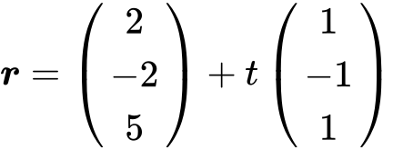 )

appropriate approach ***(M1)***

e.g.  , 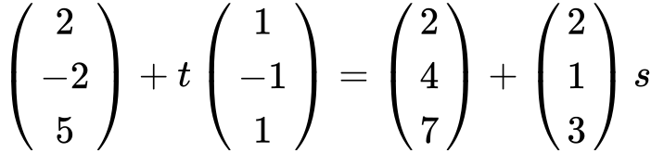

two **correct** equations ***A1A1***

e.g.  ,  , 

attempt to solve  ***(M1)***

one correct parameter ***A1***

e.g.  , 

C is  ***A1 N3***

***[6 marks]***

**2a.** *[5 marks]*

The diagram shows quadrilateral ABCD with vertices A(1, 0), B(1, 5), C(5, 2) and D(4, −1) .

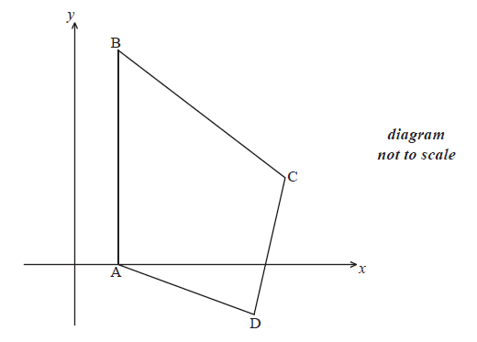

(i) Show that 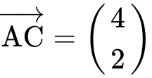 .

(ii) Find  .

(iii) Show that  is perpendicular to  .

## Markscheme

(i) correct approach ***A1***

e.g. 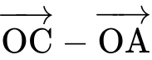 , 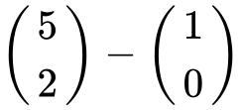

 ***AG N0***

(ii) appropriate approach ***(M1)***

e.g.  , 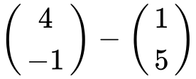 , move 3 to the right and 6 down

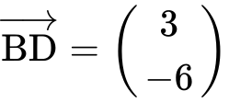 ***A1 N2***

(iii) finding the scalar product ***A1***

e.g.  , 

valid reasoning ***R1***

e.g.  , scalar product is zero

 is perpendicular to  ***AG N0***

***[5 marks]***

**2b.** *[4 marks]*

The line (AC) has equation  .

(i) Write down vector ***u*** and vector ***v*** .

(ii) Find a vector equation for the line (BD).

## Markscheme

(i) correct “position” vector for ***u***; “direction” vector for ***v*** ***A1A1 N2***

e.g. 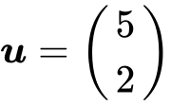 , 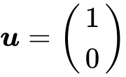 ; 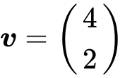 , 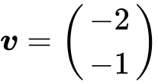

accept in equation e.g. 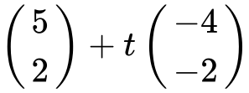

(ii) any correct equation in the form  , where 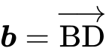

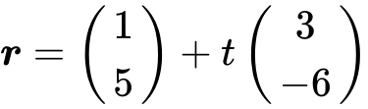 , 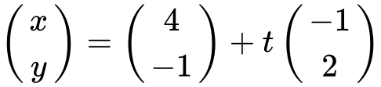 ***A2 N2***

***[4 marks]***

**2c.** *[3 marks]*

The lines (AC) and (BD) intersect at the point  .

Show that  .

## Markscheme

**METHOD 1**

substitute (3, *k*) into equation for (AC) or (BD) ***(M1)***

e.g.  , 

value of *t* or *s* ***A1***

e.g.  ,  , 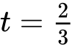 , 

substituting ***A1***

e.g. 

 ***AG N0***

**METHOD 2**

setting up two equations ***(M1)***

e.g.  ,  ; setting vector equations of lines equal

value of *t* or *s* ***A1***

e.g.  ,  , 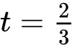 , 

substituting ***A1***

e.g. 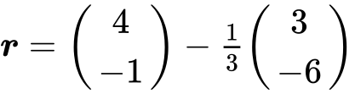

 ***AG N0***

***[3 marks]***

**2d.** *[5 marks]*

The lines (AC) and (BD) intersect at the point  .

**Hence** find the area of triangle ACD.

## Markscheme

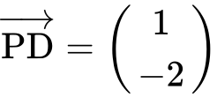 ***(A1)***

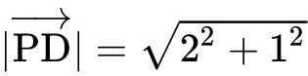  ***(A1)***

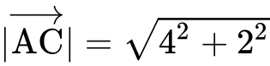  ***(A1)***

area 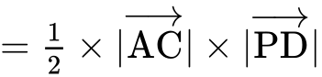 () ***M1***

 ***A1 N4***

***[5 marks]***

**3.** *[7 marks]*

Let 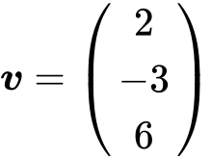 and 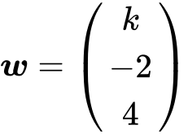 , for  . The angle between ***v*** and ***w*** is  .

Find the value of  .

## Markscheme

correct substitutions for  ;  ;  ***(A1)(A1)(A1)***

e.g.  ,  ; 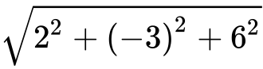 ,  ; 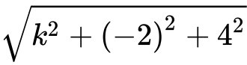 , 

evidence of substituting into the formula for scalar product ***(M1)***

e.g. 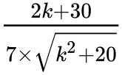

correct substitution ***A1***

e.g. 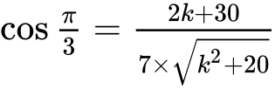

 ***A2 N5***

***[7 marks]***

**4a.** *[2 marks]*

The line  is represented by the vector equation 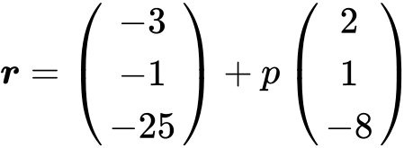 .

A second line  is parallel to  and passes through the point B(, , ) .

Write down a vector equation for  in the form  .

## Markscheme

any correct equation in the form  (accept any parameter) ***A2 N2***

e.g. 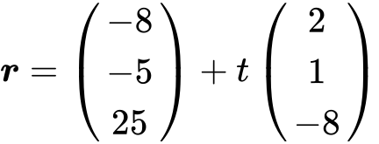

**Note**: Award ***A1*** for  , ***A1*** for  , ***A0*** for  .

***[2 marks]***

**4b.** *[5 marks]*

A third line  is perpendicular to  and is represented by 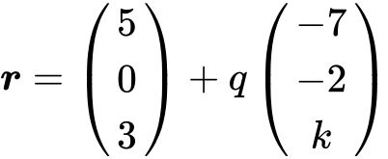 .

Show that  .

## Markscheme

recognizing scalar product must be zero (seen anywhere) ***R1***

e.g. 

evidence of choosing direction vectors 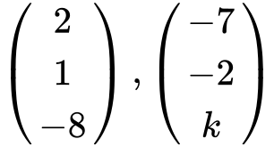 ***(A1)(A1)***

correct calculation of scalar product ***(A1)***

e.g. 

simplification that clearly leads to solution ***A1***

e.g.  , 

 ***AG N0***

***[5 marks]***

**4c.** *[6 marks]*

The lines  and  intersect at the point A.

Find the coordinates of A.

## Markscheme

evidence of equating vectors ***(M1)***

e.g.  , 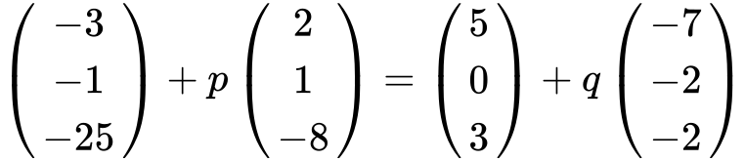

any **two** correct equations ***A1A1***

e.g.  ,  , 

attempting to solve equations ***(M1)***

finding **one** correct parameter ( ,  )  ***A1***

the coordinates of A are  ***A1 N3***

***[6 marks]***

**4d.** *[5 marks]*

The lines and intersect at point C where 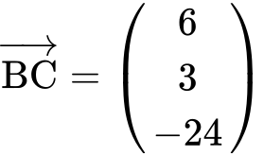 .

(i) Find  .

(ii) Hence, find 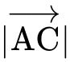 .

## Markscheme

(i) evidence of appropriate approach ***(M1)***

e.g. 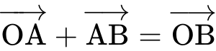 , 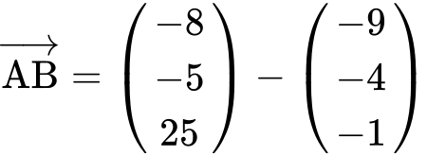

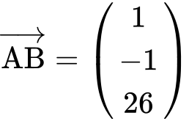 ***A1 N2***

(ii) finding 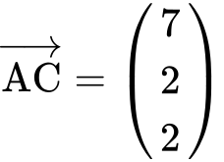 ***A1***

evidence of finding magnitude ***(M1)***

e.g. 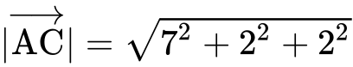

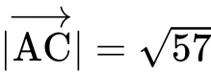 ***A1 N3***

***[5 marks]***

**5a.** *[2 marks]*

Let 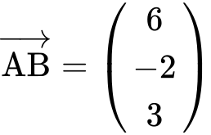 and 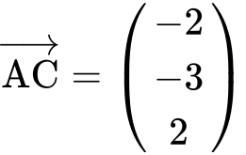 .

Find  .

## Markscheme

evidence of appropriate approach ***(M1)***

e.g. 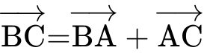 , 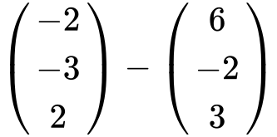

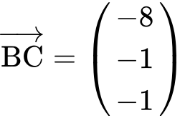 ***A1 N2***

***[2 marks]***

**5b.** *[3 marks]*

Find a unit vector in the direction of  .

## Markscheme

attempt to find the length of  ***(M1)***

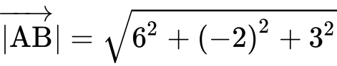  ***(A1)***

unit vector is 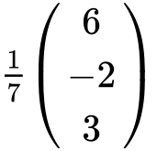 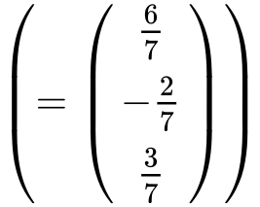 ***A1 N2***

***[3 marks]***

**5c.** *[3 marks]*

Show that  is perpendicular to  .

## Markscheme

recognizing that the dot product or  being 0 implies perpendicular ***(M1)***

correct substitution in a scalar product formula ***A1***

e.g.  , 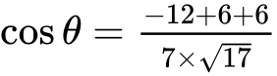

correct calculation ***A1***

e.g. 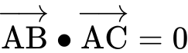 , 

therefore, they are perpendicular ***AG N0***

***[3 marks]***

**6a.** *[4 marks]*

*In this question, distance is in metres.*

Toy airplanes fly in a straight line at a constant speed. Airplane 1 passes through a point A.

Its position, *p* seconds after it has passed through A, is given by 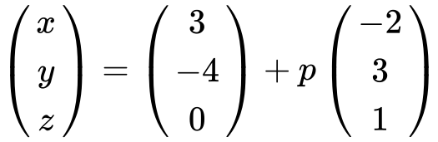 .

(i) Write down the coordinates of A.

(ii) Find the speed of the airplane in .

## Markscheme

(i) (3, , 0) ***A1 N1***

(ii) choosing velocity vector 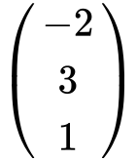 ***(M1)***

finding magnitude of velocity vector ***(A1)***

e.g. 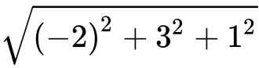 , 

speed   ***A1 N2***

***[4 marks]***

**6b.** *[5 marks]*

After seven seconds the airplane passes through a point B.

(i) Find the coordinates of B.

(ii) Find the distance the airplane has travelled during the seven seconds.

## Markscheme

(i) substituting  ***(M1)***

 ***A1 N2***

(ii) **METHOD 1**

appropriate method to find  or  ***(M1)***

e.g. 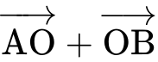 , 

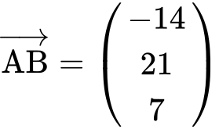 or 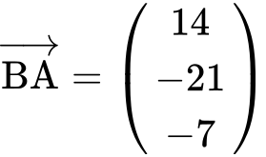  ***(A1)***

distance   ***A1 N3***

**METHOD 2**

evidence of applying distance is speed × time ***(M2)***

e.g. 

distance   ***A1 N3***

**METHOD 3**

attempt to find AB2 , AB ***(M1)***

e.g.  , 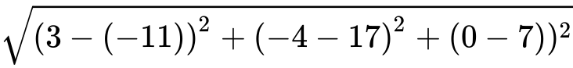

AB2 , AB  ***(A1)***

distance AB   ***A1 N3***

***[5 marks]***

**6c.** *[7 marks]*

Airplane 2 passes through a point C. Its position *q* seconds after it passes through C is given by 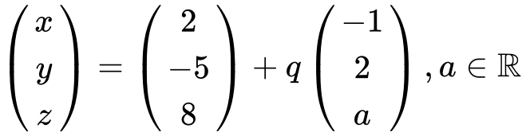 .

The angle between the flight paths of Airplane 1 and Airplane 2 is  . Find the two values of *a*.

## Markscheme

correct direction vectors 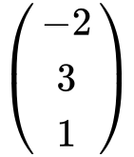 and 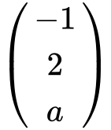 ***(A1)(A1)***

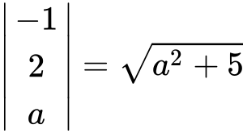 , 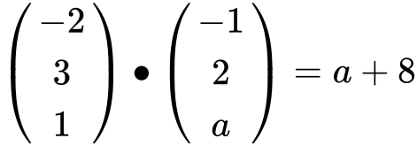 ***(A1)(A1)***

substituting ***M1***

e.g. 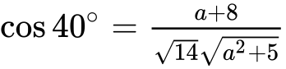

 ,  ***A1A1 N3***

***[7 marks]***

**7a.** *[5 marks]*

Let 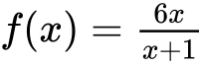 , for  .

Find  .

## Markscheme

**METHOD 1**

evidence of choosing quotient rule  ***(M1)***

e.g. 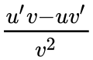

evidence of correct differentiation (must be seen in quotient rule) ***(A1)(A1)***

e.g. 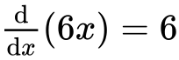 , 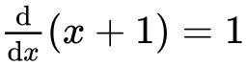

correct substitution into quotient rule ***A1***

e.g. 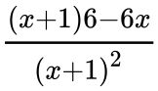 , 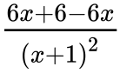

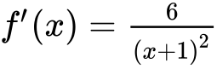 ***A1 N4***

***[5 marks]***

**METHOD 2**

evidence of choosing product rule ***(M1)***

e.g.  , 

evidence of correct differentiation (must be seen in product rule)  ***(A1)(A1)***

e.g.  , 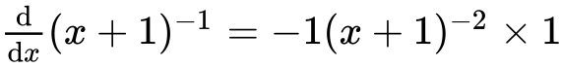

correct working ***A1***

e.g.  , 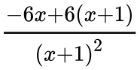

 ***A1 N4***

***[5 marks]***

**7b.** *[4 marks]*

Let 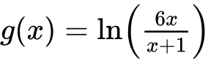 , for  .

Show that 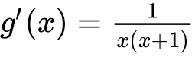 .

## Markscheme

**METHOD 1**

evidence of choosing chain rule ***(M1)***

e.g. formula, 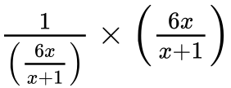

correct reciprocal of 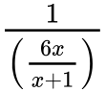 is 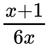 (seen anywhere) ***A1***

correct substitution into chain rule ***A1***

e.g. 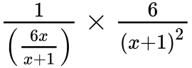 , 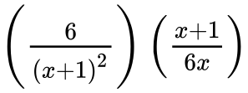

working that clearly leads to the answer ***A1***

e.g. 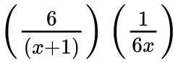 , 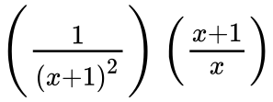 , 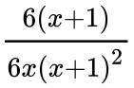

 ***AG N0***

***[4 marks]***

**METHOD 2**

attempt to subtract logs ***(M1)***

e.g.  , 

correct derivatives (must be seen in correct expression) ***A1A1***

e.g. 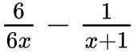 , 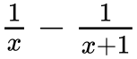

working that clearly leads to the answer ***A1***

e.g. 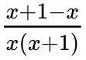 , 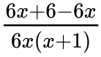 , 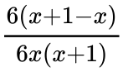

 ***AG N0***

***[4 marks]***

**7c.** *[7 marks]*

Let 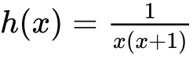 . The area enclosed by the graph of *h* , the *x*-axis and the lines 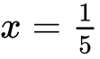 and  is  . Given that 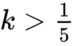 , find the value of *k* .

## Markscheme

valid method using integral of *h*(*x*) (accept missing/incorrect limits or missing  )  ***(M1)***

e.g. 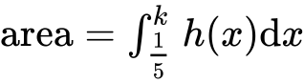 , 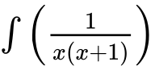

recognizing that integral of derivative will give original function ***(R1)***

e.g. 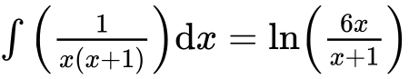

correct substitution and subtraction ***A1***

e.g. 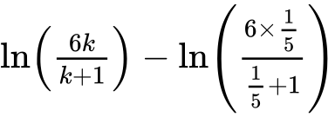 , 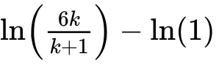

setting **their** expression equal to  ***(M1)***

e.g. 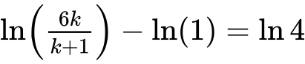 , 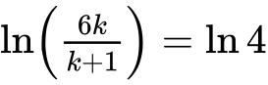 , 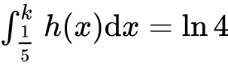

correct equation without logs  ***A1***

e.g.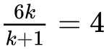 , 

correct working  ***(A1)***

e.g.  , 

 ***A1 N4***

***[7 marks]***

**8a.** *[2 marks]*

Part of the graph of  is shown below.

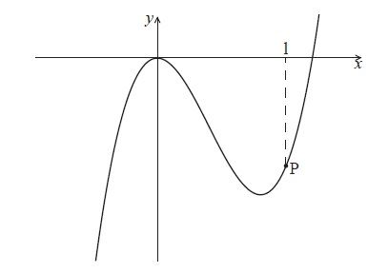

The point P lies on the graph of  . At P, *x* = 1.

Find  .

## Markscheme

 ***A1A1 N2***

**Note:** Award ***A1***for each correct term.

***[2 marks]***

**8b.** *[4 marks]*

The graph of  has a gradient of  at the point P. Find the value of  .

## Markscheme

setting their derivative equal to 3 (seen anywhere) ***A1***

e.g. 

attempt to substitute  into  ***(M1)***

e.g. 

correct substitution into  ***(A1)***

e.g.  , 

 ***A1 N2***

***[4 marks]***

**9a.** *[3 marks]*

In this question, you are given that 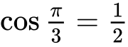 , and 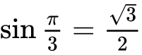 .

The displacement of an object from a fixed point, O is given by  for  .

Find  .

## Markscheme

 ***A1A2 N3***

**Note**: Award ***A1*** for 1, ***A2*** for  .

***[3 marks]***

**9b.** *[4 marks]*

In this interval, there are only two values of *t* for which the object is not moving. One value is  .

Find the other value.

## Markscheme

evidence of valid approach ***(M1)***

e.g. setting 

correct working ***A1***

e.g.  , 

 ,  ,  ***(A1)***

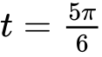 ***A1 N3***

***[4 marks]***

**9c.** *[3 marks]*

Show that  between these two values of *t* .

## Markscheme

evidence of valid approach ***(M1)***

e.g. choosing a value in the interval 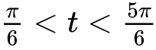

correct substitution ***A1***

e.g. 

 ***A1***

 ***AG N0***

***[3 marks]***

**9d.** *[5 marks]*

Find the distance travelled between these two values of *t* .

## Markscheme

evidence of approach using *s* or integral of  ***(M1)***

e.g.  ; 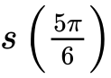 , 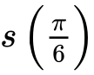 ; 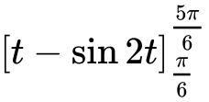

substituting values and subtracting ***(M1)***

e.g. 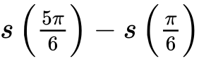 , 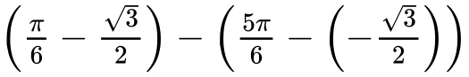

correct substitution ***A1***

e.g. 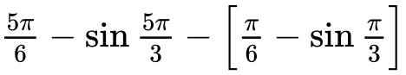 , 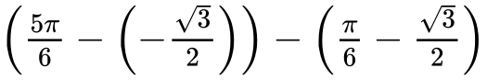

distance is 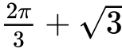 ***A1A1 N3***

**Note**: Award ***A1*** for  , ***A1*** for  .

***[5 marks]***

**10a.** *[1 mark]*

Let  .

Write down  .

## Markscheme

 ***A1 N1***

***[1 mark]***

**10b.** *[4 marks]*

The tangent to the graph of *f* at the point  has gradient *m* .

(i) Show that  .

(ii) Find *b* .

## Markscheme

(i) evidence of valid approach ***(M1)***

e.g.  , 

correct manipulation ***A1***

e.g.  , 

 ***AG N0***

(ii) evidence of finding   ***(M1)***

e.g. 

 ***A1 N2***

***[4 marks]***

**10c.** *[1 mark]*

Hence, write down the equation of this tangent.

## Markscheme

 ***A1 N1***

***[1 mark]***

**11a.** *[6 marks]*

Let 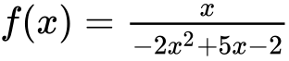 for  ,  ,  . The graph of  is given below.

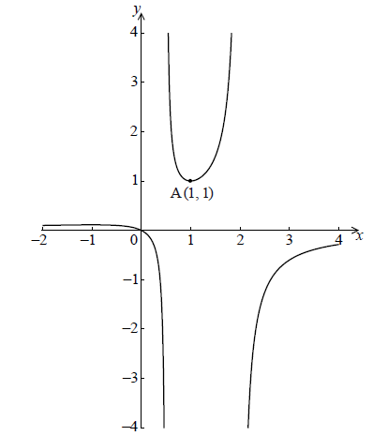

The graph of  has a local minimum at A(, ) and a local maximum at B.

Use the quotient rule to show that 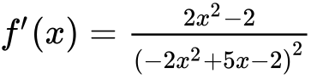 .

## Markscheme

correct derivatives **applied** in quotient rule ***(A1)A1A1***

, 

**Note:** Award ***(A1)*** for 1, ***A1*** for  and ***A1*** for , **only** if it is clear candidates are using the quotient rule.

correct substitution into quotient rule ***A1***

*e.g.* 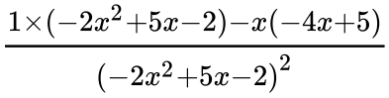 , 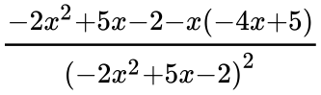

correct working ***(A1)***

*e.g.* 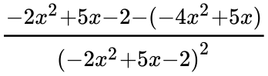

expression clearly leading to the answer ***A1***

*e.g.* 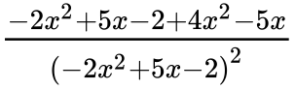

 ***AG N0***

***[6 marks]***

**11b.** *[7 marks]*

Hence find the coordinates of B.

## Markscheme

evidence of attempting to solve  ***(M1)***

e.g. 

evidence of correct working ***A1***

e.g. 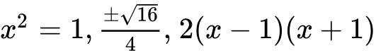

correct solution to quadratic ***(A1)***

e.g. 

correct *x*-coordinate  (may be seen in coordinate form 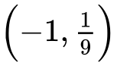 ) ***A1 N2***

attempt to substitute  into *f* (do not accept any other value) ***(M1)***

e.g. 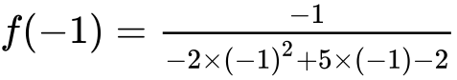

correct working

e.g. 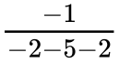 ***A1***

correct *y*-coordinate 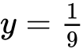 (may be seen in coordinate form  ) ***A1 N2***

***[7 marks]***

**11c.** *[3 marks]*

Given that the line  does not meet the graph of *f* , find the possible values of *k* .

## Markscheme

recognizing values between max and min ***(R1)***

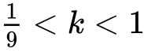 ***A2 N3***

***[3 marks]***

**12a.** *[2 marks]*

The following diagram shows part of the graph of a quadratic function .

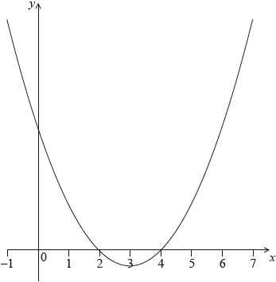

The vertex is at  and the -intercepts at 2 and 4.

The function  can be written in the form .

Write down the value of  and of .

## Markscheme

 ***A1A1 N2***

***[2 marks]***

**12b.** *[2 marks]*

The function can also be written in the form .

Write down the value of  and of .

## Markscheme

 ***A1A1 N2***

***[2 marks]***

**12c.** *[2 marks]*

Find the -intercept.

## Markscheme

attempt to substitute  into their  ***(M1)***

*eg*

 ***A1 N2***

***[2 marks]***

**13.** *[6 marks]*

Three consecutive terms of a geometric sequence are , 6 and .

Find the possible values of .

## Markscheme

**METHOD 1**

valid approach ***(M1)***

*eg*

correct equation in terms of  only ***A1***

*eg*

correct working ***(A1)***

*eg*

valid attempt to solve **their** quadratic equation ***(M1)***

*eg*factorizing, formula, completing the square

evidence of correct working ***(A1)***

*eg*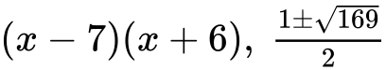

 ***A1 N4***

**METHOD 2 (finding *r* first)**

valid approach ***(M1)***

*eg*

correct equation in terms of  only ***A1***

*eg*

evidence of correct working ***(A1)***

*eg*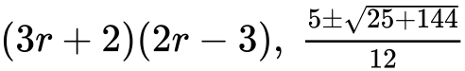

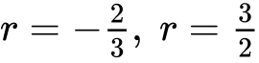 ***A1***

substituting their values of  to find  ***(M1)***

*eg*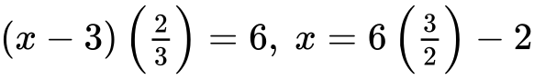

 ***A1 N4***

***[6 marks]***

**14a.** *[3 marks]*

Let  and , for .

Solve .

## Markscheme

valid approach ***(M1)***

*eg* sketch

0, 1.73843

 ***A1A1 N3***

***[3 marks]***

**14b.** *[3 marks]*

Find the area of the region enclosed by the graphs of  and .

## Markscheme

integrating and subtracting functions (in any order) ***(M1)***

*eg*

correct substitution of their limits **or** function (accept missing )

***(A1)***

*eg*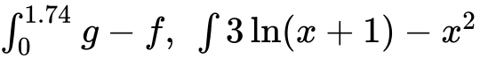

**Note:** Do not award ***A1*** if there is an error in the substitution.

1.30940

1.31 ***A1 N3***

***[3 marks]***

**15a.** *[3 marks]*

A population of rare birds, , can be modelled by the equation , where  is the initial population, and  is measured in decades. After one decade, it is estimated that 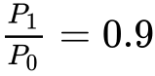.

(i) Find the value of .

(ii) Interpret the meaning of the value of .

## Markscheme

(i) valid approach ***(M1)***

*eg*



 ***A1 N2***

(ii) correct interpretation ***R1 N1***

*eg*population is decreasing, growth rate is negative

***[3 marks]***

**15b.** *[5 marks]*

Find the least number of **whole** years for which 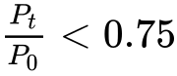.

## Markscheme

**METHOD 1**

valid approach (accept an equality, but do not accept 0.74) ***(M1)***

*eg*

valid approach to solve **their** inequality ***(M1)***

*eg*logs, graph

 ***A1***

28 years ***A2 N2***

**METHOD 2**

valid approach which gives both crossover values accurate to at least 2 sf ***A2***

*eg*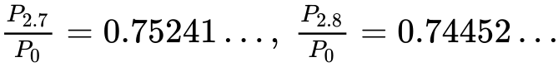

 ***(A1)***

28 years ***A2 N2***

***[5 marks]***

**16a.** *[4 marks]*

The price of a used car depends partly on the distance it has travelled. The following table shows the distance and the price for seven cars on 1 January 2010.

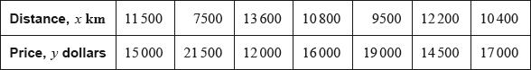

The relationship between  and  can be modelled by the regression equation .

(i) Find the correlation coefficient.

(ii) Write down the value of  and of .

## Markscheme

**Note:** There may be slight differences in answers, depending on which values candidates carry through in subsequent parts. Accept answers that are consistent with their working.

(i) valid approach ***(M1)***

*eg*correct value for  (or for  or  seen in (ii))



 ***A1 N2***

(ii) 

 ***A1A1 N2***

***[4 marks]***

**16b.** *[3 marks]*

On 1 January 2010, Lina buys a car which has travelled .

Use the regression equation to estimate the price of Lina’s car, giving your answer to the nearest 100 dollars.

## Markscheme

**Note:** There may be slight differences in answers, depending on which values candidates carry through in subsequent parts. Accept answers that are consistent with their working.

correct substitution into **their** regression equation

*eg* ***(A1)***

 ***(A1)***

 (must be rounded to the nearest 100 dollars) ***A1 N3***

***[3 marks]***

**16c.** *[4 marks]*

The price of a car decreases by 5% each year.

Calculate the price of Lina’s car after 6 years.

## Markscheme

**Note:** There may be slight differences in answers, depending on which values candidates carry through in subsequent parts. Accept answers that are consistent with their working.

**METHOD 1**

valid approach ***(M1)***

*eg*

 (may be seen in their expression) ***(A1)***

correct expression ***(A1)***

*eg*



 ***A1 N2***

**METHOD 2**

attempt to find all six terms ***(M1)***

*eg*, table of values

5 correct values (accept values that round correctly to the nearest dollar)

 ***A2***



 ***A1 N2***

***[4 marks]***

**16d.** *[4 marks]*

Lina will sell her car when its price reaches dollars.

Find the year when Lina sells her car.

## Markscheme

**Note:** There may be slight differences in answers, depending on which values candidates carry through in subsequent parts. Accept answers that are consistent with their working.

**METHOD 1**

correct equation ***(A1)***

*eg*

valid attempt to solve ***(M1)***

*eg*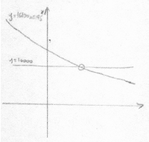, using logs

9.28453 ***(A1)***

year 2019 ***A1 N2***

**METHOD 2**

valid approach using table of values ***(M1)***

**both** crossover values (accept values that round correctly to the nearest dollar) ***A2***

*eg*

year 2019 ***A1 N2***

***[4 marks]***

**17a.** *[2 marks]*

Let 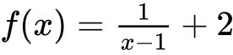, for .

Write down the equation of the horizontal asymptote of the graph of .

## Markscheme

 (correct equation only) ***A2 N2***

***[2 marks]***

**17b.** *[2 marks]*

Find .

## Markscheme

valid approach ***(M1)***

*eg*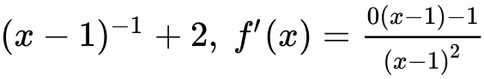

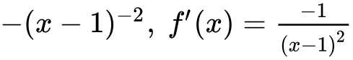 ***A1 N2***

***[2 marks]***

**17c.** *[2 marks]*

Let , for . The graphs of  and  have the same horizontal asymptote.

Write down the value of .

## Markscheme

correct equation for the asymptote of 

*eg* ***(A1)***

 ***A1 N2***

***[2 marks]***

**17d.** *[4 marks]*

Given that , find the value of .

## Markscheme

correct derivative of *g* (seen anywhere) ***(A2)***

*eg*

correct equation ***(A1)***

*eg*

7.38905

 ***A1 N2***

***[4 marks]***

**17e.** *[4 marks]*

There is a value of , for , for which the graphs of  and  have the same gradient. Find this gradient.

## Markscheme

attempt to equate **their** derivatives ***(M1)***

*eg*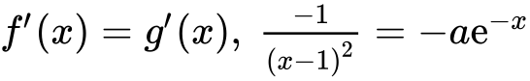

valid attempt to solve **their** equation ***(M1)***

*eg*correct value outside the domain of  such as 0.522 or 4.51,

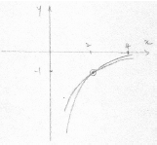

correct solution (may be seen in sketch) ***(A1)***

*eg*

gradient is  ***A1 N3***

***[4 marks]***

**18a.** *[3 marks]*

Let , for .

Find .

## Markscheme

interchanging  and  (seen anywhere) ***(M1)***

*eg*

evidence of correct manipulation ***(A1)***

*eg*

 ***A1 N2***

**Notes:** If working shown, and they do not interchange  and , award ***A1A1M0*** for .

If no working shown, award ***N1*** for .

|  |
| --- |
|  |

**18b.** *[3 marks]*

Let  be a function so that . Find .

## Markscheme

**METHOD 1**

attempt to form composite (in any order) ***(M1)***

*eg*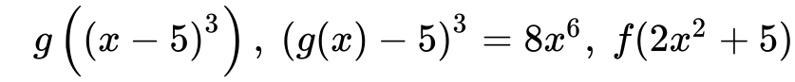

correct working ***(A1)***

*eg*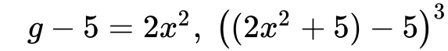

 ***A1 N2***

**METHOD 2**

recognising inverse relationship ***(M1)***

*eg*

correct working

*eg* ***(A1)***

 ***A1 N2***

**19a.** *[2 marks]*

The following diagram shows part of the graph of a quadratic function .

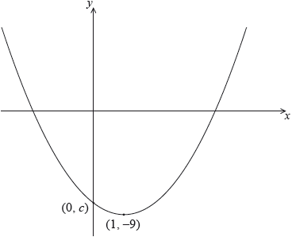

The vertex is at , and the graph crosses the *y*-axis at the point .

The function can be written in the form .

Write down the value of  and of .

## Markscheme

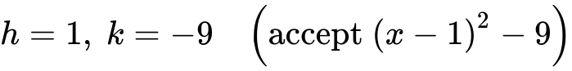 ***A1A1 N2***

***[2 marks]***

**19b.** *[5 marks]*

Let . The graph of  is obtained by a reflection of the graph of  in the -axis, followed by a translation of 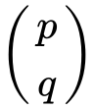.

Find the value of  and of .

## Markscheme

evidence of correct reflection ***A1***

*eg*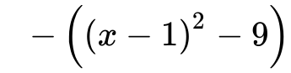, vertex at , *y*-intercept at 

valid attempt to find horizontal shift ***(M1)***

*eg*

 ***A1 N2***

valid attempt to find vertical shift ***(M1)***

*eg*

 ***A1 N2***

**Notes:** An error in finding the reflection may still allow the correct values of  and  to be found, as the error may not affect subsequent working. In this case, award ***A0*** for the reflection, ***M1A1*** for , and ***M1A1*** for .

If no working shown, award ***N0*** for .

***[5 marks]***

**20a.** *[2 marks]*

Let , for . The following diagram shows part of the graph of .

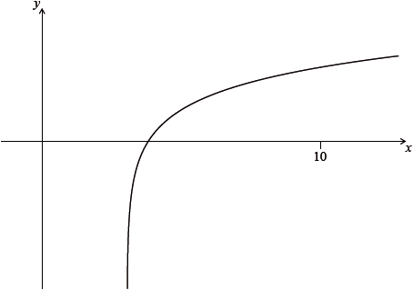

Find the equation of the vertical asymptote to the graph of .

## Markscheme

valid approach ***(M1)***

*eg*horizontal translation  units to the right

 (must be an equation) ***A1 N2***

***[2 marks]***

**20b.** *[2 marks]*

Find the -intercept of the graph of .

## Markscheme

valid approach ***(M1)***

*eg*

 ***A1 N2***

***[2 marks]***

**20c.** *[3 marks]*

The region enclosed by the graph of , the -axis and the line  is rotated ° about the -axis. Find the volume of the solid formed.

## Markscheme

attempt to substitute either **their correct** limits or the function into formula involving  ***(M1)***

*eg*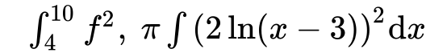



volume =  ***A2 N3***

***[3 marks]***

***Total [7 marks]***

**21a.** *[2 marks]*

The first three terms of a geometric sequence are , and .

Find the value of .

## Markscheme

valid approach ***(M1)***

*eg*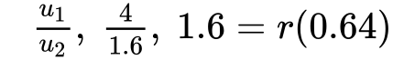

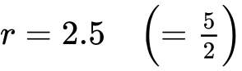 ***A1 N2***

***[2 marks]***

**21b.** *[2 marks]*

Find the value of .

## Markscheme

correct substitution into  ***(A1)***

*eg*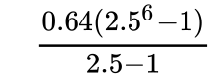

 (exact),  ***A1 N2***

***[2 marks]***

**21c.** *[3 marks]*

Find the least value of  such that .

## Markscheme

**METHOD 1 (analytic)**

valid approach ***(M1)***

*eg*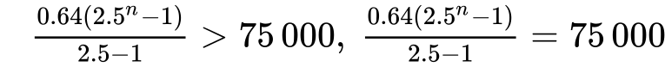

correct inequality (accept equation) ***(A1)***

*eg*

 ***A1 N1***

**METHOD 2 (table of values)**

**both** crossover values ***A2***

*eg*

 ***A1 N1***

***[3 marks]***

***Total [7 marks]***

Printed for Bronx Early College Academy

© International Baccalaureate Organization 2018

International Baccalaureate® - Baccalauréat International® - Bachillerato Internacional®