Homework: Trig free response questions

**1.** Solve the equation  , for  . *[7 marks]*

**2a.** Let 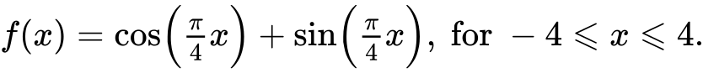

Sketch the graph of . *[3 marks]*

**2b.** Find the values of  where the function is decreasing. *[5 marks]*

**2c.** The function  can also be written in the form 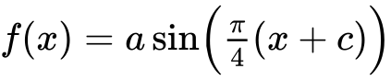, where , and . Find the value of ; *[3 marks]*

**2d.** The function  can also be written in the form , where , and . Find the value of . *[4 marks]*

**3a.** The following diagram shows the graph of a function .

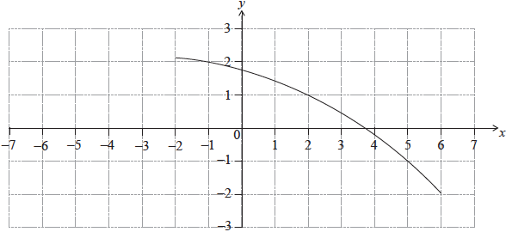

Find . *[2 marks]*

**3b.** Find . *[3 marks]*

**3c.** On the same diagram, sketch the graph of . *[2 marks]*

**4a.** *[3 marks]*

The following diagram shows a circular play area for children.

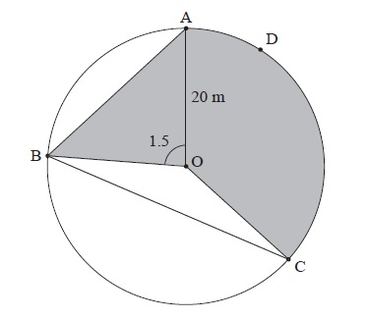

The circle has centre O and a radius of 20 m, and the points A, B, C and D lie on the circle. Angle AOB is 1.5 radians.

Find the length of the chord [AB].

**4b.** *[2 marks]*

Find the area of triangle AOB.

**4c.** *[3 marks]*

Angle BOC is 2.4 radians.

Find the length of arc ADC.

**4d.** *[3 marks]*

Angle BOC is 2.4 radians.

Find the area of the shaded region.

**4e.** *[4 marks]*

Angle BOC is 2.4 radians.

The shaded region is to be painted red. Red paint is sold in cans which cost  each. One can covers . How much does it cost to buy the paint?