**Unit test:** Integration as the area under a curve, volumes of rotation (46 marks)

**1a.** Consider a function  such that 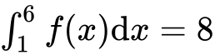. Find 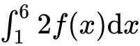. *[2 marks]*

**1b.** Find 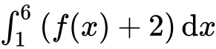. *[4 marks]*

**2a.** Find 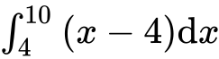 . *[4 marks]*

**2b.** Part of the graph of  , for  , is shown below. The shaded region *R* is enclosed by the graph of  , the line  , and the *x*-axis.

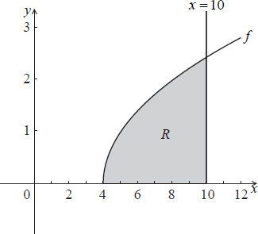

Find the area of the shaded region. *[3 marks]*

**3.** The following diagram shows the graph of 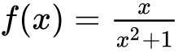, for , and the line .

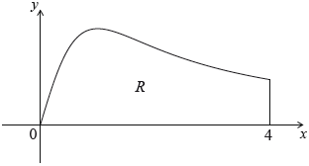

Let  be the region enclosed by the graph of  , the -axis and the line .

Find the area of . *[6 marks]*

**4a.** Let  and , for .

Solve . *[3 marks]*

**4b.** Find the area of the region enclosed by the graphs of  and . *[3 marks]*

**5.** Let , for     . The following diagram shows the graph of .

There are -intercepts at .

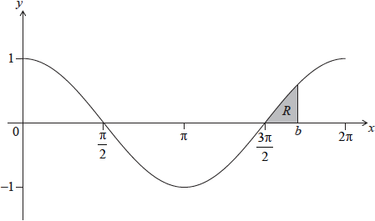

The shaded region  is enclosed by the graph of , the line , where , and the -axis. The area of  is 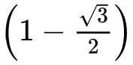. Find the value of . *[8 marks]*

**6a.** A particle P moves along a straight line. Its velocity  after  seconds is given by , for . The following diagram shows the graph of .

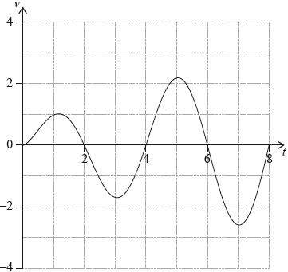

Write down the first value of  at which P changes direction. *[1 mark]*

**6b.** Find the **total** distance travelled by P, for . *[2 marks]*

**6c.** A second particle Q also moves along a straight line. Its velocity,  after  seconds is given by  for . After  seconds Q has travelled the same total distance as P.

Find . *[4 marks]*

**7a.** **All lengths in this question are in metres.**

Let , for . Mark uses  as a model to create a barrel. The region enclosed by the graph of , the -axis, the line  and the line  is rotated 360° about the -axis. This is shown in the following diagram.

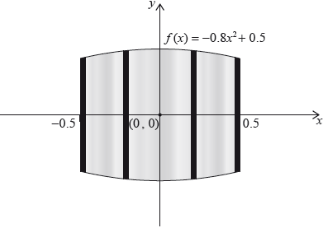

Use the model to find the volume of the barrel. *[3 marks]*

**7b.** The empty barrel is being filled with water. The volume  of water in the barrel after  minutes is given by . How long will it take for the barrel to be half-full? *[3 marks]*