**Homework: Integration exam problems**

**1a.** Let , for . The graph of  passes through the point , where .

Find the value of . *[2 marks]*

**1b.** The following diagram shows part of the graph of .

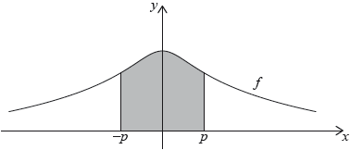

The region enclosed by the graph of , the -axis and the lines  and  is rotated 360° about the -axis. Find the volume of the solid formed. *[3 marks]*

**2a.** Find . *[4 marks]*

**2b.** Find , given that  and . *[3 marks]*

**3.** Let 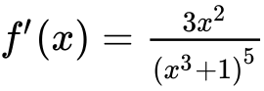. Given that , find . *[6 marks]*

**4.** Let . Find , given that 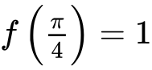. *[7 marks]*

**5a.** Let  and .

The graphs of  and  intersect at  and , where .

Find the value of  and of . *[3 marks]*

**5b.** Hence, find the area of the region enclosed by the graphs of  and . *[3 marks]*

**6a.** A particle P moves along a straight line. Its velocity  after  seconds is given by , for . The following diagram shows the graph of .

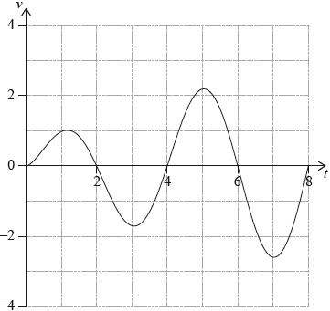

Write down the first value of  at which P changes direction. *[1 mark]*

**6b.** Find the **total** distance travelled by P, for . *[2 marks]*

**6c.** A second particle Q also moves along a straight line. Its velocity,  after  seconds is given by  for . After  seconds Q has travelled the same total distance as P.

Find . *[4 marks]*

**7a.** **All lengths in this question are in metres.**

Let , for . Mark uses  as a model to create a barrel. The region enclosed by the graph of , the -axis, the line  and the line  is rotated 360° about the -axis. This is shown in the following diagram.

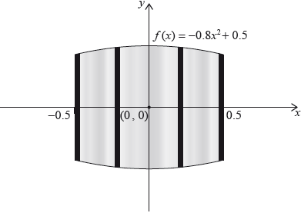

Use the model to find the volume of the barrel. *[3 marks]*

**7b.** The empty barrel is being filled with water. The volume  of water in the barrel after  minutes is given by . How long will it take for the barrel to be half-full? *[3 marks]*

**8a.** A particle P starts from a point A and moves along a horizontal straight line. Its velocity  after  seconds is given by

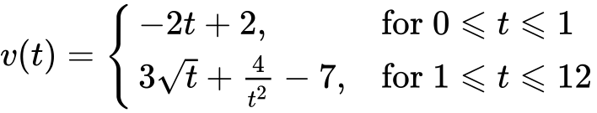

The following diagram shows the graph of .

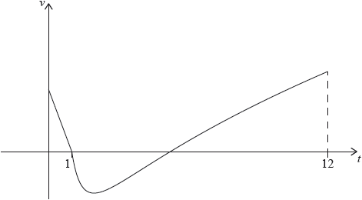

Find the initial velocity of . *[2 marks]*

**8b.** P is at rest when  and .

Find the value of . *[2 marks]*

**8c.** When , the acceleration of P is zero.

(i) Find the value of .

(ii) Hence, find the **speed** of P when . *[4 marks]*

**8d.** (i) Find the total distance travelled by P between  and .

(ii) Hence or otherwise, find the displacement of P from A when . *[6 marks]*

**9a.** The following diagram shows the graph of , for , where .

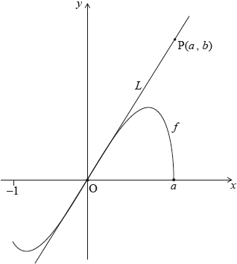

The line  is the tangent to the graph of  at the origin, O. The point  lies on .

(i) Given that 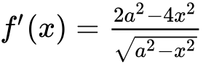, for , find the equation of .

(ii) Hence or otherwise, find an expression for  in terms of . *[6 marks]*

**9b.** The point  lies on the graph of . Let  be the region enclosed by the graph of  and the -axis. This information is shown in the following diagram. *[6 marks]*

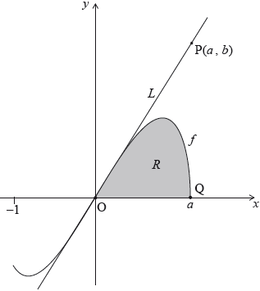

Let  be the area of the region .

Show that 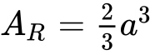.

**9c.** Let  be the area of the triangle OPQ. Given that , find the value of . *[4 marks]*