**Pretest**: Integration of solids from rotation

**1a.** Let , for . The following diagram shows part of the graph of .

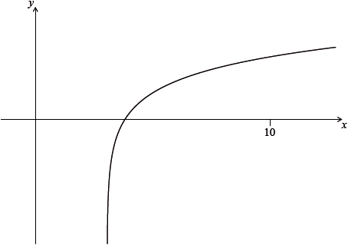

Find the equation of the vertical asymptote to the graph of . *[2 marks]*

**1b.** Find the -intercept of the graph of . *[2 marks]*

**1c.** The region enclosed by the graph of , the -axis and the line  is rotated ° about the -axis. Find the volume of the solid formed. *[3 marks]*

**2a.** Let , for .

Sketch the graph of . *[3 marks]*

**2b.** Solve . *[2 marks]*

**2c.** The region enclosed by the graph of  and the -axis is rotated  about the -axis.

Find the volume of the solid formed. *[3 marks]*

**3a.** Let . [no calculator on this problem]

Find 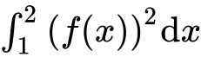. *[4 marks]*

**3b.** The following diagram shows part of the graph of .

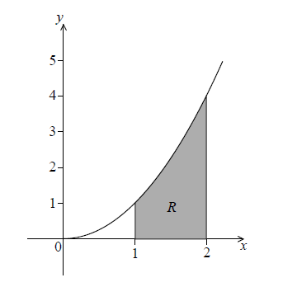

The shaded region is enclosed by the graph of , the -axis and the lines  and .

Find the volume of the solid formed when is revolved  about the -axis. *[2 marks]*

**4a.** Let . Part of the graph of is shown in the following diagram.

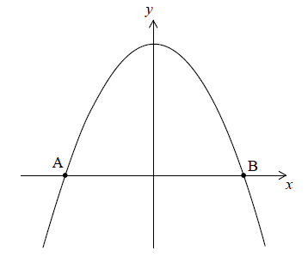

The graph crosses the -axis at the points  and .

Find the -coordinate of  and of . *[3 marks]*

**4b.** The region enclosed by the graph of  and the -axis is revolved  about the -axis.

Find the volume of the solid formed. *[3 marks]*

**5a.** The graph of  , for  , is shown below.

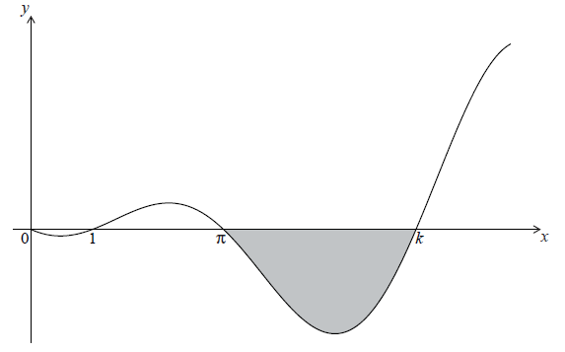

The graph has -intercepts at , ,  and  .

Find *k* . *[2 marks]*

**5b.** The shaded region is rotated  about the *x*-axis. Let *V* be the volume of the solid formed.

Write down an expression for *V* . *[3 marks]*

**5c.** Find *V* . *[2 marks]*

**6.** The graph of  , for  , is shown below. [no calculator on this problem]

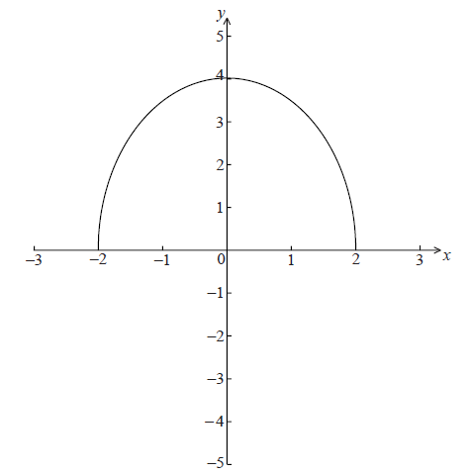

The region enclosed by the curve of *f* and the *x*-axis is rotated  about the *x*-axis.

Find the volume of the solid formed. *[6 marks]*

**7a.** Let  . Line *L* is the normal to the graph of *f* at the point (4, 2) . *]* [no calculator]

Show that the equation of *L* is  . *[4 marks*

**7b.** Point A is the *x*-intercept of *L* . Find the *x*-coordinate of A. *[2 marks]*

**7c.** In the diagram below, the shaded region *R* is bounded by the *x*-axis, the graph of *f* and the line *L* .

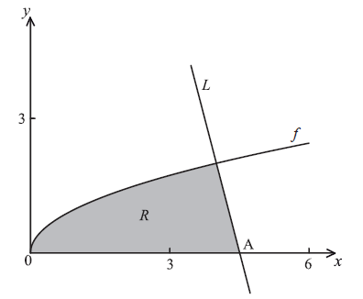

Find an expression for the area of *R* . *[3 marks]*

**7d.** The region *R* is rotated  about the *x*-axis. Find the volume of the solid formed, giving your answer in terms of  . *[8 marks]*

**8a.** Let  and , for .

Solve . *[3 marks]*

**8b.** Find the area of the region enclosed by the graphs of  and . *[3 marks]*