**Unit 5 Exam:** With calculator (early finishers) [40 marks]

**6a.** Let  , for  . The graph of *f* is shown below.

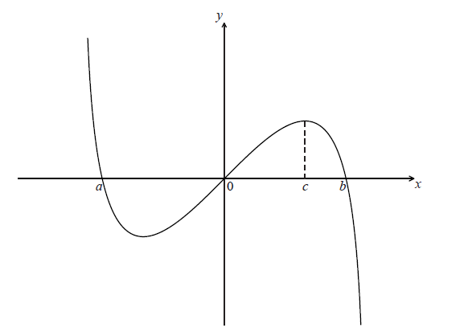

The graph of *f* crosses the *x*-axis at  ,  and  .

Find the value of *a* and of *b*. *[3 marks]*

**6b.** The graph of *f* has a maximum value when  .

Find the value of *c*. *[2 marks]*

**6c.** The region under the graph of *f* from  to  is rotated  about the *x*-axis. Find the volume of the solid formed. *[3 marks]*

**6d.** Let *R* be the region enclosed by the curve, the *x*-axis and the line  , between  and  .

Find the area of *R*. *[4 marks]*

**7a.** Let  ,  .

Show that  . *[3 marks]*

**7b.** Let the line *L* be the normal to the curve of *f* at  .

Find the equation of *L*. *[5 marks]*

**7c.** The graph of *f* and the line *L* intersect at the point (0, 1) and at a second point P.

(i)     Find the *x*-coordinate of P.

(ii)    Find the area of the region **enclosed** by the graph of *f* and the line *L*. *[6 marks]*

**8a.** The following diagram shows the graphs of  and  , for  .

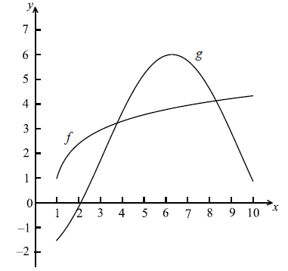

Let *A* be the area of the region **enclosed** by the curves of *f* and *g*.

(i)     Find an expression for *A*.

(ii)    Calculate the value of *A*. *[6 marks]*

**8b.** (i)     Find .

(ii)    Find . *[4 marks]*

**8c.** There are two values of *x* for which the gradient of *f* is equal to the gradient of *g*. Find both these values of *x*. *[4 marks]*