# 6-4-P1_Calculus-integration

**1a.** *[3 marks]*

Let  and , for .

Solve .

**1b.** *[3 marks]*

Find the area of the region enclosed by the graphs of  and .

**2a.** *[2 marks]*

Let . The graph of  is shown in the following diagram.

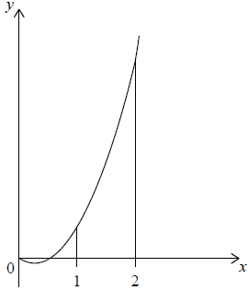

Find .

**2b.** *[4 marks]*

Find the area of the region enclosed by the graph of , the *x*-axis and the lines *x* = 1 and *x* = 2 .

**3.** *[6 marks]*

Let . Given that , find .

**4a.** *[2 marks]*

Consider a function  such that 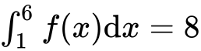.

Find 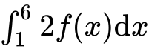.

**4b.** *[4 marks]*

Find 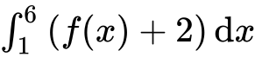.

**5a.** *[3 marks]*

Let  and .

The graphs of  and  intersect at  and , where .

Find the value of  and of .

**5b.** *[3 marks]*

Hence, find the area of the region enclosed by the graphs of  and .

**6a.** *[1 mark]*

Let *g*(*x*) = −(*x* − 1)2 + 5.

Write down the coordinates of the vertex of the graph of *g*.

**6b.** *[3 marks]*

Let *f*(*x*) = x2. The following diagram shows part of the graph of *f*.

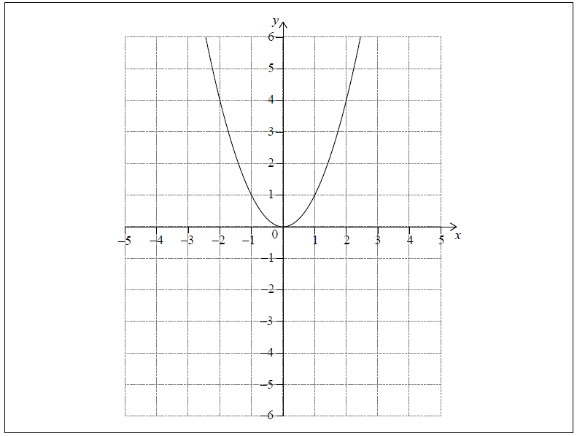

The graph of *g* intersects the graph of *f* at *x* = −1 and *x* = 2.

On the grid above, sketch the graph of g for −2 ≤ *x* ≤ 4.

**6c.** *[3 marks]*

Find the area of the region enclosed by the graphs of *f* and *g*.

**7.** *[6 marks]*

The graph of a function *h* passes through the point .

Given that , find .

**8a.** *[2 marks]*

Let , for . The graph of  passes through the point , where .

Find the value of .

**8b.** *[3 marks]*

The following diagram shows part of the graph of .

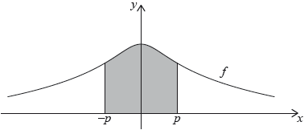

The region enclosed by the graph of , the -axis and the lines  and  is rotated 360° about the -axis. Find the volume of the solid formed.

**9a.** *[4 marks]*

Find .

**9b.** *[3 marks]*

Find , given that  and .

**10.** *[6 marks]*

Let 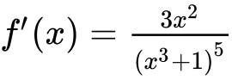. Given that , find .

**11a.** *[3 marks]*

Find 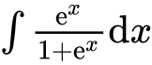 .

**11b.** *[4 marks]*

Find  .

**12a.** *[2 marks]*

Find  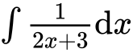 .

**12b.** *[4 marks]*

Given that 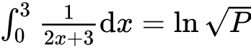 , find the value of *P*.

**13.** *[7 marks]*

Let . Find , given that 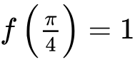.

**14.** *[6 marks]*

The following diagram shows the graph of 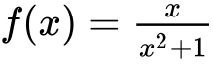, for , and the line .

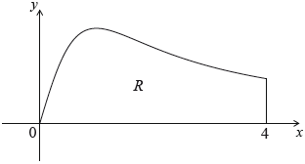

Let  be the region enclosed by the graph of  , the -axis and the line .

Find the area of .

**15.** *[6 marks]*

Let 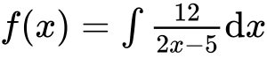 ,  . The graph of  passes through (, ) .

Find  .

**16.** *[8 marks]*

Let , for     . The following diagram shows the graph of .

There are -intercepts at .

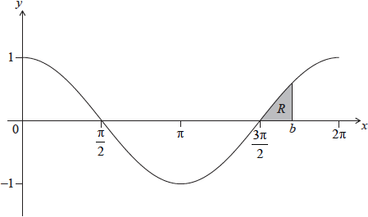

The shaded region  is enclosed by the graph of , the line , where , and the -axis. The area of  is 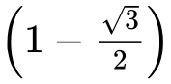. Find the value of .

**17.** *[6 marks]*

Given that 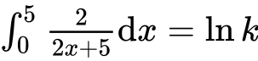 , find the value of *k* .

**18a.** *[6 marks]*

A function *f*(*x*) has derivative *f ′*(*x*) = 3*x*2 + 18*x*. The graph of *f* has an *x*-intercept at *x* = −1.

Find *f*(*x*).

**18b.** *[4 marks]*

The graph of *f* has a point of inflexion at *x* = *p*. Find *p*.

**18c.** *[3 marks]*

Find the values of *x* for which the graph of *f* is concave-down.

**19a.** *[3 marks]* (#13 in Tangents file)

Let , for . The following diagram shows part of the graph of .

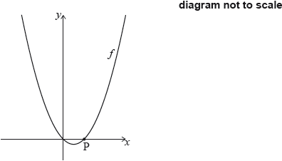

The graph of  crosses the -axis at the origin and at the point .

Show that .

**19b.** *[3 marks]*

The line *L* is the normal to the graph of *f* at P.

Find the equation of  in the form .

**19c.** *[4 marks]*

The line  intersects the graph of  at another point Q, as shown in the following diagram.

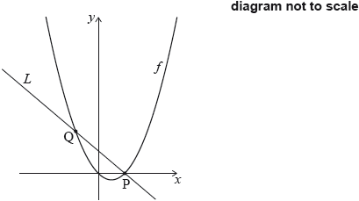

Find the -coordinate of Q.

**19d.** *[6 marks]*

Find the area of the region enclosed by the graph of  and the line .

**20a.** *[3 marks]*

Let 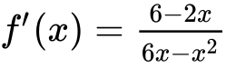, for .

The graph of  has a maximum point at P.

Find the -coordinate of P.

**20b.** *[8 marks]*

The -coordinate of P is .

Find , expressing your answer as a single logarithm.

**20c.**

The graph of  is transformed by a vertical stretch with scale factor . The image of P under this transformation has coordinates .

Find the value of  and of , where .

**21a.** *[2 marks]*

A particle P moves along a straight line. The velocity *v* m s−1 of P after *t* seconds is given by *v* (*t*) = 7 cos *t* − 5*t*cos *t*, for 0 ≤ *t* ≤ 7.

The following diagram shows the graph of *v*.

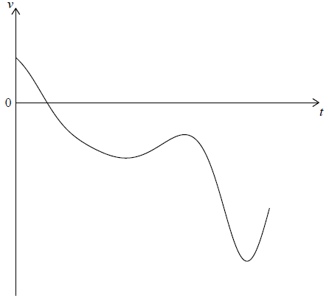

Find the initial velocity of P.

**21b.** *[3 marks]*

Find the maximum speed of P.

**21c.** *[3 marks]*

Write down the number of times that the acceleration of P is 0 m s−2 .

**21d.** *[4 marks]*

Find the acceleration of P when it changes direction.

**21e.** *[3 marks]*

Find the total distance travelled by P.

**22a.** *[2 marks]*

**Note: In this question, distance is in metres and time is in seconds.**

A particle P moves in a straight line for five seconds. Its acceleration at time  is given by , for .

Write down the values of  when .

**22b.** *[2 marks]*

Hence or otherwise, find all possible values of  for which the velocity of P is decreasing.

**22c.** *[6 marks]*

When , the velocity of P is .

Find an expression for the velocity of P at time .

**22d.** *[4 marks]*

Find the total distance travelled by P when its velocity is increasing.

**23a.** *[1 mark]* (#19 Tangents file)

Let . The following diagram shows part of the graph of .

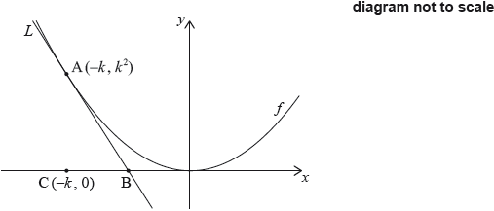

The line  is the tangent to the graph of  at the point , and intersects the -axis at point B. The point C is .

Write down .

**23b.** *[2 marks]*

Find the gradient of .

**23c.** *[5 marks]*

Show that the -coordinate of B is .

**23d.** *[2 marks]*

Find the area of triangle ABC, giving your answer in terms of .

**23e.** *[7 marks]*

The region  is enclosed by , the graph of , and the -axis. This is shown in the following diagram.

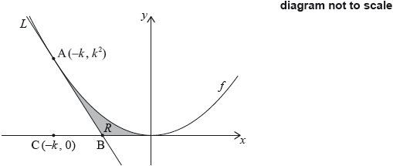

Given that the area of triangle ABC is  times the area of , find the value of .

**24a.** *[1 mark]*

Let  and , for .

The graph of  can be obtained from the graph of  by two transformations:

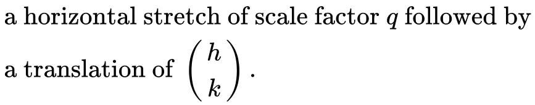

Write down the value of ;

**24b.** *[1 mark]*

Write down the value of ;

**24c.** *[1 mark]*

Write down the value of .

**24d.** *[2 marks]*

Let , for . The following diagram shows the graph of  and the line .

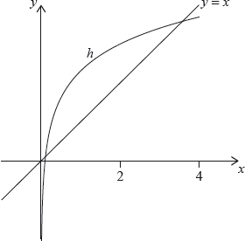

The graph of  intersects the graph of  at two points. These points have  coordinates 0.111 and 3.31 correct to three significant figures.

Find 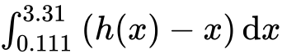.

**24e.** *[3 marks]*

Hence, find the area of the region enclosed by the graphs of  and .

**24f.** *[7 marks]*

Let  be the vertical distance from a point on the graph of  to the line . There is a point  on the graph of  where  is a maximum.

Find the coordinates of P, where .

**25a.** *[3 marks]*

Consider a function , for . The following diagram shows the graph of , the derivative of .

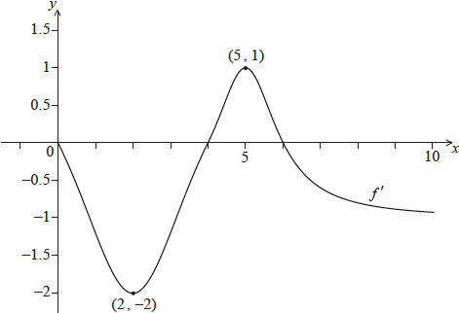

The graph of  passes through  and , and has -intercepts at ,  and .

The graph of  has a local maximum point when . State the value of , and justify your answer.

**25b.** *[1 mark]*

Write down .

**25c.** *[4 marks]*

Let  and .

Find .

**25d.** *[4 marks]*

Verify that , where .

**25e.** *[4 marks]*

The following diagram shows the graph of , the derivative of .

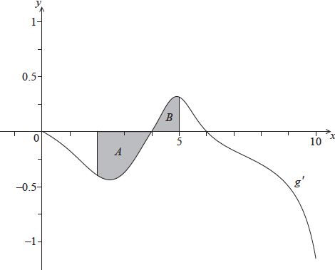

The shaded region  is enclosed by the curve, the -axis and the line , and has area .

The shaded region  is enclosed by the curve, the -axis and the line , and has area .

Find .

**26a.** *[6 marks]*

The following diagram shows the graph of , for , where .

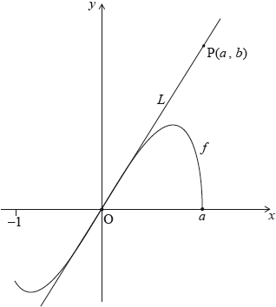

The line  is the tangent to the graph of  at the origin, O. The point  lies on .

(i)     Given that 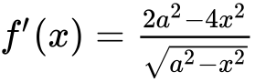, for , find the equation of .

(ii)     Hence or otherwise, find an expression for  in terms of .

**26b.** *[6 marks]*

The point  lies on the graph of . Let  be the region enclosed by the graph of  and the -axis. This information is shown in the following diagram.

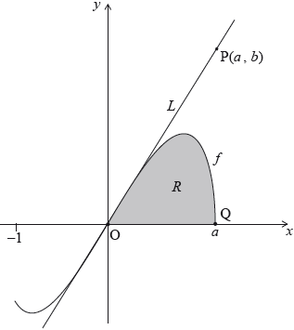

Let  be the area of the region .

Show that 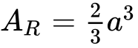.

**26c.** *[4 marks]*

Let  be the area of the triangle OPQ. Given that , find the value of .

**27a.** *[4 marks]*

Let 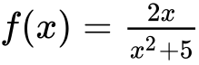.

Use the quotient rule to show that 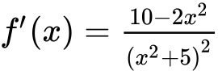.

**27b.** *[4 marks]*

Find 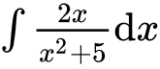.

**27c.** *[7 marks]*

The following diagram shows part of the graph of .

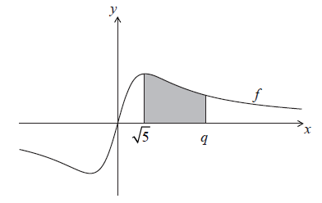

The shaded region is enclosed by the graph of , the -axis, and the lines  and . This region has an area of . Find the value of .