**Homework:** Read and be prepared to discuss tomorrow. Review geometric series.

A saving account has an interest rate of 2%. What does that mean?

It means that, if you have $100 today, in a year it will be worth $102. Because it’s in the bank, the 2% return (and we ignore taxes) is pretty safe. We say that 2% is a “risk free” return.

A friend has an investment idea. He is starting an online business, which sounds promising but also risky. He asks you for an investment of $100. How much would you want to make at the end of the year? Given the risk, you probably want the prospect of more than $102. Maybe $120? $150? 20% or 50% are “high risk” returns.

What about the stock market? This a “medium risk” investment. Let’s use a return number somewhere in the middle – to make things simple, let’s use 10%.

That means that, as an investor, you would be happy to invest $100 today, but only if you thought there was a good chance of this growing into $110 in a year’s time. If it only grows to $105 (or shrinks to $95) you will be disappointed. If it grows to $125 in a year, you are pretty happy…

So 10% is the cost of your capital. We call it the “cost of capital”. It’s essentially the “medium risk” equivalent of an interest rate.

Likewise, if an investment offers the prospect of $100 in a year’s time, how much is it worth today?

Answer: $100/1.1, or almost $91 today.

$100 in 2 years? $100/(1.1)^2, or $82.60 today.

What about $100 every year from now on, how much is that worth?

We can calculate it:

$100 100/1.1 100/(1.1)^2 100/(1.1)^3…..

Today year 1 year 2 year 3….. 100/(1.1)^4

Or 100 * (1 + 1/1.1 + 1/1.1^2 + 1/1.1^3 + ……)

Which is 100 * (1 + x + x2 + x3 + ….) where y = 1./1.1 (or 0.9090909…)

What is the formula for that?

Answer: 100 * (1/(1-1/1.1)) = 1100, or $1000 if we want to know the value today.

So it’s worth 10x the amount that the investor receives. If the company pays out to investors all the profits that it makes in a given year, then the $100 represents earnings.

So we can say that a company that keeps profits at $100, and pays them all out to its shareholders (owners), should be worth $1000. To the P/E, or price/earnings ratio, is 10.

Formula: value = earnings/interest rate, or earnings * P/E.

The P/E = 1/discount rate

But companies tend to do grow over time. How does that affect the valuation, and the P/E?

Assume again that a company makes profits (earnings) of $100 this year, and pays them all out to shareholders. But this time, let’s assume that earnings grow at 5% a year. This would be pretty good if it can do this forever.

What is this growing company worth?

Value = 100 + 100 * 1.05/1.1 + 100 * (1.05)^2/(1.1^2) + 100 * (1.05^3/(1.1^3) + …..

This looks like 1 + x + x2 + x3 + …., but this time the x isn’t 1/1.1, it’s 1.05/1.1

What is the sum of this series? 1 / (1-1.05/1.1) = 1.1/.05 = 22.

So now the value is 22 * $100, which is $2200 a year from now, or $2000 in today’s money.

So the value of this company is 20x the amount of the annual payment.

If there a formula? I turns out there is: value = earnings/(discount rate – growth rate).

And the P/E = 1/(discount rate – growth rate).

Let’s graph P/Es as a function of the growth rate: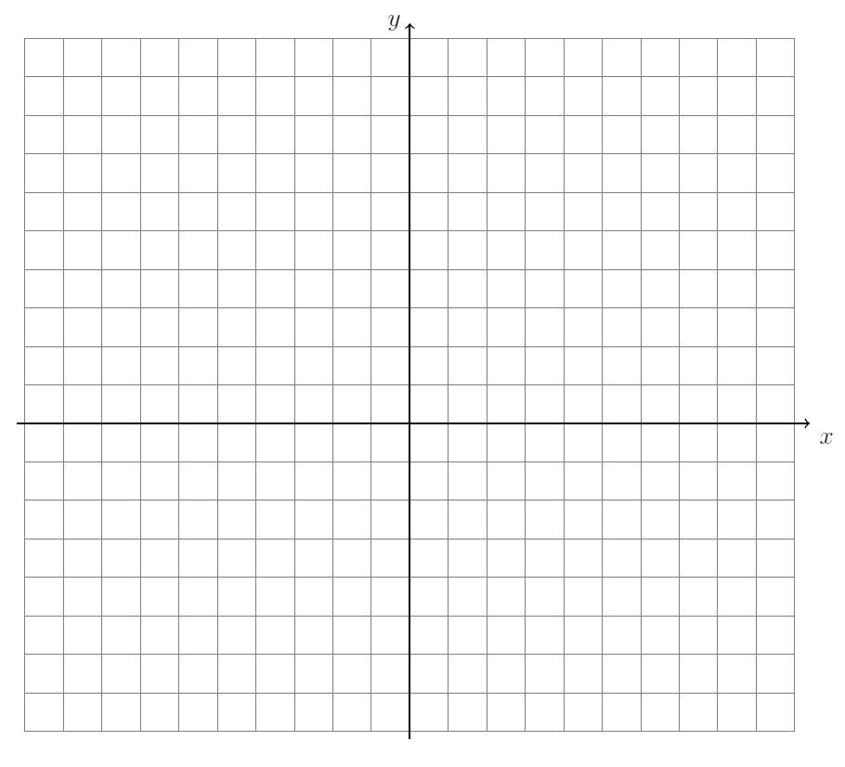

Now let’s do some examples.

**GAP:**

This is a clothing store chain (Gap, Old Navy, Banana Republic). The company makes $850 million in profits every year. This company hasn’t grown at all in the past 5 years:

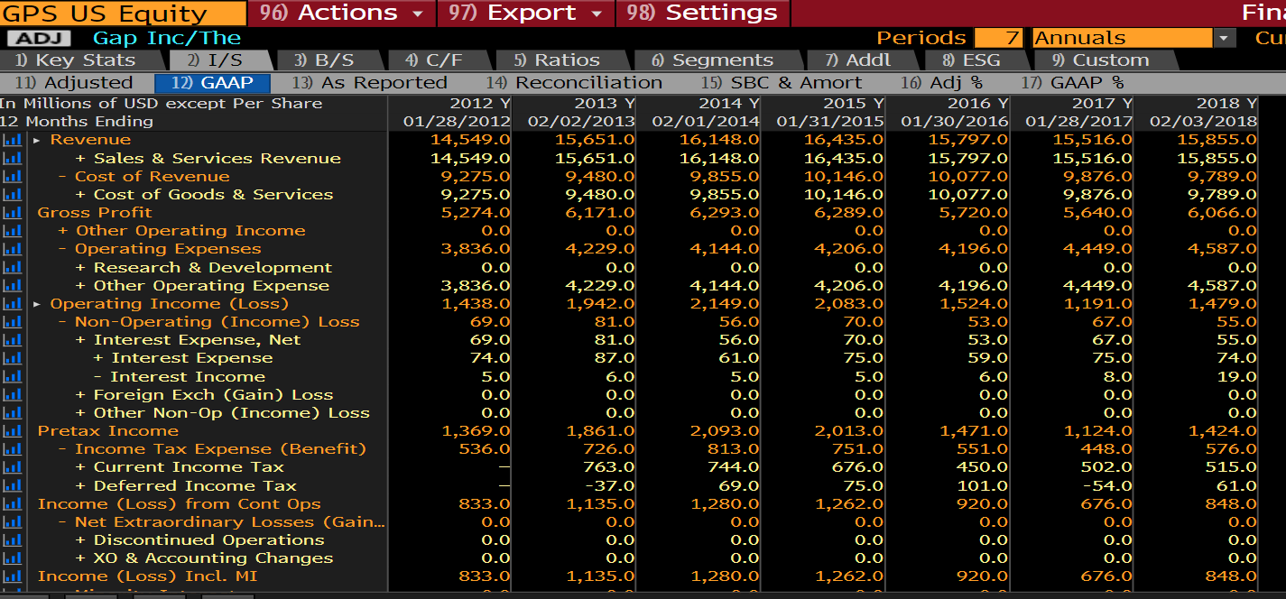

How much would you pay for such a business?

As we saw, if the profits are $850m, and they aren’t growing, maybe we would pay a P/E ratio of 10x (a discount rate of 10%, with no growth). There are 380 million shares, so that would mean that the business is worth $800 million * 10 / 380 million, or $22.35 per share. What is the price of the shares in the market? $24.50. That’s a P/E of 11 – is that reasonable? What growth rate would you need to assume that Gap with achieve to justify an 11x P/E?

How about another company?

**Amazon:**

Amazon made net profits of $10 billion last year and has 490 million shares. So it earns profits of $20.40 per share. It’s earnings per share (or EPS) is $20.40. What is its P/E? Well the shares cost $1650 each, to that’s a P/E of 80x. How fast would Amazon need to grow to get to a P/E of 80x?

At some point, Amazon will stop growing. At that point, it will only be worth a P/E of 10. What would it’s profits need to be? $1650/10 * 490 million, or $80 billion. It would have to be 8x as big as it is today.

Amazon’s revenues were $230 billion last year. If it were to be 8x as big, that would be $1.8 trillion, or almost 10% of the entire US economy…. Possible?

Which is the more attractive investment: Gap at 11x P/E or Amazon at 80x P/E?

If Amazon was to get