# 6-5-P1_Calculus-volumes

**1a.** *[3 marks]*

Let . Part of the graph of is shown in the following diagram.

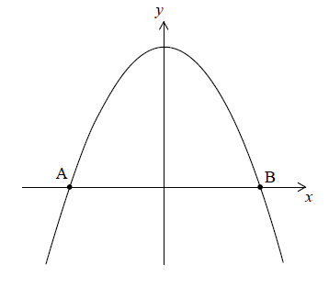

The graph crosses the -axis at the points  and .

Find the -coordinate of  and of .

**1b.** *[3 marks]*

The region enclosed by the graph of  and the -axis is revolved  about the -axis.

Find the volume of the solid formed.

**2a.** *[3 marks]*

Let .

Find the -intercepts of the graph of .

**2b.** *[3 marks]*

The region enclosed by the graph of  and the -axis is rotated  about the -axis.

Find the volume of the solid formed.

**3a.** *[4 marks]*

Find 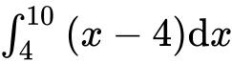 .

**3b.** *[3 marks]*

Part of the graph of  , for  , is shown below. The shaded region *R* is enclosed by the graph of  , the line  , and the *x*-axis.

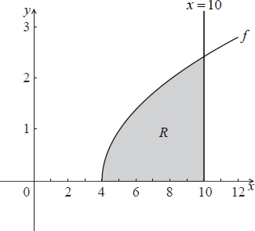

The region *R* is rotated  about the *x*-axis. Find the volume of the solid formed.

**4a.** *[2 marks]*

Let , for . The following diagram shows part of the graph of .

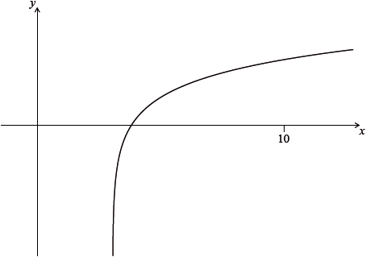

Find the equation of the vertical asymptote to the graph of .

**4b.** *[2 marks]*

Find the -intercept of the graph of .

**4c.** *[3 marks]*

The region enclosed by the graph of , the -axis and the line  is rotated ° about the -axis. Find the volume of the solid formed.

**5a.** *[4 marks]*

Let .

Find 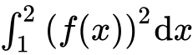.

**5b.** *[2 marks]*

The following diagram shows part of the graph of .

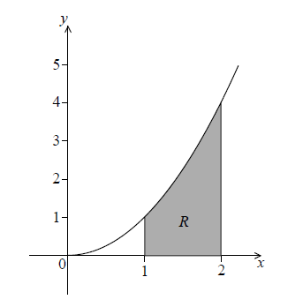

The shaded region is enclosed by the graph of , the -axis and the lines  and .

Find the volume of the solid formed when is revolved  about the -axis.

**6a.** *[2 marks]*

Let  for 0 ≤  ≤ 1.5. The following diagram shows the graph of .

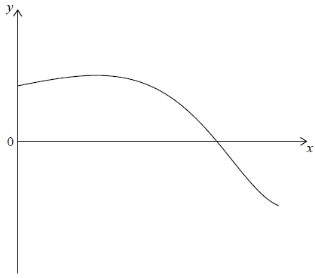

Find the *x*-intercept of the graph of .

**6b.** *[3 marks]*

The region enclosed by the graph of , the *y*-axis and the *x*-axis is rotated 360° about the *x*-axis.

Find the volume of the solid formed.

**7a.** *[2 marks]*

The graph of  , for  , is shown below.

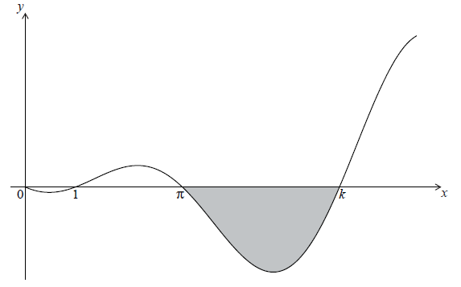

The graph has -intercepts at , ,  and  .

Find *k* .

**7b.** *[3 marks]*

The shaded region is rotated  about the *x*-axis. Let *V* be the volume of the solid formed.

Write down an expression for *V* .

**7c.** *[2 marks]*

The shaded region is rotated  about the *x*-axis. Let *V* be the volume of the solid formed.

Find *V* .

**8a.** *[3 marks]*

Let  ,  .

Sketch the graph of *f* on the following set of axes.

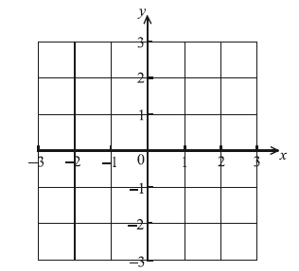

**8b.** *[1 mark]*

The graph of *f* intersects the *x*-axis when  ,  . Write down the value of *a*.

**8c.** *[4 marks]*

The graph of *f* is revolved  about the *x*-axis from  to   . Find the volume of the solid formed.

**9a.** *[3 marks]*

Let , for .

Sketch the graph of  on the following grid.

**9b.** *[2 marks]*

Solve .

**9c.** *[3 marks]*

The region enclosed by the graph of  and the -axis is rotated  about the -axis.

Find the volume of the solid formed.

**10a.** *[3 marks]*

Let 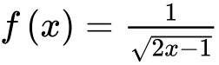, for .

Find .

**10b.** *[4 marks]*

Part of the graph of *f* is shown in the following diagram.

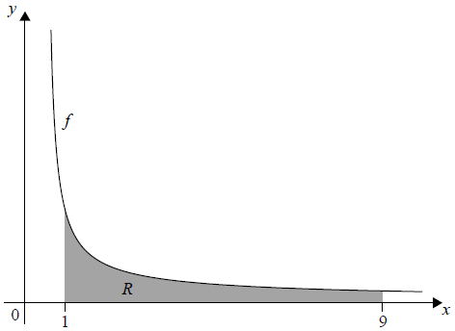

The shaded region *R* is enclosed by the graph of *f*, the *x*-axis, and the lines *x* = 1 and *x* = 9 . Find the volume of the solid formed when *R* is revolved 360° about the *x*-axis.

**11a.** *[3 marks]*

**All lengths in this question are in metres.**

Let , for . Mark uses  as a model to create a barrel. The region enclosed by the graph of , the -axis, the line  and the line  is rotated 360° about the -axis. This is shown in the following diagram.

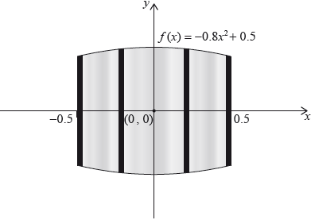

Use the model to find the volume of the barrel.

**11b.** *[3 marks]*

The empty barrel is being filled with water. The volume  of water in the barrel after  minutes is given by . How long will it take for the barrel to be half-full?

**12.** *[6 marks]*

The graph of  , for  , is shown below.

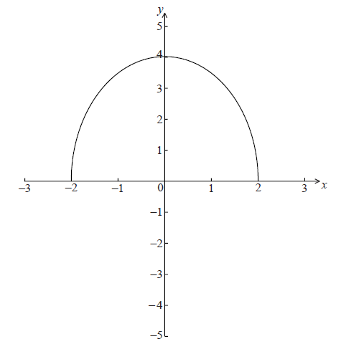

The region enclosed by the curve of *f* and the *x*-axis is rotated  about the *x*-axis.

Find the volume of the solid formed.

**13.** *[7 marks]*

The graph of  between  and  is rotated  about the *x*-axis. The volume of the solid formed is  . Find the value of *a*.

**14a.** *[2 marks]*

Let . The following diagram shows part of the graph of .

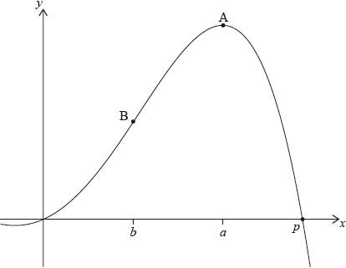

There are -intercepts at  and at . There is a maximum at A where , and a point of inflexion at B where .

Find the value of .

**14b.** *[2 marks]*

Write down the coordinates of A.

**14c.** *[1 mark]*

Write down the rate of change of  at A.

**14d.** *[4 marks]*

Find the coordinates of B.

**14e.** *[3 marks]*

Find the the rate of change of  at B.

**14f.** *[3 marks]*

Let  be the region enclosed by the graph of  , the -axis, the line  and the line . The region  is rotated 360° about the -axis. Find the volume of the solid formed.

**15a.** *[3 marks]*

Let  , for  . The graph of *f* is shown below.

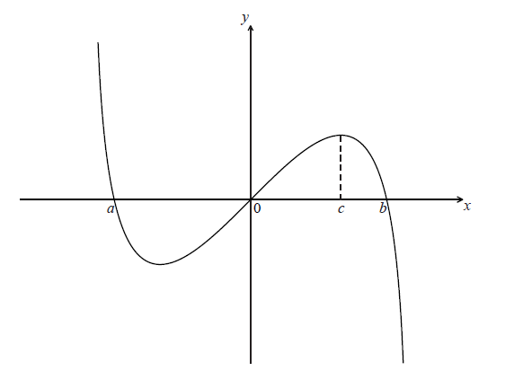

The graph of *f* crosses the *x*-axis at  ,  and  .

Find the value of *a* and of *b* .

**15b.** *[2 marks]*

The graph of *f* has a maximum value when  .

Find the value of *c* .

**15c.** *[3 marks]*

The region under the graph of *f* from  to  is rotated  about the *x*-axis. Find the volume of the solid formed.

**15d.** *[4 marks]*

Let *R* be the region enclosed by the curve, the *x*-axis and the line  , between  and  .

Find the area of *R* .

**16a.** *[3 marks]*

Let  , for  . The following diagram shows the graph of *f* .

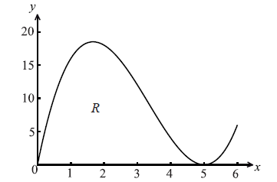

Let R be the region enclosed by the *x*-axis and the curve of *f* .

Find the area of *R*.

**16b.** *[4 marks]*

Find the volume of the solid formed when *R* is rotated through  about the *x*-axis.

**16c.** *[7 marks]*

The diagram below shows a part of the graph of a quadratic function  . The graph of *g* crosses the *x*-axis when  .

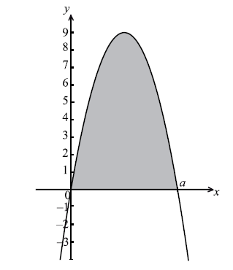

The area of the shaded region is equal to the area of *R*. Find the value of *a*.

**17a.** *[5 marks]*

Let  .

(i) Write down the range of the function *f* .

(ii) Consider  ,  . Write down the number of solutions to this equation. Justify your answer.

**17b.** *[2 marks]*

Find  , giving your answer in the form  where  .

**17c.** *[7 marks]*

Let 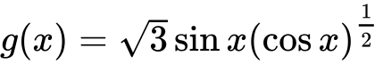 for  . Find the volume generated when the curve of *g* is revolved through  about the *x*-axis.

**18a.** *[4 marks]*

Let 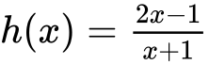 ,  .

Find  .

**18b.** *[7 marks]*

(i)     Sketch the graph of *h* for  and  , including any asymptotes.

(ii)    Write down the equations of the asymptotes.

(iii)   Write down the *x*-intercept of the graph of *h* .

**18c.** *[5 marks]*

Let *R* be the region in the first quadrant enclosed by the graph of *h* , the *x*-axis and the line .

(i)     Find the area of *R*.

(ii)    Write down an expression for the volume obtained when *R* is revolved through  about the *x*-axis.

**19a.** *[4 marks]*

Let  . Line *L* is the normal to the graph of *f* at the point (4, 2) .

Show that the equation of *L* is  .

**19b.** *[2 marks]*

Point A is the *x*-intercept of *L* . Find the *x*-coordinate of A.

**19c.** *[3 marks]*

In the diagram below, the shaded region *R* is bounded by the *x*-axis, the graph of *f* and the line *L* .

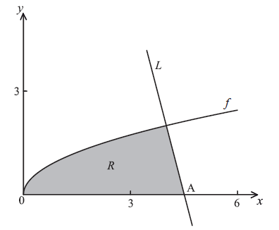

Find an expression for the area of *R* .

**19d.** *[8 marks]*

The region *R* is rotated  about the *x*-axis. Find the volume of the solid formed, giving your answer in terms of  .

**20a.** *[6 marks]*

The following table shows the probability distribution of a discrete random variable , in terms of an angle .



Show that .

**20b.** *[3 marks]*

Given that , find .

**20c.** *[6 marks]*

Let , for . The graph of between  and  is rotated 360° about the -axis. Find the volume of the solid formed.